Healthcare Organization Change Management
Sohin Mandepudi
Wilmington University

Healthcare Organization Change Management
In every organization change management has become a crucial process to overcome all the problems. After years of failed change efforts, researchers are saying that knowledge of the change process is crucial(Fred C. Lunenburg,2010). There are many models which could provide benefits for the organizations by implementing the change using them. The difficulties in the change management are handled by the organization employees of the current processes. Risks can occur if the organization fails in applying the change management techniques to establish new strategy. The current position and the situation of the organization is changed using the change management. So that the organization can be transformed to the desired stage to acquire the best results.
Because of the medical errors more than 99000 people got affected with this which stated by the Institute of Medicines. The quality of the medicines and patients safety is affected because of the medical errors. Major threats for the patients in the hospital are the errors that occur in the medications and the long term treatment that take place in the hospital. Customer's trust, safety and the security of the patients is affected because of the medication errors that occur in the hospital. It also causes financial loss for the hospitals. For the patients and the customers who approach the hospital will be safe from the medication and the medicines. For instance the hospital which is located in New York started implementing the bar-coding system using IT so that the human errors can be resolved in the organization. Thus, the operations that take place in the organization will be efficient and accurate. The bar-coding technology and IT are integrated in the healthcare organization for the effective implementation changes in the organization to reduce the faults. The profile of the patient is obtained easily with the use of databases in the organization and using the barcode scanning they can scan the patient records from the databases. They can also validate all the profiles of the patients and the drugs used by them using the scanner.
Change Management Role in the Organization
Human resources and the business results are managed using the process, techniques and the rules that are followed using the application to establish the change using the change management. Managing the change in the company is the difficult for the employees and the management of the organization. Way of transforming the present to the better situation is the organizational change. There are three types of changes in the organization they are,
- Adaption
- Controlling and
- Implementation
This transformation of the organization makes benefit to the individual or groups or the businesses. Some of the changes that can happen in the organization with the implementation of the change management is,
- The structure of the organization
- The system of the organization and the processes that occur in the organization.
- The role of the employees and job.
Change Management Models
Various changes in management methods help to implement the change in the company. Change management models are:
- Lewin’s Dynamic Stability Model
- Kubler-Ross Stages of Change Model
- Kotter’s Phases of Change Model
- Prosci Change Management Model
- Satir’s Change Process Model.
Lewin’s Dynamic Stability Model
To manage the change in the organizations Kurt Lewin has introduced three steps for efficient implementation. His model is a simple and easy-to-understand framework for managing change known as Unfreeze – Change – Refreeze ("Lewin's", n.d). The process unlocking the situation in the organization is referred as the unfreeze step in the first stage of change management in organization. Keeping in mind the end goal to stick the association into the new execution refreezing procedure is important
To understand and change the organization Kurt has introduced simple and practical which can be understood by everyone to manage change in the organization. The process of change management and the implementation can be done by following the Lewins steps for change management. The process that is followed by Kurt Lewins is well planned and goal oriented. Because of its simplicity this Kurt Lewin's change management models suits well for all the organizations which is mostly suggested by several managers in the company. The process of executing the change in the organization is a step by step process which is followed by the organizations. Complex issues in the organization are controlled using the Kurt Lewins change management model.
Lewin’s Management Change Model
Kurt Lewin (1951) introduced the three-step change model (Alicia Kritsonis, 2005). This is the most simple and the practical model which represents the change in the management. In the Lewin’s Management Change Model there are three changes of stages which are widely used nowadays. They are,
- Unfreeze stage
- Transition stage
- Refreeze stage

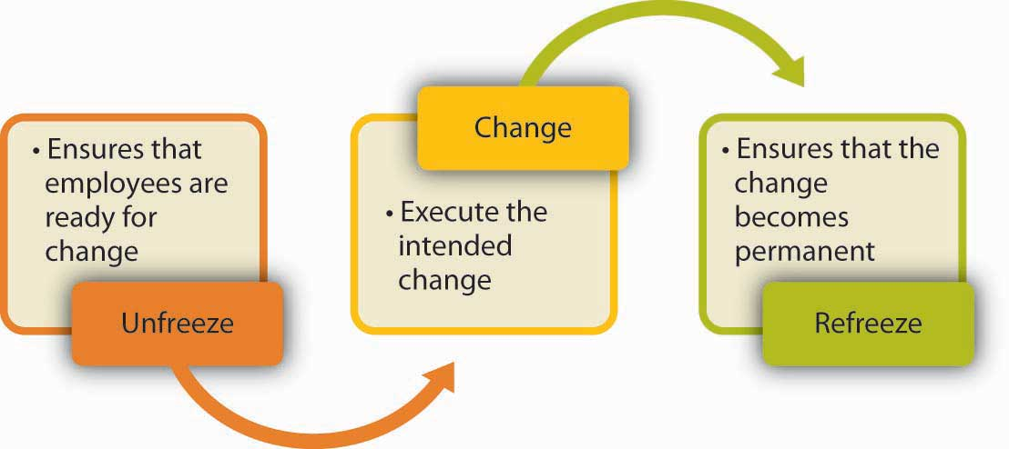
Figure 1: Kurt Lewins Change Management Model
Unfreeze Stage
According to Lewin, the first step in the process of changing behavior is to unfreeze the existing situation or status quo (Alicia Kritsonis, 2005). Old behavior ways of thinking, processes, people and organizational structure must all be careful to examine the people and show how change is important to meet the competitive advantage of the market (Kurt Lewin). Most of the people hesitate to change frequently as they want to get fixed to the safe zones. They feel uncomfortable when any changes occur in the environment. They fell comfortable in the environment when no changes occur. In order to overcome them from all the changes Unfreeze stage has been initiation which gives motivation for the people in the Unfreeze stage. Motivation is more important to change the people in the Unfreeze stage. The people in this stage can take a decision by weighing the pros and cons of the motivated concepts.
Transition Stage (Changing Phase)
Lewin’s second step in the process of changing behavior is movement (Alicia kritsonis,2005). Transition stage is the occurring stage. In this stage people do not change for motivation and they very hard change for the situations that occur. This is not an easy stage because people do not change for motivation and making them to understand the work they need support to change with the environment. Support is the main important point in this stage because the people need training, coaching and making them to understand the mistakes. Most of the people in this stage struggle very hardly. The way of behavior and new thinking will start in this stage. This is the most important phase because it should be organized carefully and executed smoothly.
Refreeze Stage
Last stage of the Lewin’s change management model is the refreeze stage. In this stage the behavior is stabilized and the implementation is changed. The final stage in this change management model is the Refreeze Stage which is also known for the symbol of stabilizing and solidifying. The organizational process, goals and structure are the changes made in the earlier stages are now accepted and moved to a new stage called as new norm. The most important point to note here is that people should not move back to the older stages of thinking and to the implementation of change. To maintain this stage most of the efforts should be put. The purpose of refreezing is to stabilize the new equilibrium resulting from the change by balancing both the driving and restraining forces(Alicia kritsonis,2005).
Implementation of Lewin’s Model
To understand and to relate the behaviors of the people in the organization Lewins theory is used in most of the organizations to make the people in the organization to understand the patterns of change. The stages that are involved in the change of the organization is moving, refreezing and unfreezing which are mentioned in the Kurt Lewins change management theory.
Unfreezing
Unfreeze stage is used to first part in making the changes for the organization. The primary focus of the organization is the vendor selection and generating the information for the nurses and the visiting of the sites.. Therefore with the help of the employees and the users in the organization agreements can be made. The deployment of the instruments in the organization is the major consideration for choosing and executing the barcodes in the organization. The barcode is helpful in scanning all the medications in the organization like cards, medicines barcode and the patients passes in the organization. The implementation is done to make the users understand the benefits and the process that needs to be changed. Making the people understand the process is very difficult because most of the people hesitate to change. In the initial phase the tracking and the documentation should be done so that proper plan can be made from the feedback given by the people. The basic procedures of the phase are,
- Coaching in the initial stage and awareness.
- Benefits of Change
- Planning for Change
To implement the change in the organization the employees in the hospitals are insisted carry the COW i.e compute on wheels. This equipment is used by the employees to scan the scan the barcodes that are labeled on the patient beds and the medicines that are prescribed for the patients. So that no errors can occur and fraud will not occur in the organization. The carts that are used in the organization to store all the patient medicines and the first aids are also scanned using COW. With the help of this equipment the nurse in the hospital can clarify the patient doubts regarding the drug consumption. This information can be known by them because this equipment is connected to the hospital database which consist of all the information about the patient, drug prescriptions of the patients, dosage etc. If the usage of the equipment is effectively used by the employees then the change is implemented successfully in the organization. The goal of the organization such as errors and the fraud can be reduced.
Moving or Change
The successful change of implementing the Lewins theory in the organization mostly supported by the staff and the management. In this stage the organization completely implements the barcode scanning system so that human errors will be reduced in the organization. The recovery and the backup should be done in order to set up the documentation for the initial phase. In this stage people are in the occurring stage. The various steps in implementing the phase are,
  - Change in the proposed process.
  - Backup
  - Maintenance of files
  - Plan for communication
Refreezing
The final step in the change process involves stabilizing the change at a new quasi-stationary equilibrium, which is called refreezing (Fred C. Lunenburg,2010). Maintaining the feedback and feedback analyzing is the most important factor to concern because it shows how to rectify the mistakes by feedback. The relation between the user and the organization will be stronger because of understanding the feedbacks of maintenance. Trustworthy relationship will be maintained.. The processes in the final stage are given below.
- Coaching should be given through manuals.
- Making the manuals available for the customers
Nonstop help from the medical caretakers, the whole staff in the social insurance association and from the partners required until the change is finished and solidify in the human services framework. And all clients are OK with the new change introduced. Human services associations got benefit from the effective change that is implemented in the organization.
Conclusion
To make the organization benefit in all the ways change management helps the organization a lot to get profits and reduce the errors in the organization. The various kinds of operations in the organization can be treated using the Lewins change management model. The problems that occur due to humans in the organization will be reduced in the healthcare industry with the implementation of the barcode scanning system.

References
Alicia Kritsonis (2005). Comparison of Change Theories. Retrieved from
http://www.nationalforum.com/Electronic%20Journal%20Volumes/Kritsonis,%20Alicia%20Comparison%20of%20Change%20Theories%20IJMBA%20V8%20N1%202005.pdf
Fred.C.Lunenburg (2010). Approaches to Managing Organizational Change. Retrieved from
http://www.nationalforum.com/Electronic%20Journal%20Volumes/Lunenburg,%20Fred%20C%20Approaches%20to%20Managing%20Organizational%20Change%20IJSAID%20v12%20n1%202010.pdf
Lewin's (n.d). Lewin"s Change Management Model. Retrieved from
http://www.nwacademy.nhs.uk/sites/default/files/86_1722011_lewin_s_change_management_model.pdf

