Different people different expressions
Human beings usually portray different emotions on a particular activity. The expressions often are given defines or explain a specific issue which a certain group of people is facing in a particular environment. International students face a lot of challenges while undertaking their studies in the foreign countries since they encounter various environmental issues in the institutions they are enrolled. The fact that these students are facing several problematic issues has brought up the varying expression from different people, who posts their statements online. This profile focuses on the various expressions which people make concerning international students as the challenges they face is concerned.
Include a paragraph about the Humans of UW-Stout Facebook page.
International students face a lot of difficulties in the institutions which they enroll in the foreign countries. This aspect has faced a lot of expressions from various people in the world. People all over the world have varying views on the challenges the students face, and they sometimes tend to propose ridiculous suggestions on the best solutions for problems they face.
People make their expressions via various social media platforms by some features provided such as human UW-Stout. Human UW-stout is a communication function facilitated by Facebook and was designed by Dr. Carter. The communication platform was created to promote learning for English students which Dr. Carter taught. The platform has been used differently by students rather than the primary reason why the tutor meant. Students are posting pictures which expresses confusion statements and which portray they varying opinions concerning various issues which they face or their friends’ encounters in their institution's environmental context. This profile discusses different pictures and quotes which students or people have posted concerning the challenges which international students face in the international environments.
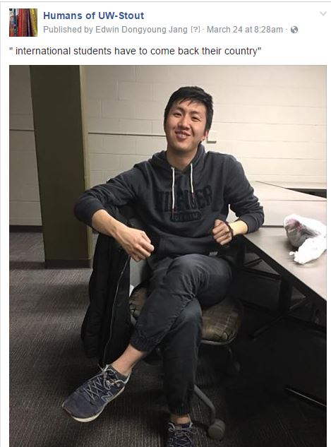
The first picture and quote by Edwin Dongyoung Jang is a student seated and expressing his personal point of view the best solution which international students should consider. He quotes ‘international students should come back home.' Even though international students face some problematic issues in the different environments going home should not be the solution. I see the quote disturbing since the students should focus on the primary issue which made or motivated them to undertake their studies abroad rather than in the home institutions.

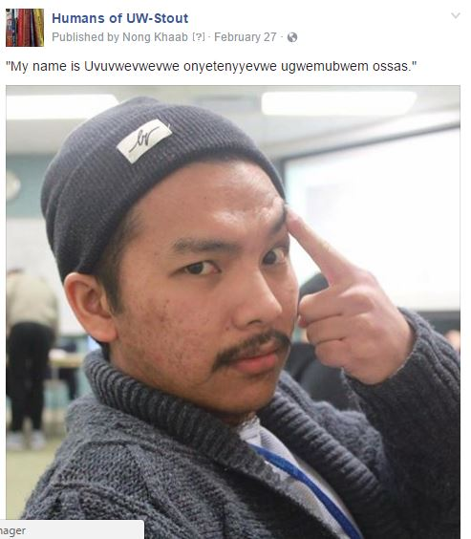
The second picture and quote by Nong Khaad do not suggest any solution to the challenges which international students are facing. The picture is of a student's face who decided to write what he feels in important for him to post in the human UW-stout.

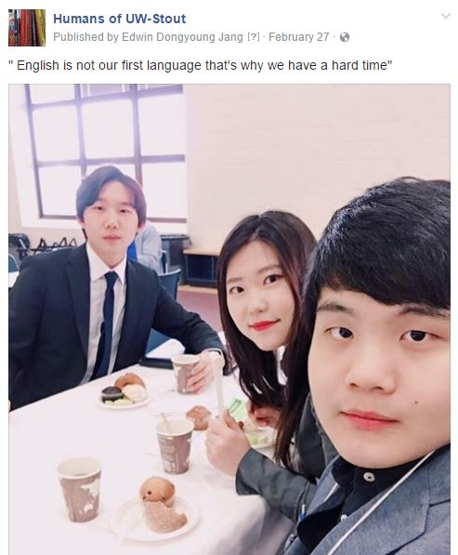
The third picture and quote by Edwin Dongyoung Jang pass a very signifying information as the challenges which international students are facing in the foreign environment. The quote ‘English is not our first language that's why to have a hard time,' portrays the challenge which they are facing. I see the information imperative since s group of international students decided to use the communication platform to expression the problematic issue which they are facing in the institution. Even though the students should be taking time studying or doing their assignments they decided to post the message during the free time. The picture has three students are taking snacks which portray it was they were free or after lessons.
Conclusion
The three pictures and quotes portray different expressions from students concerning the challenges which international students are facing in the new environment. The first picture and quote reflect the solution which the students should take and that is going back home where they will be comfortable. The second picture and quote do not portray anything important rather than an expression of a student's name. The third picture and quote are of great importance since it reflects the primary problem international students are facing in the new environment.

