Lab Assignment #4
Due date: 12:00 pm, 09/26/2016

Problem Description
Write a coin flipping program with a twist, you can manipulate the coin toss to favor either heads or tails. The program will ask which side of the coin the user wants to favor, heads, tails, or neither. The program will then ask the user how much that side will be favored. For instance, if the user indicates that they want to favor heads by 20, the probability of the coin flipping heads will be 70%. Next, the program will ask how many times the user would like to flip the manipulated coin and will simulate that many flips. Finally, the program will tell the user how many times each side was flipped.
Assignment Requirements
- Create a flowchart detailing the program
- Create adequate pseudocode for each portion of the code, do not forget your program header
- The program needs to accept user input to determine three things, the side to favor, the percentage, and the number of times the coin will be flipped
- You will need to run four test cases detailed below and provide screenshots showing you have run the cases:

Case | Side to favor | Percentage to favor | Number of flips
1 | Neither | N/A | 1000
2 | Heads | 20% | 1000
3 | Tails | 10% | 1000
4 | Tails | 50% | 1000
Example run of the program
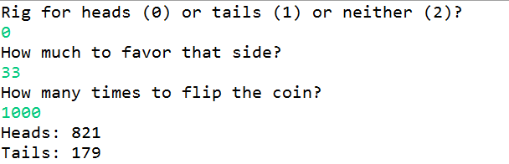

Submission Requirements
Your assignment submission should be prepared as follows:
- The flowchart diagram document
- The Java source code file (i.e., *.java file) you write for this assignment
- The MS Word document containing the screen captures of all test cases you run, making sure the screens show the input and output. To receive the credit for completing testing, your screen captures should include all four test cases.

Submit all files above into the dropbox of this assignment.

Assignment Assessment
Task Items | Complete & Correct | Incomplete/  Partially Correct | Missing
Solution Design  (flowchart diagram) (15%) | 100% | By % | 0
Solution Pseudo-Code (Java comments) (10%) | 100% | By % | 0
Java Program (60%) | 100% | By % | 0
Testing Completeness (15%) | 100% | By % | 0

Please do not email your assignment to the instructor.

