Student Name
Professor Kelly Jordan
ARTH 102
23 August 2013
Fra Angelico at San Marco
In person, the Annunciation (ca. 1440-45) fresco by Fra Giovanni da Fiesole, known today as Fra Angelico, looks very different than in photographs. Seeing the painting at the once Dominican monastery, allows the observer to look up at the work at the top of the stairway giving it a lofty presence. After all, the announcement to Mary that she is to conceive the Son of God is the prime step to the fulfillment of the prophecy of Christ. The scene should be exalted. Fra Angelico was commissioned by Cosimo de’ Medici to paint various works in the monastery (Davies et al. 320). The sparse setting of the two characters, Mary and the angel Gabriel, with arches imitating the convent’s own architecture seems very fitting considering that it was designed for monks who had divested themselves from earthly goods. Though the scene is serene, some may experience discomfort due to the feeling that the figures are too large for the space. Would Mary and Gabriel bump their heads on the ceiling if they stood (321)? Color for the majority of the fresco has a subtle softness about it with the exception of Gabriel’s rainbow wings. Photographs are not likely to pick up the metallic glimmer or glitter experienced in face-to-face examination. The Annunciation may not be Fra Angelico’s finest work but this and other works in the convent may have set the stage for change with its austerity and 3-D perspective (231).
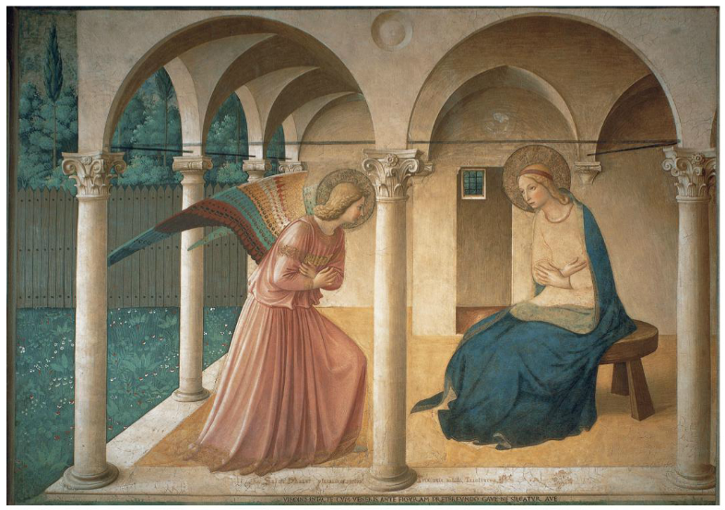
Fra Angelico. Annunciation. Ca. 1440-1445. Fresco on dormitory level of the Convent of San Marco.
Janson’s Basic History of Western Art. 9th ed. By Penelope Davies et al.
Boston: Pearson Education, Inc. 321. Print.

Works Cited
Sheldon, Dyan. The Whales’ Song. New York: Penguin Books, 1991. Print.
Pinkowski, Jennifer. “A Different View of Paleo-Indians.” American Archaeology Summer 2013: 12-18. Print
Zucker, Steven and Beth Harris. “Cimabue, Santa Trinita Madonna.” Khan Academy. Web. June 2013. < https://www.khanacademy.org/humanities/art-history/art-history-1300-1400-proto-renaissance/florence/v/cimabue--maesta-of-santa-trinita--1280-900-1290?qa_expand_key=ag5zfmtoYW4tYWNhZGVteXJqCxIIVXNlckRhdGEiTHVzZXJfaWRfa2V5X2h0dHA6Ly9ub3VzZXJpZC5raGFuYWNhZGVteS5vcmcvZmI5NjJjNjYxMjg0OTM0MzI0NThjZThkM2Q4NjMwMjcMCxIIRmVlZGJhY2sYge4FDA>

