Assignments
1. For the data in (i) and (ii), draw a timeline for each of the following scheduling algorithms and compute the turnaround time and the waiting time.
In each case, also compute the average turnaround and waiting times.
- First Come First Served (FCFS)
- Shortest Process Next (SPN)
- Shortest Remaining Time (SRT)
Note: Execution time is measured in CPU cycles.
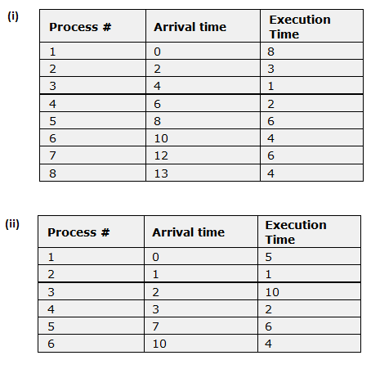
(60 marks)
2. Six processes (process1, process2, process3, process4, process5 and process6) are in the READY queue waiting to be processed. Their estimated execution times, measured in CPU cycles, are 10, 2, 8, 5, 2 and 4.
The processes are processed in this sequence: process1, process2, process3, process4, process5 and process6.
(i) Using the FCFS scheduling policy, what is the turnaround time for each of the processes and the average turnaround time?
(ii) If the sequence is changed to process2, process4, process3, process1, process5 and process6, now what is the turnaround time for each of the processes and the average turnaround time?
(iii) Using the SPN scheduling policy and the sequence from (ii), what is the turnaround time for each of the processes and the average turnaround time?
(40 marks)

If using an outside resource when responding to these questions, please support your responses with in-text citations and references, following APA referencing guidelines (available on WRAP).

