Name: Michael Figueroa
The Human Body
TEST-2

Choose the best option

(2 Points Each) = 40 Points
- Traits that involve more than one set of alleles are called

a. Condominant | c. Heterozygous
b. Incomplete | d. Polygenic

- Which association is incorrect?
a. Mouth-starch digestion | c. Small intestine- Starch, Lipid, Protein digestion
b. Esophagus-Protein digestion | d. Stomach- Food storage

- To lower blood acidity,

a. Hydrogen ions are excreted, and bicarbonate ions are reabsorbed | c. Hydrogen ions and bicarbonate ions are reabsorbed
b. Hydrogen ions are reabsorbed, and bicarbonate ions are excreted | d. Hydrogen ions and bicarbonate ions are excreted.

- A karyotype is prepared

a. for an unborn child through amniocentesis chorionic villi sampling | c. as a means of diagnosing an abnormal chromosome disorder
b. by arranging chromosomes into pairs by size, shape, and banding patterns | d. all of the above are correct.

- Spongy bone
a. Contains osteons | c. Lends no strength to bones
b. Contains red bone marrow, where blood cells are formed. | d. All of these are correct.

- Muscles are covered by fibrous connective tissue called the

a. Fascicle | c. Fascia
b. Tendon | d. Retinaculum

- A reflex arc

a. Always involves the spinal cord | c. Usually involves only one sensory and one motor neuron
b. Occurs only in the arms and legs | d. Allows a quicker response than voluntary movement.

- A sensory receptor
a. Is the first portion of a reflex arc | c. Can be integral or external
b. Initiates nerve impulses | d. All of these are correct.

- The hypothalamus does not:

a. Control skeletal muscles | c. Control the pituitary gland
b. Regular thirst | d. Regulate body temperature

- Retinal is

a. A derivative of vitamin A | c. A part of rhodopsin
b. Sensitive t light energy | d. All of these are correct.

11. Growth hormone is produced by the
a. Posterior adrenal gland | c. Kidneys
b. Posterior pituitary | d. Anterior pituitary .

12. By what process are most molecules secreted from the blood into the tubule?

a. Osmosis | c. Active transport
b. Diffusion | d. Facilitated diffusion

13. A bone is considered

a. A tissue | c. A system
b. An organ | d. A part of the integumentary system.

14. In metaphase I of meiosis I, the chromosomes

a. Separate from their homologue | c. Appear random and singly
b. Line up singly at the equator. | d. Line up with their homologue at the equator other living things

15. The thin, darkly pigmented layer that underlies most of the sclera is

a. the conjunctiva | c. the retina
b. the cornea | d. the choroid

16. A spinal nerve takes nerve impulses

a. To the CNS | c. Both to and away from the CNS
b. Away from the CNS | d. From the CNS to the spinal cord.
17. Which of the following muscles would have motor units with the lowest innervation ratio?
a. Leg muscle | c. Muscles that move the fingers
b. Arm muscles | d. Muscles of the trunk

18. The bump seen on the outside of the ankle is part of the
a. femur | c. fibula
b. tibia | d. tarsal bones
19. The amino acids that must be consumed in the diet are called essential. Nonessential amino acids
a. Can be produced by the body | c. Are stored in the body until needed
b. Are only needed occasionally | d. Can be taken in by supplements

20. Cells that are examined in karyotyping of a fetus usually come from------------
a. Chorionic Villi | c. Amniotic Fluid
b. Skin Cells | d. Chorionic villi and Amniotic Fluid

Fill in the Blanks

(2 Points Each) = 12 Points
- ---------------glands are ductless.

- An alternative form of a gene is called-----------.

- The three types of joints are------------.
- Glucagon causes--------------------.

- A male with two ore more X chromosomes along with a single Y chromosome has------------------------------syndrome.

- During------- mitotic phase during which daughter chromosomes move toward the poles of the spindle.
True (T) or False (F)

(2 Points Each) =10 Points

- The pectoral girdle is specialized for flexibility of movement
- The term phalanges refer to the bones in both the fingers and the toes.
- Bones synthesize vitamin D for the body.
- Bones store minerals and fat.
- Most bones develop through endochondral ossification.

Match the Pair

(2 Points Each)= Total 30

1 | Klinefelter syndrome | A | Point of attachment for sister chromatids
2 | Poly-X female | B | Female with undeveloped ovaries and uterus, unable to undergo puberty, normal intelligence, lives normally with hormone replacement..
3 | Down syndrome | C | XXY male, can inherit more than two X chromosomes
4 | Turner syndrome | D | Coiled and condensed chromatin
5 | Jacobs syndrome | E | Male or female, mentally retarded, short stature, flat face, stubby fingers, large tongue, simian palm crease
6 | Centriole | F | Can have two chromatids
7 | Trapezius | G | XXX or XXXX female
8 | Chromosome | H | Caused by nondisjunction during spermatogenesis
9 | Centromere | I | Head and Neck
10 | Interleukins | J | Found at a pole in the center of an aster
11 | Hamstring group | K | Trunk
12 | Rectus Abdominis | L | Arm
13 | Triceps Brachii | M | Thigh
14 | Gluteus medius | N | Gastrocnemius
15 | Flexes leg and foot | O | Abductus thigh

1
2
3
4
5
6
7
8
9
10
11
12
13
14
15

Answer The Following

(1 Points Each, first 4 questions) =4

- A man with a widow’s peak has a mother with a straight hairline. Widow’s peak (W) is dominant over straight hairline (w). What is the genotype of the man?

- Both a man and woman are heterozygous for freckles. Freckles (F) are dominant over no freckles (f). What is the chance that their child will have freckles? Explain.

- Both you and your sister or brother have attached earlobes, yet your parents have unattached earlobes. Unattached earlobes (E) are dominant over attached earlobes (e). What are the genotype of your parents?

- A father has dimples, the mother does not have dimples, and all five of their children have dimples. Dimples (D) are dominant over no dimples (d). Give the probable genotypes of all persons concerned.

Label the Diagram

4 Points

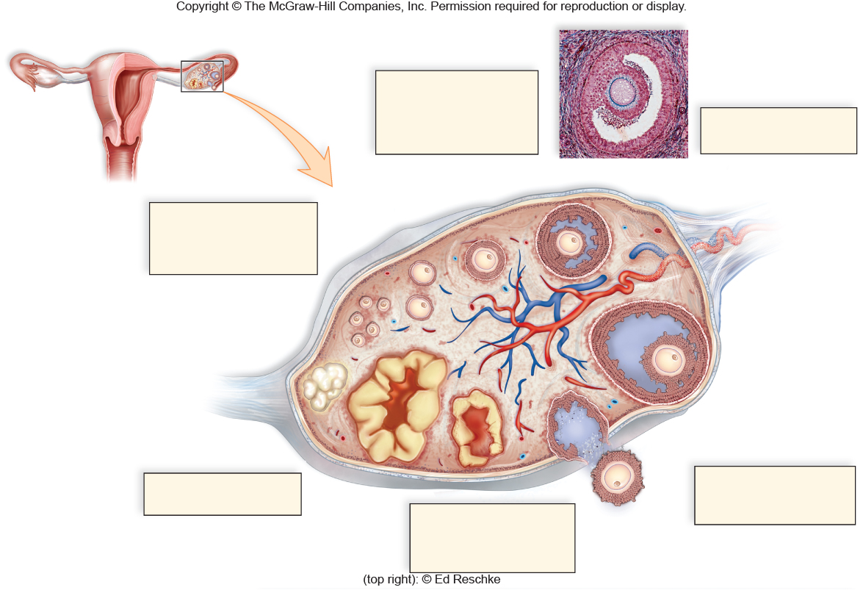

Arrows Clockwise
A
B
C
D
E

