The Marketing Plan
Hakim Callahan
Argosy University

MARKETING PLAN
SECTION 1: THE ENVIRONMENT
The environment in marketing refers to the environmental factors which include, economic, political, Social, technological, and also legal factors. They comprise of both micro and macro environment. SWOT analysis will also be included in the plan in this section.
1.1) Introduction to Marketing
Marketing as an action or else a business that serves the purpose of promoting products as well as selling as selling the particular products. It includes carrying out a market research and advertising. The research carried out will be of much significance to the Waters Bottling Company (WBC) of Munsonville in discovering new potential markets for their product(s) and identify the current competitors in the market. Besides, the research will help the company to access information concerning their operations and the products they deal with. Also, advertising will make the firm known to new markets hence increasing sales by enlarging the market served.
Marketing Mix
According to (Peter & Donnelly, 2009, the marketing mix is one of the foundation concepts of marketing that can be applied by the Waters Bottling Company to accomplish the marketing goals and objectives `in the targeted market. It can, therefore, be termed as a tool for marketing and includes four elements namely; the product, the price, the place, and promotion. The product that the company will market will be the Crystal blue which is mountain water that has been properly filtered naturally using the granite found in the mountains where the water is found.

The price of the Crystal Blue product will be determined by the location of the market where it will be sold. Besides, the price may also be different basing on whether the product was sold to individuals per product or in packs. The competitors may further determine the price of the product as the company may lower the price to compete favorably with other firms or raise prices if it owns some production rights to become a monopoly in a particular area. The company will sell the Crystal Blue products in places that are easily accessible, that is, at gas stations, drugstores and grocery stores so as to make it more convenient for the customers to find the product. The company will do promotion through advertising, that is, through the use of grocery ads, commercials through the television and magazines. It will also be advertised as a health product by well know celebrity so as attract the attention of many potential customers.
1.1.2) The Marketing Environment
Marketing environment is a term referring to forces and factors that have the capacity to influence the ability of the company in building and sustaining the successful relationships with its customers. As per (Oldroyd & Chartered Institute of Marketing, 2007), there are three levels of marketing environment necessary to understand developing a business plan. These are; Microenvironment which consists of very small forces to note, that have a high probability of affecting their ability to serve the customers.
Second is the macro environment which includes a larger part of the forces in the society. They influence the microenvironment in more substantial part. Lastly is the Mesa environment which refers to the industry that the company operates ion and the market for the industry. There are three possible responses to the marketing environment from which the company will choose. They are; first adapting to the environment after reacting to it( for the uncontrollable environments), second is applying aggressiveness so as to influence forces in the environment ( In proactive environments) and third only watching and reacting to the forces in the market (in reactive markets) just as depicted by (Peter & Donnelly, 2009).
1.1.3) Marketing and its relationship with other functional areas of
Business
Marketing will help the company to obtain their goals as well as accomplishing their mission and visions by allowing an opportunity for application of the strategies laid for the company. The company enhances co-operation with the others areas of business responsibility in the Water Bottling Company. These areas include strategy, finance, human resources, equipment, operations, and technology. Marketing either as an action or business in the WBC makes use of all the areas of the company responsibility to achieve the goals and objectives of the marketing plan. All the sectors apply in marketing.
1.2) Strategic Marketing
Strategic marketing forms the foundation of the marketing plan. The Waters Bottling Company will, therefore, formulate a good strategy for marketing using the data collected through research and focusing on the product mix so that it may maximize the profits and cause the business to sustain (Drummond, Ensor, & Ashford, 2008). The marketing strategy of WBC will combine its marketing plans into a comprehensive plan. Besides, marketing will be the way in which the firm will differentiate itself from its competitors effectively by capitalizing on its strengths, that is, both current and potential) as mentioned in the SWOT analysis in the business plan of the company.
In effect to these, the company will be able to provide consistently better products than its competitors to the customers. Strategic marketing planning is, therefore, the process in which both the operational and managerial staff of the company will have to pass through to create and implement the effective marketing strategies formulated. It then takes some aspects of business marketing and promotion as well into consideration. Below is a illustration of how the process will be;
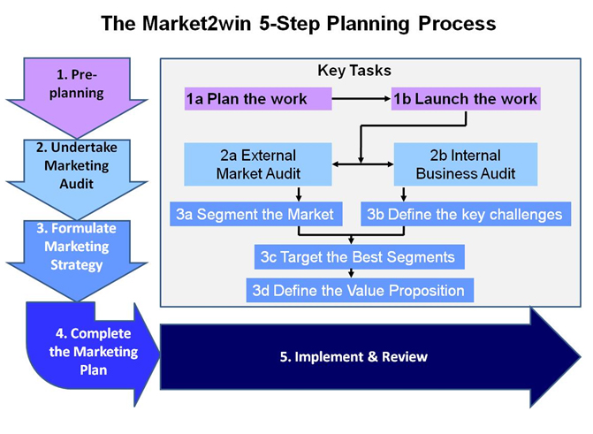
1.3) Strategy
1.3.1) Organizational levels
The company will have three organizational levels. These are;
According to (Nijssen & Frambach, 2011), they include the corporate level, which will include the inputs of marketing like competitive analysis and the business unit level that serves as a marketing bridge between the present situations and the desired future position, by coming up with strategies that are appropriate for the desired future.
The third will be the Product/Market level which will be formulating and implementing the programs so as to give support to the strategy marketing perspective.
1.3.2) Goals and Objectives
The company's goal of marketing is to improve on sales. Its objective is to make sure that the product reaches new markets to widen the market and popularize both the product and the Water Bottling Company. Operating within the objectives will help the company to achieve its goals.
1.4) Planning Gap
1.4.1) Ethics in Marketing
Marketing has ethical issues that must be adhered to protect the customers/consumers or enhance proper competition (Westwood, 2016). Some of the ethical issues the company must make sure they follow include.
- False advertisement where the marketer discloses false information about the product just to attract attention and make sales.
- Failure to disclose the side effects which may affect some people who would have to opt not to take the product if they knew for the sake of their health.
- Fair competition. No company is allowed to build their name by destroying the name of the other competitor or destroying their adverts.

References
Drummond, G., Ensor, J., & Ashford, R. (2008). Strategic marketing: Planning and control. Amsterdam: Elsevier/Butterworth-Heinemann.
Nijssen, E. J., & Frambach, R. T. (2011). Creating customer value through strategic marketing planning: A management approach. New York: Springer.
Oldroyd, M., & Chartered Institute of Marketing. (2007). Marketing environment 2007-2008.
Peter, J. P., & Donnelly, J. H. (2009). Marketing management: Knowledge and skills. Boston, MA: Irwin/McGraw-Hill.
Westwood, J. (2016). How to write a marketing plan.

