Exercises in OpenStax Chemistry, Ch.14
Ryan Kilby
CHM/151
May 6, 2017
Dr. DANIEL GILBERT

Week One Exercises in OpenStax Chemistry, Ch. 14

Chapter Fourteen
18. Calculate the pH and the pOH of each of the following solutions at 25 °C for which the substances ionize completely:

(a) 0.200 M HCl
HCl = H⁺ + Cl⁻
Substances ionize completely results in

$$\left[H^{+}\right]=\left[{Cl}^{-}\right]=c\left(HCl\right)=0.200 mol/L$$
$$pH=-\log\left[H^{+}\right]=-\log{0.200}=-\left(-0.70\right)=0.7$$

(b) 0.0143 M NaOH

NaOH = Na⁺ + OH⁻
Substances ionize completely results in

$$\left[{Na}^{+}\right]=\left[{OH}^{-}\right]=c\left(NaOH\right)=0.0143 mol/L$$
$$pOH=-\log\left[{OH}^{-}\right]=-\log{0.0143}=-\left(-1.84\right)=1.84$$
$$pH=14-pOH=14-1.84=12.16$$

(c) 3.0 M HNO3

HNO₃ = H⁺ + HNO₃⁻
Substances ionize completely results in

$$\left[H^{+}\right]=\left[{NO_{3}}^{-}\right]=c\left(HNO_{3}\right)=3.0 mol/L$$
$$pH=-\log\left[H^{+}\right]=-\log{3.0}=-0.48$$

(d) 0.0031 M Ca(OH)2

Substances ionize completely results in
$$\left[{OH}^{-}\right]=2×c\left(Ca(OH)_{2}\right)=2×0.0031\frac{mol}{L}=0.0062\frac{mol}{L}$$
$$pOH=-\log\left[{OH}^{-}\right]=-\log{0.0062}=-\left(-2.21\right)=2.21$$
$$pH=14-pOH=14-2.21=11.79$$

36. What is the ionization constant at 25 °C for the weak acid (CH3)2 NH2 +, the conjugate acid of the weak base

(CH3)2NH, Kb = 7.4 × 10−4?

$$K_{i}=\frac{\left[H^{+}\right][\left(CH_{3})_{2}NH\right]}{[\left(CH_{3})_{2}NH_{2}^{+}\right]}$$

So we can also have

$$K_{c}=\frac{\left[{H_{3}O}^{+}\right][\left(CH_{3})_{2}NH\right]}{[\left(CH_{3})_{2}NH_{2}^{+}\right][H_{2}O]}$$

$$K_{i}=\frac{1}{K_{b}}=\frac{1}{7.4×10^{-4}}=1.35×10^{3}$$

52. Which of the following will increase the percent of HF that is converted to the fluoride ion in water?

(a) addition of NaOH

(b) addition of HCl

(c) addition of NaF

The addition of NaOH because it gives OH- ions which force the equilibrium to shift right, so it will increase the percent of the HF that will be converted to the fluoride ion in water.
HF (aq) ⇌ H⁺ (aq) + F⁻ (aq)
H⁺ (aq) + OH⁻ (aq) ⇌ H₂O (l)( we will remove H+ ions from water)
- NaOH = Na⁺ (aq) + OH⁻ (aq)

60. Calculate the ionization constant for each of the following acids or bases from the ionization constant of its conjugate base or conjugate acid:

(a) F−
F⁻ + H₃O⁺ ⇌ HF + H₂O
$$K_{b}(F^{-})=\frac{[HF]}{\left[F^{-}\right][H_{3}O^{+}]}$$
Conjugated acid HF:
HF ⇌ H⁺ + F⁻
$$K_{a}(HF)=\frac{\left[H^{+}\right][F^{-}]}{[HF]}$$
$$\left[H^{+}\right]=[H_{3}O^{+}]$$
$$K_{b}\left(F^{-}\right)=\frac{1}{K_{a}(HF)}$$

(b) NH4 +
NH₄⁺ ⇌ NH₃ + H⁺
$$K_{a}(NH_{4}^{+})=\frac{\left[H^{+}\right][NH_{3}]}{[NH_{4}^{+}]}$$
Conjugated base NH₃:
NH₃ + H₃O⁺ ⇌ NH₄⁺ + H₂O
$$K_{b}(NH_{3})=\frac{[NH_{4}^{+}]}{\left[NH_{3}\right][H^{+}]}$$
$$\left[H^{+}\right]=[H_{3}O^{+}]$$
$$K_{a}(NH_{4}^{+})=\frac{1}{K_{b}(NH_{3})}$$

(c) AsO4 3−
AsO₄³⁻ + H₃O⁺ ⇌ HAsO₄²⁻ + H₂O
$$K_{b}({AsO_{4}}^{3-})=\frac{[{HAsO_{4}}^{2-}]}{\left[{AsO_{4}}^{3-}\right][H_{3}O^{+}]}$$
Conjugated acid HAsO₄²⁻:
HAsO₄²⁻ ⇌ AsO₄³⁻ + H⁺
$$K_{a}({HAsO_{4}}^{2-})=\frac{\left[{AsO_{4}}^{3-}\right][H^{+}]}{[{HAsO_{4}}^{2-}]}$$
$$\left[H^{+}\right]=\left[H_{3}O^{+}\right]$$
$$K_{b}\left({AsO_{4}}^{3-}\right)=\frac{1}{K_{a}({HAsO_{4}}^{2-})}$$

(d) (CH3)2NH2+
(CH₃)₂NH₂⁺ ⇌ (CH₃)₂NH + H⁺
$$K_{a}((CH_{3})_{2}NH_{2}^{+})=\frac{\left[(CH_{3})_{2}NH\right][H^{+}]}{[(CH_{3})_{2}NH_{2}^{+}]}$$
Conjugate base (CH₃)₂NH:
(CH₃)₂NH + H₃O⁺ ⇌ (CH₃)₂NH₂⁺ +H₂O
$$K_{b}((CH_{3})_{2}NH)=\frac{[(CH_{3})_{2}NH_{2}^{+}]}{\left[(CH_{3})_{2}NH\right][H_{3}O^{+}]}$$
$$\left[H^{+}\right]=\left[H_{3}O^{+}\right]$$
$$K_{a}(\left(CH_{3})_{2}NH_{2}^{+}\right)=\frac{1}{K_{b}((CH_{3})_{2}NH)}$$

(e) NO2−

NO₂⁻ + H₃O⁺ ⇌ HNO₂ + H₂O
$$K_{b}(NO_{2}^{-})=\frac{[HNO_{2}]}{\left[NO_{2}^{-}\right][H_{3}O^{+}]}$$
Conjugate acid HNO₂:
HNO₂ ⇌ NO₂⁻ + H⁺
$$K_{a}(HNO_{2})=\frac{\left[NO_{2}^{-}\right][H^{+}]}{[HNO_{2}]}$$
$$\left[H^{+}\right]=\left[H_{3}O^{+}\right]$$
$$K_{b}(NO_{2}^{-})=\frac{1}{K_{a}(HNO_{2})}$$

(f) HC2 O4 – (as a base)

HC₂O₄– + H₃O⁺ ⇌ H₂C₂O₄ + H₂O
$$K_{b}(HC_{2}O_{4}^{-})=\frac{[H_{2}C_{2}O_{4}]}{\left[HC_{2}O_{4}^{-}\right][H_{3}O^{+}]}$$
Conjugate acid H₂C₂O₄:
H₂C₂O₄ ⇌ H⁺ + HC₂O₄–
$$K_{a}(H_{2}C_{2}O_{4})=\frac{\left[HC_{2}O_{4}^{-}\right][H^{+}]}{[H_{2}C_{2}O_{4}]}$$
$$\left[H^{+}\right]=\left[H_{3}O^{+}\right]$$
$$K_{b}(HC_{2}O_{4}^{-})=\frac{1}{K_{a}(H_{2}C_{2}O_{4})}$$

78. Determine whether aqueous solutions of the following salts are acidic, basic, or neutral:

(a) Al(NO3)3
HNO₃ – strong acid
Al(OH)₃ – weak base
So, it is acidic

(b) RbI
HI – strong acid
RbOH – strong base
So, it is neutral

(c) KHCO2
H₂CO₃ – weak acid
KOH – strong base
It is basic

(d) CH3NH3Br
HBr – strong acid
CH₃NH₂ – weak base
So it is acidic

90. What is [H3O+] in a solution of 0.075 M HNO2 and 0.030 M NaNO2?

HNO2(aq) + H2 O(l) ⇌ H3 O+(aq) + NO2 −(aq) Ka = 4.5 × 10−5

$$pK_{a}=-\log{4.5×10^{-5}}=-\left(-4.35\right)=4.35$$
$$\left[HA\right]=0.075 M$$
$$\left[A^{-}\right]=0.030 M$$
Using Henderson Hasselbalch equation
$$pH=4.35+\log{\frac{0.030 M}{0.075 M}}=4.35-0.40=2.95$$

98. Calculate the pH of a buffer solution prepared from 0.155 mol of phosphoric acid, 0.250 mole of KH2PO4, and enough water to make 0.500 L of solution.

$$pH=pK_{a}+\log{[A^{-}]/\left[HA\right]}$$
$$\left[HA\right]=\frac{0.155 mol}{0.5 L}=0.31 M$$
$$\left[A^{-}\right]=\frac{0.250 mol}{0.5 L}=0.5 M$$
$$pH=2.12+\log{\frac{0.50 M}{0.31 M}}=2.12+0.21=2.33$$

114. Draw a curve similar to that shown in Figure 14.23 for a series of solutions of NH3. Plot [OH−] on the vertical axis and the total concentration of NH3 (both ionized and nonionized NH3 molecules) on the horizontal axis.

Let the total concentration of NH3 vary from 1 × 10−10 M to 1 × 10−2 M.

This is figure 14.23
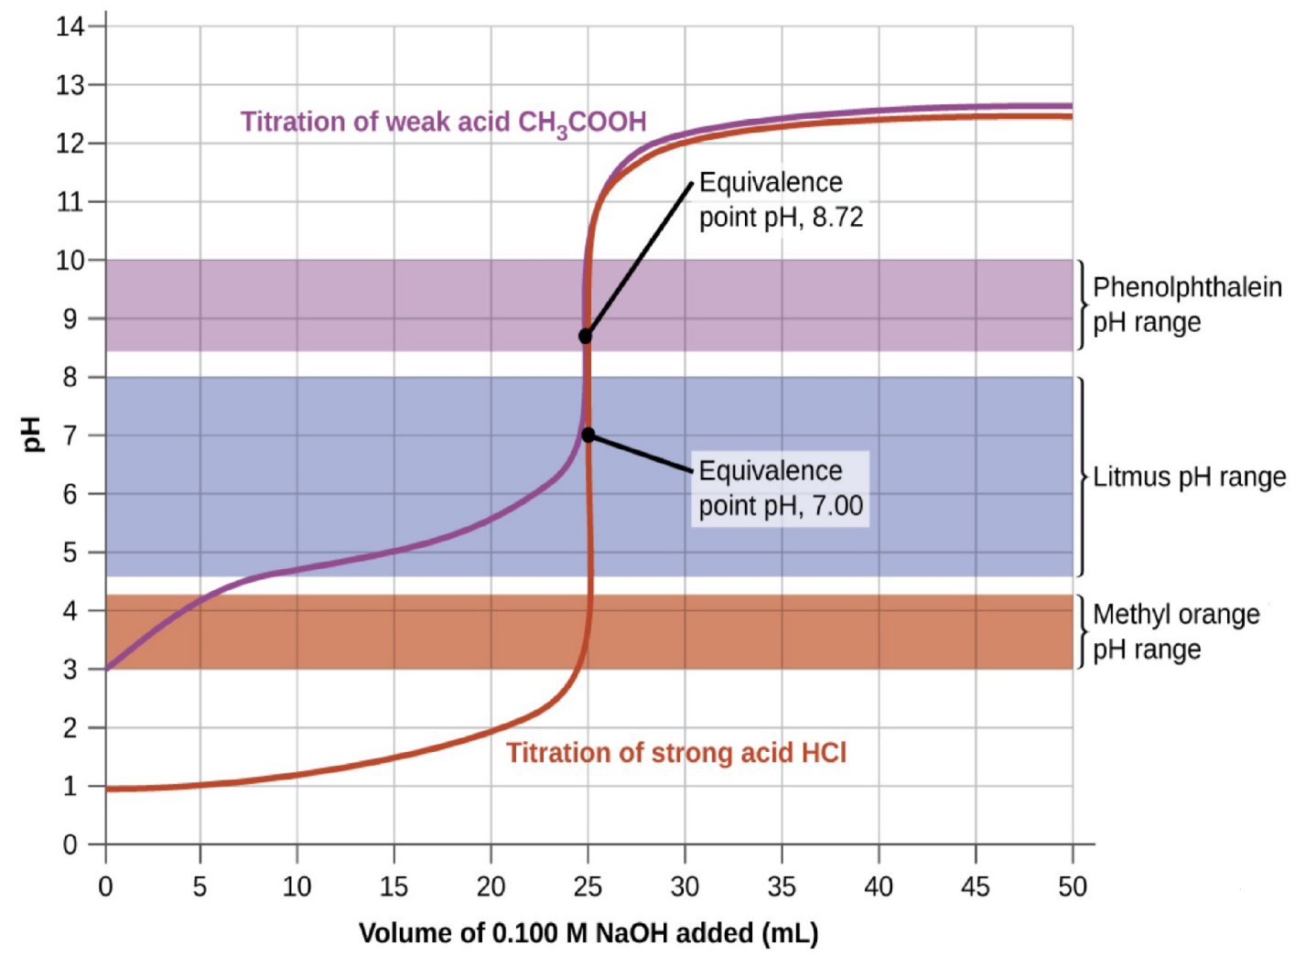

Reference
Rice University. (2015). OpenStax College. Retrieved from Rice University, Chemistry website.

