Heritage Doll
Case Background
In the US gaming and toys industry, New Heritage Doll Company has been operating successfully over the years. Their primary product for this industry is quite well know Doll category which is manufactured by the company at various ranges in accordance with the targeted age bracket of the customer. There have been some significant variations in this industry affecting the revenue figures and operating profits since 2010 and now the company is looking to avail some new opportunities to ease their constraints.
Investment Options
The CEO of the company is of the view that they should expand their production and operating capacity by more investment inflow. There are two investment option which are being considered. One option is to expand the currently running mechanism which is “Match my Doll clothing” (Option 1) and the other option which is a new one, is “Design your own Doll” (Option 2). The company needs to make a decision to opt for any of the two alternate options after a detailed evaluation with calculative analysis is being completed. The management along with analysts will evaluate these two proposals based on some assumption and then decide which one is to be adopted after reviewing their profitability.
Case Assumptions:
For the purpose of the evaluation and calculation the following assumptions have been made:
- Revenue Growth Rate of 8% and 6% is assumed for option 1 and option 2 respectively.
- For option 1, the discount rate is presumed to be 8.4% as this project bears the medium risk.
- For option 2, the discount rate is presumed to be 9% as this option is liable to very high risk being an inventive design, thus a higher discount rate is presumed.
- Income tax rate is assumed to be 40%.
- It is also being assumed that uniform cash flow projections are derived for to develop capital budget and cash flow forecast.

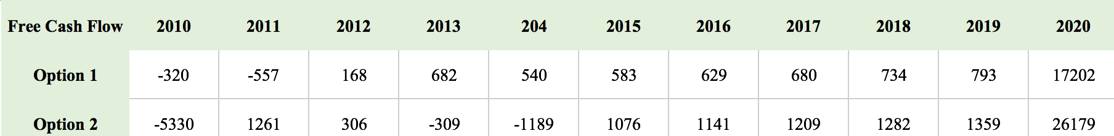
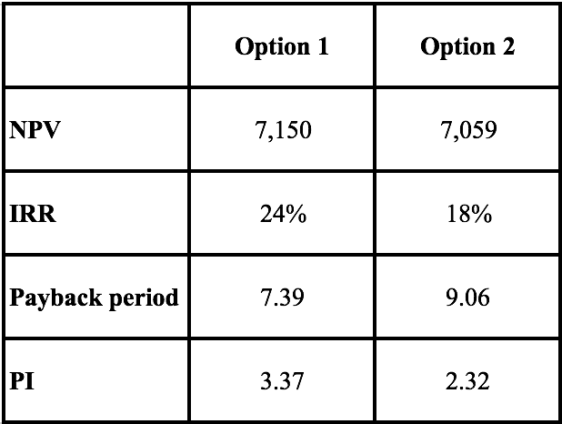
NPV
As a general rule for the Net Present Value (NPV), the project will be accepted when NPV is more than the amount of investment. As per this calculative analysis, the investment decision of option 1 which is “Matching my doll clothing Line” is more favorable as having a higher NPV than that of option 2. Although the difference is not much high to straight away accept the option one but still the higher NPV option should be accepted so as per this decision rule “Match my doll clothing line” should prevail over “Design your own doll”.
IRR (Internal Rate of Return)
As a general rule the option, having a higher IRR will be accepted. As per our calculative analysis, option 1 has an IRR being calculated at 24% and IRR calculated for option 2 is 18%. Hence, following the general rule this calculation supports the investment decision regarding “Matching my doll clothing line” and the same option should be selected.
Pay Back Period
As per the general rule for Payback period, the project with shorter payback period should be selected instead of accepting a project that has a longer payback period, which might lead the business into unsafe scenarios. As per our calculative analysis, the payback period decision rule backs the investment decision related to option 1 as having a shorter payback period than that of option 2.
PI (Profitability Index)
As per the general rule, the PI decision rule matches the NPV rule, more the PI of an investment, more it is acceptable for the business. As per our calculation, this evaluation also backs the investment decision related to option 1 as it has higher PI of 3.37 than that of option 2 having a lower PI.

Recommendations
As we have made four evaluation technique with calculation and based on all calculations and evaluations of the two projects, option 1 which is. As per the financial evaluations, this project requires shorter period to recoup its initial investment and less capital cost and also having a higher return than the second option.
What if:
- Heritage doll decides to go with Match my doll clothing line extension:
Coordinate my apparel line comprised of two or three attire and extras for the late spring. It was gigantically prevalent as a result of the big name kids who were seen wearing them. Marcy McAdams, the brand trough of the line would have liked to take advantage of its prosperity by growing the dress line to incorporate garments and adornments of all seasons.
Advantages:
- The strategy was at that point tried and tremendously prevalent. The new line would acquire in any event a similar net revenue if not more.
- There was a nature with the working of the venture and the organization had involvement with the usage of a piece of the venture.
- Would help lessen the regularity of the New Heritage's income.
Disadvantages:
- Due to the flighty way of youthful child's mold sense, the new line must be propelled rapidly and there was no opportunity to squander.
- It was additionally a bet, as nobody knew to what extent this specific venture would bring picks up for New Heritage.
- Heritage doll decides to go with Design your own doll:
This activity required in customizing the dolls as per the client's tastes and redoing them to the individual information of future proprietors. This would draw in a considerable measure of present and new proprietors to purchase and make another doll like them.
Advantages
- Would help make more deals as this was a novel idea and the deals should be possible to new and existing clients.
- It had a direct settled cost proportion.
- It served well for the organization's saying of making a novel affair for the clients.
Disadvantages
- It was an unsafe recommendation. The organization would be obscure region for the organization and a considerable measure of speculation would be required.
- It would require flawlessness in executing the venture else it would wind up in harming New Heritage's notoriety and its association with a portion of the best clients.

The argument Ms. Harris:
Two projects would be represented by Ms. Harris to Ms. Beckwith and to capital budgeting. Ms. Harris has reached that matching the clothes for dolls is feasible. Thus, she should focus on benefits for New Heritage doll. Moreover, Ms. Harris should convince the capital budgeting committee that her case will make an increase in the sales and revenues, profitability, and payback period.

