Abstract (~5%)
State briefly the purpose of the experiment, the principal results, the mode(s) of isolation, separation and purification (as appropriate) and the major conclusions. You may refer to schemes and tables found in the introduction, results and discussion sections by number.
Introduction (~5%)
State clearly the synthetic goal of the experiment. Do not begin your report with a lengthy description of background theory. The time to demonstrate your knowledge of background theory is in explaining the results you have obtained. One or two paragraphs should be adequate. Include the appropriate balanced chemical equation(s) (including structural drawings for all organic reactants and products, inorganic reagents above the arrows, and solvents and conditions below the arrows) labeled as Scheme 1. See Scheme 1 of the sample formal report.
Results
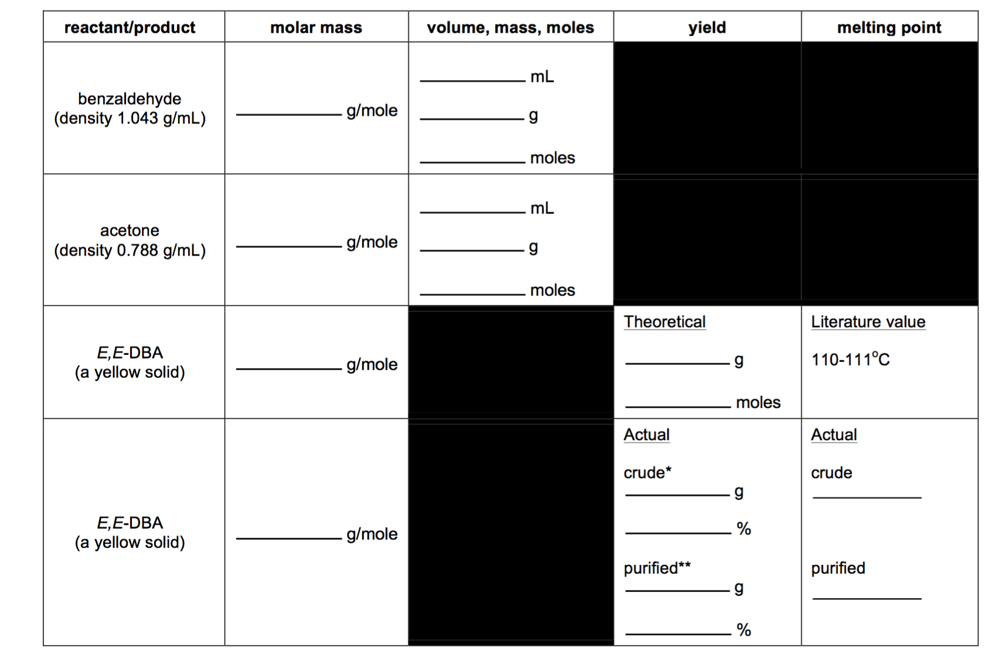
The results of the synthesis of Z-⟨-phenylcinnamic acid and E-⟨-phenylcinnamic acid are summarized in Table 1.
108-109Cº

101-103Cº

0.15g
56%

0.67g
65%

580.08 g/mole
106.2 g/mole
0.25 ml
0.26 g
0.002 moles
0.1 ml
0.07g
0.001 moles

0.234g
0.001 moles

234.24 g/mole
234.24 g/mole

Discussion (~50%)
A separate paragraph should be included for each one of the following items: -a written account of how the product was prepared (i.e. a description of the chemistry involved) along with appropriate references to any balanced reaction equations given elsewhere (e.g. in the introduction)
-a written account of how the crude product was isolated (include chemistry if appropriate)
-a written account of how the crude product was identified, wherein you cite and interpret relevant experimental data making reference to appropriate literature data
-a written account of how the crude product was purified and an evaluation of the efficiency of the purification, wherein you cite and interpret relevant experimental data making reference to appropriate literature data
-a written account of how the purified product was identified, wherein you cite and interpret relevant experimental data making reference to appropriate literature data
-a discussion of yields
Please remember, we are looking for an account of the results you obtained and the conclusions that you drew from them.
Experimental Procedure (~2%) Do not copy out the complete experimental procedure from the manual. “The preparation was carried out according to the prescribed method” will be sufficient in many instances.

