Synthesis of E,E-dibenzalacetone (E,E-DBA)
Afra ALMashari
5/18/2017

Abstract
The preparation of E,E-dibenzalacetone (Scheme 1), from benzaldehyde and acetone in the presence of ethanol and Ethanolic sodium hydroxide, is described. E,E-dibenzalacetone was purified by recrystallization, E,E-dibenzalacetone was recrystallized from. E,E-dibenzalacetone was obtained in 67.1% yield. The crude and purified products were characterized by melting point determination.

Introduction
The purpose of this experiment was to employ a based-catalyzed aldol condensation in the synthesize of E,E-dibenzalacetone and to characterize the crude and purified samples of E,E-dibenzalacetone by melting point determination. As shown in Scheme 1 this involved allowing benzaldehyde to react with acetone in the presence of ethanol and Ethanolic sodium hydroxide.
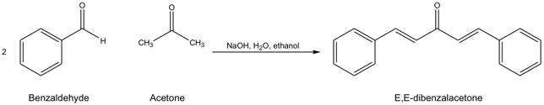
Scheme 1

Results
The results of the synthesis of E,E-dibenzalacetone are summarized in Table 1.
Compound | molar  mass (g/mol) | volume/mass moles | yield | Melting point (° C)
benzaldehyde (density 1.043 g/mL) | 106.2 g/mole | 0.25 ml  0.26 g  0.002 mole | N/A | N/A
acetone (density 0.788 g/mL) | 580.08 g/mole | 0.1 ml  0.07 g  0.001 mole | N/A | N/A
E,E-DBA  (a yellow solid) | 234.24 g/mole | N/A | Theoretical  0.234 g  0.001 mole | Literature value  110-111ºC
E,E-DBA  (a yellow solid) | 234.24 g/mole | N/A | Actual  crude*  0.645 g  63.7%  purified**  0.14 g  67.1 | Actual  Crude  109-110 ^{O}c  purified  110-111 ^{O}c
* a yellow solid ** a yellow crystals solid

Discussion

Experimental Procedure

