1)
The figure to the right illustrates the average total cost​ (ATC) and marginal cost​ (MC) curves for an orange farmer in California. Assume the market for oranges is perfectly competitive.
Suppose the market price of oranges is ​$20.00 per crate. Characterize the​ farmer's profit.
At a ​$20.00 ​price, the farmer will Break even.
The orange farmer will make a profit if the price of oranges is above
​$per crate. ​(Enter your response as an ​integer.)

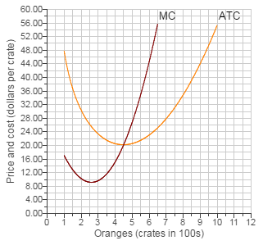
2)
Refer to the following​ table:
Quantity  ​(Bushels)  ​(Q) | Total  Revenue  ​(TR) | Total  Cost  ​(TC) | Profit  ​(TRminus−​TC) | Marginal  Revenue  ​(MR) | Marginal  Cost  ​(MC)
0 | ​$0.00 | ​$1.001.00 | ​-$1.001.00 | ​-- | ​--
1 | 4.004.00 | 4.004.00 | 0.000.00 | ​$4.004.00 | ​$3.003.00
2 | 8.008.00 | 6.006.00 | 2.002.00 | 4.004.00 | 2.002.00
3 | 12.0012.00 | 7.507.50 | 4.504.50 | 4.004.00 | 1.501.50
4 | 16.0016.00 | 9.509.50 | 6.506.50 | 4.004.00 | 2.002.00
5 | 20.0020.00 | 12.0012.00 | 8.008.00 | 4.004.00 | 2.502.50
6 | 24.0024.00 | 15.0015.00 | 9.009.00 | 4.004.00 | 3.003.00
7 | 28.0028.00 | 19.5019.50 | 8.508.50 | 4.004.00 | 4.504.50
8 | 32.0032.00 | 25.5025.50 | 6.506.50 | 4.004.00 | 6.006.00
9 | 36.0036.00 | 32.5032.50 | 3.503.50 | 4.004.00 | 7.007.00
10 | 40.0040.00 | 40.5040.50 | negative 0.50−0.50 | 4.004.00 | 8.008.00
Suppose the price of wheat rises to ​$5.00 per bushel. Farmer Parker will maximize
Profits by producing bushels of wheat (enter a whole​ number).
He will make a profit of ​$ ​(round your answer to the nearest​ penny).

3)
The table below shows the quantity of workers and total output for a local pizza parlor. Answer the following questions based on this​ table:
Quantity of Workers | Total Output
0 | 0
1 | 44
2 | —
3 | 1818
4 | 2323
5 | 2727
6 | 2525

- When the owner hires 4​ workers, the average product of labor is pizzas. ​(Enter your response rounded to two decimal​ places.)

b. The marginal product of the fifth worker is
pizzas. ​(Enter your response as a whole​ number.)
c.
If the marginal product of the second worker is​ 6, then the total number of pizzas produced when 2 workers are hired is
pizzas. ​(Enter your response as a whole​ number.)

d. Assuming the marginal product of the second worker is​ 6, the law of diminishing marginal returns set in with the
- fourth worker hired.
This is the correct answer.
- third worker hired.
- sixth worker hired.
- fifth worker hired.

4)
Lauren grows grapes. Her average variable cost ​(AVC​), average total cost ​(ATC​), and marginal cost
​(MC​) of production are illustrated in the figure to the right.

Assume the market for grapes is perfectly competitive and that the market price is
​$4.00 per crate.

Characterize​ Lauren's economic profits. Assume she produces such that she maximizes profits in the short run.
Using the rectangle drawing​ tool, shade in​ Lauren's economic profits. Attach the correct label to indicate whether she is earning a profit​ (Profit) or incurring a loss​ (Loss).

Carefully follow the instructions​ above, and only draw the required
object.
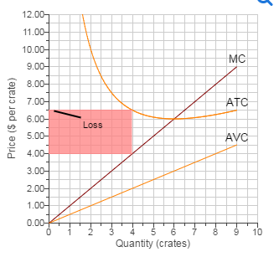

I believe this graph is correct, but I am confused why it’s correct.
6)
If a 18 percent increase in the price of Cheerios causes a 17 percent reduction in the number of boxes of cereal​ demanded, the price elasticity of demand for Cheerios is minus− ​(Enter your response rounded to two decimal​ places.)
The demand for Cheerios is inelastic or elastic?

7)
Farmer Brown grows Peaches The average total cost and marginal cost of growing
Peaches for an individual farmer are illustrated in the graph to the right. Assume the market for peaches is perfectly competitive and that the market price is
​$38 per Box. Also assume that farmer Brown is producing the amount of
Peaches that maximizes profits.

Use the rectangle drawing tool to shade in farmer​ Brown's profit. Properly label this shaded area.
Carefully follow the instructions ​above, and only draw the required objects.

Graph shown below:
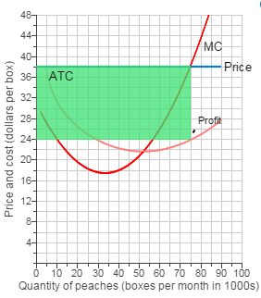

Why is this graph correct?

8)
Consider the graph below showing the market demand and supply for corn. Use the line drawing tool to graph the demand for the corn produced by one corn farmer.

Properly label this line.

Carefully follow the instructions​ above, and only draw the required objects.

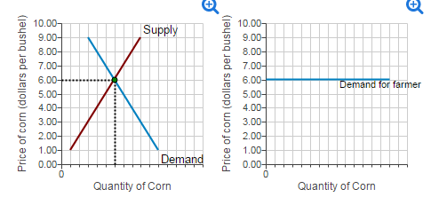

They system told me this was the correct answer in the chart on the right, but I don’t understand why. Can you explain?

9)
Consider the market for​ gasoline, illustrated in the figure to the right.
The equilibrium quantity of gasoline is million gallons (enter a numeric response using a real number rounded to two decimal​ places) and the equilibrium price is ​$ per gallon.
If instead the market price were ​$1.75 then there would be a shortage of million gallons.

Graph shown below:
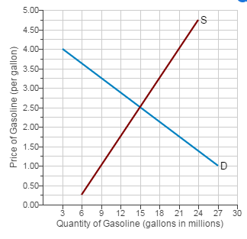

10)
Suppose the price elasticity of demand for cereal is −0.85.

If​ so, then the demand for cereal is inelastic.

In another​ example, assume the price elasticity of demand for a particular magazine is
−1.26.

The demand for the magazine is elastic.

Why is the magazine elastic?

11)
Sophia grows Christmas trees. Her cost of production is shown in the table below.
Christmas Trees | Total Cost
1 | ​$7070
2 | ​$105105
3 | ​$189189
4 | ​$287287
5 | ​$399399
6 | ​$525525
7 | ​$665665
Suppose the market for Christmas trees is perfectly competitive and that the market price for Christmas trees is $119 per tree.

How many Christmas trees should Sophia​ grow?
Sophia should grow
trees. ​(Enter your response as an integer​ value.)

What is​ Sophia's profit?
​Sophia's profit is
​$​(Enter your response to the nearest​ dollar.)

12)
Consider the two demand curves illustrated in the figure to the right.
Which of the two is relatively more elastic​?

Which is more elastic? (D1 or D2)
Graph shown below:
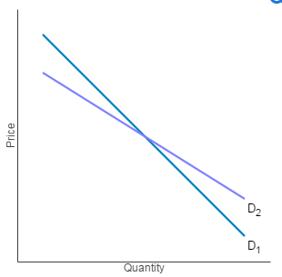

13)
[Related to Solved Problem
​#3​]
Frances sells earrings in the perfectly competitive earring market. Her output per day and costs are seen in the table to the right.
a. If the current equilibrium price in the earring market is
​$1.701.70​,
what price will Frances​ charge?
A.​$2.00
B. $1.25
C. ​$1.70
D.​ $5.00

b. Find the correct quantities for the missing values in the​ table, as represented by
​(i​, ii​, iii​, and ​iv; enter all values as dollars and cents​).
​(i​) Marginal revenue is ​$
​(ii​) Total revenue is ​$
​(iii​) Marginal revenue is ​$
​(iv​) Total revenue is ​$

c. What quantity of earrings will maximize​ Frances' profit?
earnings.

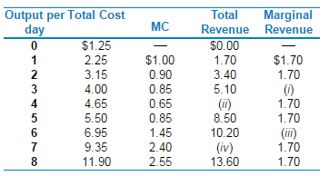

14)
If the market price ​'Pmkt​' is above the price ​'P0​', then quantity supplied is
greater than quantity demanded and the market is in surplus
.
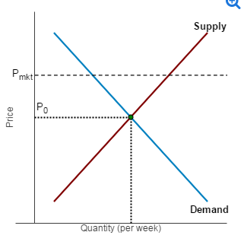

The answers are in red, but I am still unclear on the why its greater and the market has a surplus.?

