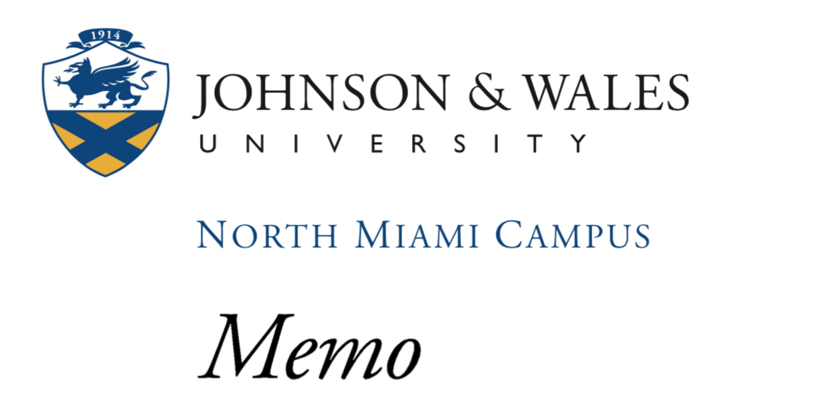
To Wayne Chan
From JWU Consulting
Date 3/24/17
Re In House Communication Brief
CC: TC Rogers

Client: RaceWorz
Auto Club DragWay, 9300 Cherry Ave, Fontana, CA 92335
Contact: Wayne Chan; Wayne@raceworz.com

On March 17, 2017 our team, JWU Consulting, reached out to the owner Wayne Chan of Raceworz. We reached out in order to assist Mr. Chan on expanding the Raceworz experience. JWU Consulting felt that this event could attract more families. This memo is to update our consulting manager, TC Rogers, on our group’s current progress.

Raceworz is a car enthusiast heaven. Its mission is to provide its participants with competitive car shows/racing events. This event combines the finest cars from all over for its participants to view. JWU Consulting is aiming to make this event more family friendly by adding some interactive games and events for the children.

JWU Consulting will provide recommendations on different interactive games that can be added for the children. We will also create a marketing plan. The marketing plan is to ensure its new participants that Raceworz is indeed a family friendly environment. This marketing plan will attract new participants and in turn boost profits for the company. Raceworz will market this new family friendly environment via email, social media, and mail.

In theory, after our marketing and interactive games have been set up we expect a bigger turn out to this event. We will also have a participant review stand for those new family participants to leave their reviews. If we can make Raceworz equally family friendly as it is adult we will not only increase the number of new participants, but will in turn increase the overall revenue of RaceWorz.

Primary Research
Our primary resource has been Wayne Chan of Raceworz. From our first email he has been very helpful and stated that he is more than happy to help JWU Consulting in this project. He is excited to hear about our new ideas. The company page has also been a valuable asset. It has given us the information we need about the company itself and what it offers

Timeline
- March 17, 2017: Initial contact with RaceWorz.
- March 18, 2017: Problems in company are identified. The problem was narrowed down to making Raceworz more family friendly and then marketing the family friendly environment of this event.
- March 22- March 27: Create Formal Consulting agreement with client. Explain ideas for a family friendly environment to client.
- Research marketing opportunities for DreamMore. Prepare a report to present the pros and cons for each opportunity.
- March 28-April 4: Prepare report of pros and cons of each individual idea for an interactive children’s section.
- April 4- April 10: Create a mock survey to receive feedback on how participants feel about this interactive children’s section.
- April 11- April 17: Review survey
- April 18- April 24: Send in a written progress report to advisor and client. This is to let both our advisor and client know how the project is turning out and let them provide us with feedback.
- April 25- May 1: Wait for feedback from advisor and client.
- May 2- May 8: Make changes according to both advisor and client feedback.
- May 18, 2017: Final project due

Team Members
Karina Pineda
Megan Keenan
MyThao Ngyyen
Shontika Wynn
Jialiang Yu

Research Methods

Annotated Bibliography

