ASSIGNMENT 08
K07 Computer Programming I
Directions: Be sure to save an electronic copy of your answer before submitting it to Ashworth College for grading. Unless otherwise stated, answer in complete sentences, and be sure to use correct English, spelling and grammar.

(Restaurant Bill Calculator) A restaurant wants an app that calculates a table’s bill. The app should display all the menu items from Fig. 15.53 in four ComboBoxes. Each ComboBox should contain a category of food offered by the restaurant (Beverage, Appetizer, Main Course and Dessert).

The user can choose from one of these ComboBoxes to add an item to a table’s bill. As each item is selected in the ComboBoxes, add the price of that item to the bill. The user can click the Clear Bill Button to restore the Subtotal:, Tax: and Total: fields to $0.00.

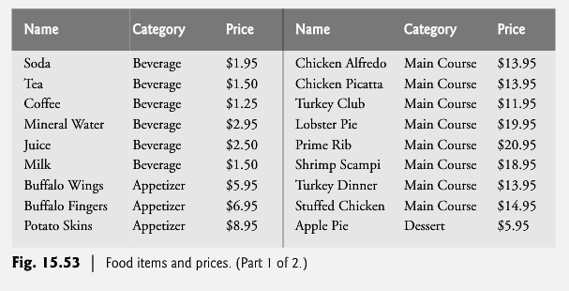

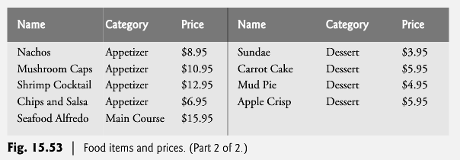
Grading Rubric

Please refer to the rubric below for the grading criteria for this assignment.

