CCNA SECURITY SKILLS EXAM INSTRUCTIONS

When you have completed the Skills Exam, add your Full Name and Student ID# to the box provided in the PKT file. Save the PKT file and send it as an email attachment to your instructor. This assignment should be submitted no later than 11:59 pm on Wednesday, October 19.

Dallas Context-Based Firewall Configuration
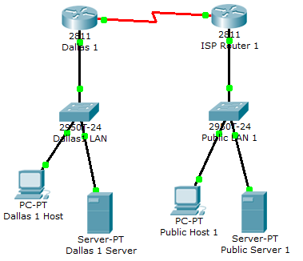

Task 1: Outbound ACL Configuration
- On the Dallas-1 router, create an ACL that will permit all TCP traffic while denying all other traffic.

- Apply this ACL to the Inside Interface (F0/0) for inbound traffic.

Task 2: Inbound ACL Configuration
- On the Dallas-1 router, create an ACL that will deny all TCP traffic while permitting all IP traffic.

- Apply this ACL to the Outside Interface for inbound traffic. The Outside interface for Dallas-1 is Serial 0/0/1.
Task 3: Create and Apply CBAC Rule

- On the Dallas-1 router, create a CBAC Rule named FWRULE for TCP with alerts enabled.
- Apply the CBAC Rule to the inside interface (F0/0).

Verification

You can verify your configuration as follows:

- From the Dallas-1 Host PC’s Web browser, verify that you can open the Public Server 1 website at 200.100.0.11.
- From the Public Host 1 PC’s Web browser, verify that you cannot open the Dallas-1 Server website at 200.100.10.11. The CBAC firewall should block this outside connection.

IPSec Site-to-Site VPN Configuration
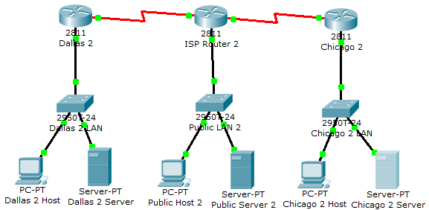

Task 1: IPSec IKE Policy
On the Dallas-2 and Chicago-2 routers, configure the folIowing ISAKMP policies:
Encryption: 3DES
Authentication: Pre-shared Keys
Data Integrity: MD5
Diffie-Hellman: Group 2
SA Lifetime: 12 hours

Task 2: Pre-Shared Key and VPN Peer Configuration
On the Dallas-2 and Chicago-2 routers, configure the following shared key and peer information:
Pre-shared Key: ccnasecurity
Site-to-Site Peer: Dallas-2 Peer is 200.100.20.2,
Chicago-2 Peer is 200.100.10.2

Task 3: Create an IPSec Transform Set named MySet

On the Dallas-2 and Chicago-2 routers, create a Transform set called MySet that that specifies the use of ESP with 3DES encryption.

Task 4: Define VPN Interesting Traffic

On the Dallas-2 and Chicago-2 routers, create an ACL that permits all TCP traffic while denying all other traffic.

Task 5: Configure a Crypto Map for the IPSec VPN

On the Dallas-2 and Chicago-2 routers, create a Crypto Map named MyMap with the following parameters.

- Match address to ACL defined in Task 4.
- Set the transform set to MySet
- Set the peer to 200.100.20.2 for Dallas-2 and 200.100.10.2 for Chicago-2.
Task 6: Apply the Crypto Map to the Outside Interfaces

On the Dallas-2 and Chicago-2 routers, apply the crypto map to the outside interface. The Dallas outside interface is Serial 0/0/1 and the Chicago outside interface is Serial 0/0/0.

Verification

You can verify your configuration as follows:

- From the Dallas-2 Host PC’s Web browser, verify that you can open the Chicago-2 Server website at 200.100.20.11.
- On the Dallas-2 router, execute the show crypto ipsec sa command to verify the Encapsulation and Encryption of packets in the VPN tunnel.
AAA Authentication Configuration
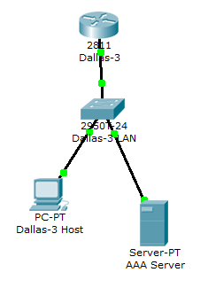

Task 1: Local Username/Password Configuration
On the Dallas-3 router, configure a username student with the password cisco.

Task 2: AAA Default login configuration
On the Dallas-3, enable AAA with the aaa new-model command.

Configure default AAA authentication using a TACACS+ server as the preferred authentication method with local usernames/passwords a backup authentication method.

Task 3: Configure the TACACS+ AAA server

Configure the AAA Server with the following parameters:

- Use the TACACS+ protocol.
- Use Dallas-3 as the client hostname and 192.168.100.1 as the client IP address.
- Configure the username admin with the password adminpass and add it to the AAA Database.

Verification

You can verify your configuration as follows:

- From the Dallas Host PC’s Command Prompt, telnet to 192.168.100.1. If the AAA service is working the login will be admin/adminpass.
- On the AAA Server, disable the AAA Service. From the Dallas Host PC’s Command Prompt, telnet to 192.168.100.1. With the AAA service disabled, the local username/password student/cisco should work as the backup authentication method.
- Re-enable the AAA Server.

