ECET-365 Lab 4
Irving Sanchez
Objective:
- Use the previous lab 2 codes by modify
- Use number values for the duty cycle to discover the Clockwise, Counter Clockwise (Maximum & Minimum angels of the servos)
- Using the Dip-Switches to

Codes:
#include <hidef.h> /* common defines and macros */
#include "derivative.h" /* derivative-specific definitions */

void MSDelay (unsigned int);
void main(void) {

unsigned int ArrM1[]={20,30,40,50};
unsigned int ArrM2[]={25,35,45,55};
unsigned int Lab4, Lab4High, Lab4Low;
unsigned int z;

DDRP = 0xFF;
DDRH = 0x00;

PWMPRCLK = 0x02; //$02;
PWMSCLA = 125; //$7D;
PWMCLK = 0xFF; ;
PWMPOL = 0x30; //$10;
PWMCAE = 0x00; //$00;
PWMCTL = 0x0; //$00;

PWME = 0x30;
//PTP = 0x00;

//Channel = 4
PWMCNT4 = 30;
PWMPER4 = 100;

//Channel = 5
PWMCNT5 = 30;
PWMPER5 = 50;

for (;;){

Lab4 = PTH;
Lab4High = Lab4 & (0b11110000);
Lab4Low = Lab4 & (0b00001111);
Lab4High = Lab4 >> 4;

PWMDTY4 = ArrM1[Lab4Low];
PWMDTY5 = ArrM2[Lab4High];
MSDelay(150);
}
}

void MSDelay(unsigned int itime) {

unsigned int i, j;
for (i=0; i<itime; i++)
for (j=0; j<15000; j++);
asm("nop");
}

Results:

Channel 4:
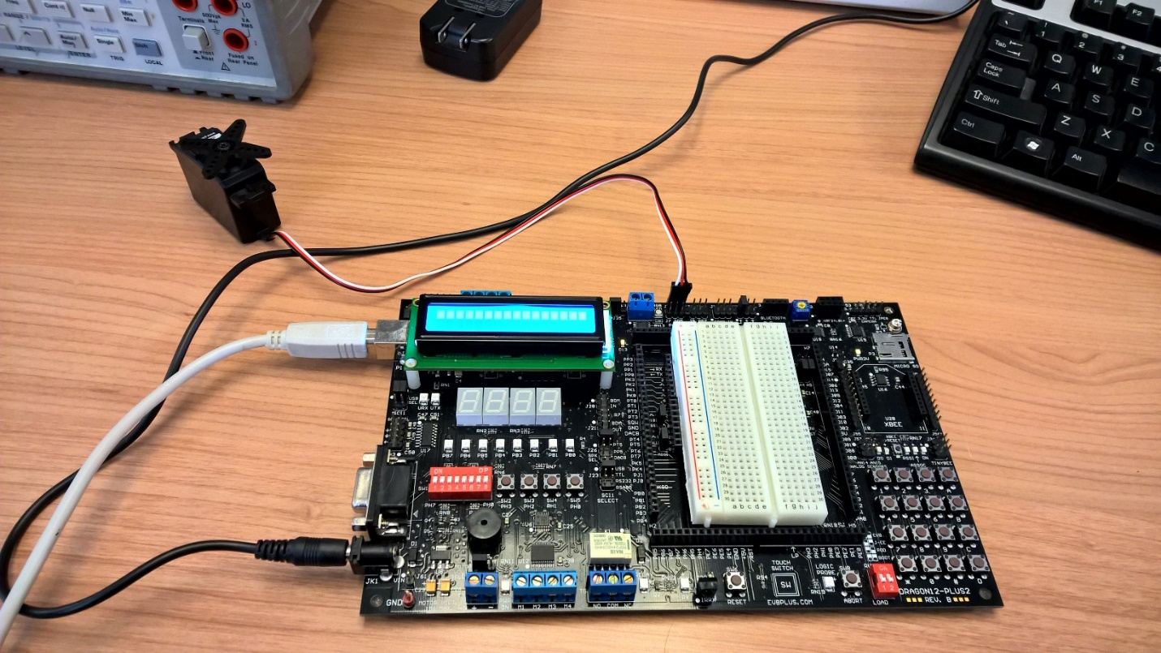
Channel 5:
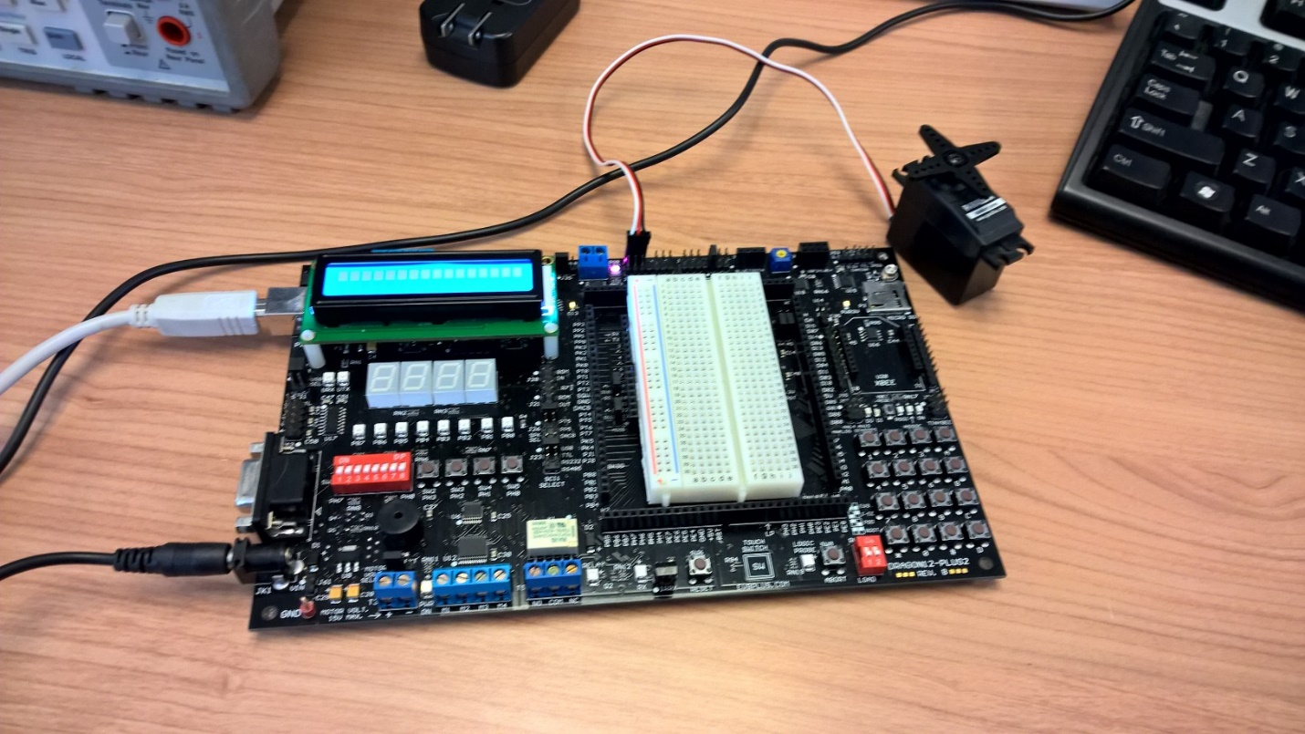

Two-Servos (Channel 4 & 5):
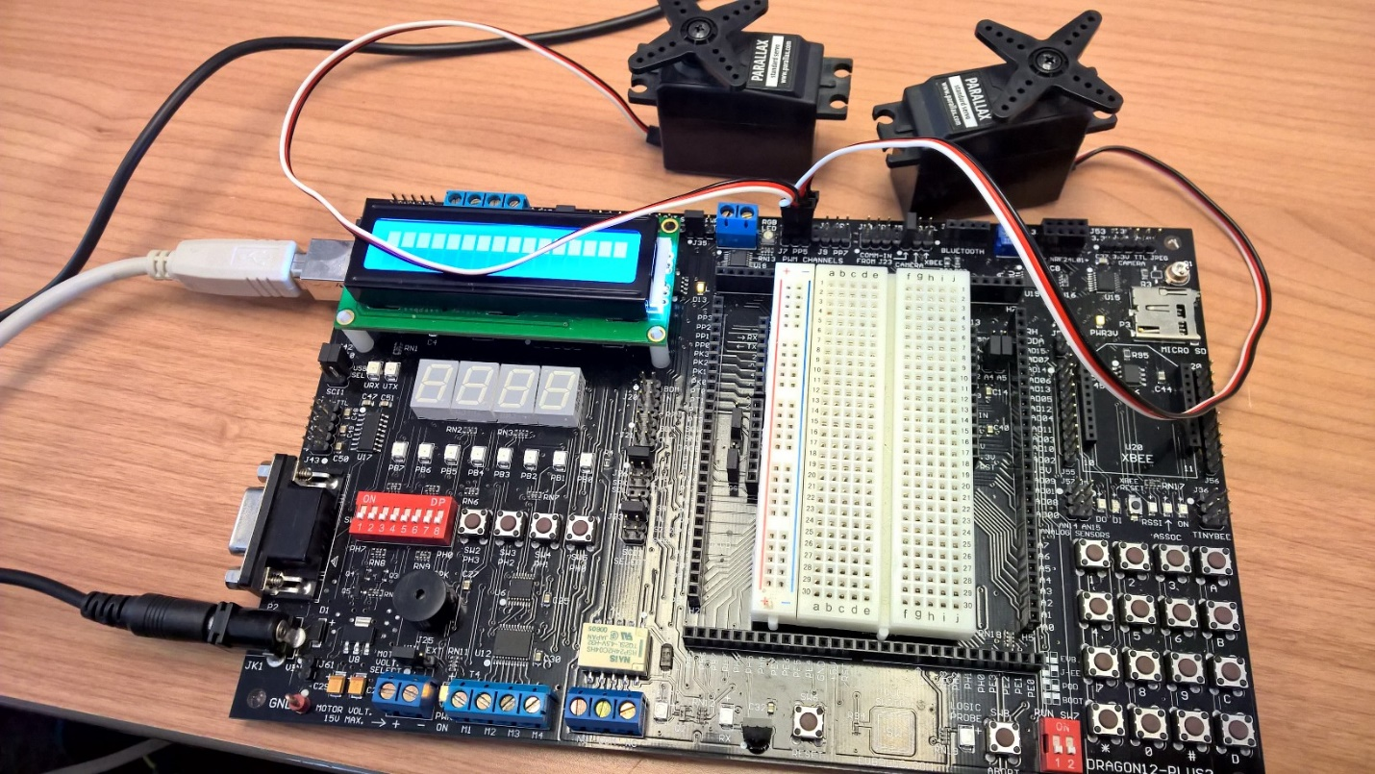

Conclusion:
For this lab we used two servo motors and connected them to the dragon board in order to control them using dip switches. We were able to toggle the motors from left to right by messing around with the switches. Seen how motors work differently coming from other motors mention in class it makes me want to know more but one challenge at the time.

