Lab 1: Getting Started( Pseudo Code,Algorithms & Flow Chart)

Objective(s) :
- To create a logical diagram
- To add text to a diagram and format the text
- To create a flowchart diagram using shapes and connectors

Introduction

Microsoft Office Visio is drawing and diagramming software that helps transform concepts into a visual representation. Here we are going to focus on how to create a logical diagram and flow chart when drawn in Visio.

Getting Started

1. BASIC FLOWCHARTING SHAPES AND SYMBOLS

Flowcharts use special shapes to represent different types of actions or steps in a process. Lines and arrows show the sequence of the steps, and the relationships among them.
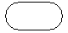 | Start/End  The terminator symbol marks the starting or ending point of the system. It usually contains the word "Start" or "End."
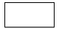 | Action or Process  A box can represent a single step ("add two cups of flour"), or and entire sub-process ("make bread") within a larger process.
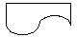 | Document  A printed document or report.
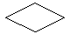 | Decision  A decision or branching point. Lines representing different decisions emerge from different points of the diamond.
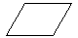 | Input/Output  Represents material or information entering or leaving the system, such as customer order (input) or a product (output).
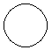 | Connector  Indicates that the flow continues where a matching symbol (containing the same letter) has been placed.
Flow Line
Lines indicate the sequence of steps and the direction of flow.

Flow chart
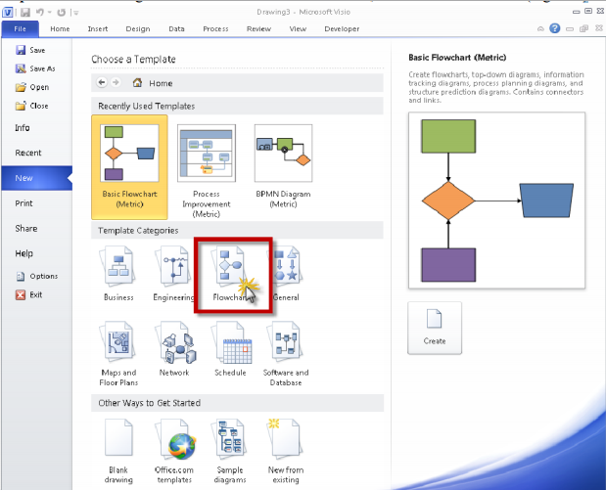
Step 1: From the categories areas select Basic Flow Chart, and select Flow Chart.

Step 2: Double click on Flow Chart, you will see Visio Screen Layout.

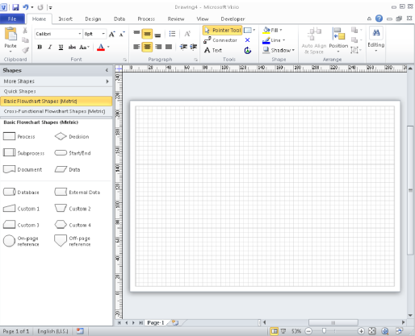

Working with Shapes from a Basic Flow chart Template:
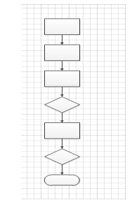

Layout your screen as follows
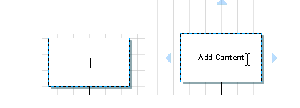
Adding Text to the shape

Adding the Connector
a. Select the Diamond Shape
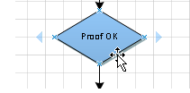

b. Select the connector tool button from the home tab
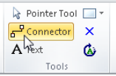

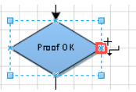
c. Move the mouse to the position shown below note the cursor has changed to reveal the connector tool. As you position to a point you can connect to the shape a small red square will appear.

d. Depress the left mouse key and drag the mouse pointer to the center left edge connection point of the shape above.
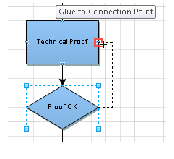

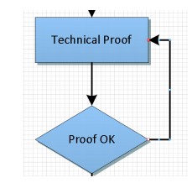
e. Release the mouse Button and you will see a connector from the diamond to the rectangle above and shown.

Add text to connectors
a. Double click on the connector line to type in text.
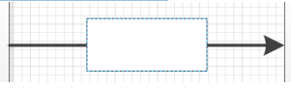

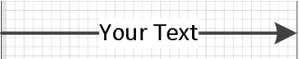
b. Enter your required text then click away from the Line

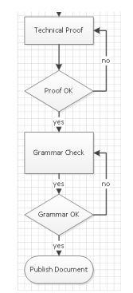
c. Layout Document as below.

Exercises
Exercise 1 (grades)
Draw a flowchart to read a student’s three grades, calculate the average of the grades, then display the average grade.:

Exercise 2 (volume)
Draw a flowchart for a program that reads the height, length, and width of a rectangular box, calculates and displays the volume. Note: volume = lwh

Exercise 3 (inputvalues)
Draw a flowchart for a program that prompts the user to input an integer value and tests if the input value is positive or negative. The program displays an output message according to the following cases:
a. Input value is 0
b. Input value is positive
c. Input value is negative
Exercise 4 (Salary)
Draw a flowchart to reads the salary of an employee and prints:
"Manager" → if the salary is above 20000,
"Supervisor" → if the salary is above 15000,
"Technician" → if the salary is above 8000..
Exercise 5 (Prediction)
We would like to predict the size of an insect population for the week 3 and 4 based on data for week 1 and 2. The weekly rate of growth is a percentage of the population at the beginning of the week. Draw flow chart of this problem.

