How Donuts are manufactured.
FDSCI 305
05/10/17
Brandie Hodges

I do not work at a doughnut processing facility but I wish I did.

A yeast doughnut is fried dough consisting of flour, sugar, milk, shortening, salt, water, egg or egg whites, and a never ending variety of flavors. I've read and researched where the name donuts came from and discovered these treats were once called oily cakes. Elizabeth Gregory of New Amsterdam fried dough with walnuts for her son which is where the name, supposedly, originates. Making doughnuts has evolved from once having no hole to a hole to different types, such as, yeast and cake doughnuts. A cake doughnuts batter can be dropped right into vegetable oil from the mixer to fry for 90 seconds then the donuts are off to the conveyor to cool. As for yeast doughnuts the process is more time consuming. A high speed mixer is needed to knead the dough. Workers then pull the batter from the mixer into bins and spread batter onto a sheet. The donuts are formed now by rollers or later by an extruder. Rollers flatten the doughnuts to 3/4 of an inch. The flatten sheet then will come into contact with a low speed roller that molds these doughnuts into logs. Those “dough logs” are dusted with corn starch to keep from being stuck to the cutting machinery. A conveyor with a retractable arm drops the doughnuts into moving wire mesh trays. If using the extruder process the leavened dough is put into the hopper by hand. The extruder uses a pressure cutter system to create the desired size and shape of doughnuts. In 15 minutes an extruder will yield 30 dozen doughnuts. A doughnut stamper can be used in addition to an extruder by stamping the flatten sheet into a .5-.75 inch thick shape of a doughnut. The extra product left over from shaping the donut can be remixed into another batch to keep waste low.
Following the process of shaping a machine like a bread box, a proofer, uses heat and humidity to leaven yeast dough while moving numerous trays up and down for 20 minutes. The temperature must be 125 degrees Fahrenheit. A temperature too cold won't activate the yeast, vice versa, a temperature too hot will kill the yeast which will prevent the dough from leaving. If the fermentation process does not happen then the dough will yield fat creating a tough doughnut no one will enjoy.
The next step for these doughnuts is to the fryer where right before the doughnuts are let off the conveyor a gate slows them down so there is no hot oil splash. Only a certain amount of dough is put into the fryer at a time to regulate cooking temperatures. The oil in the fryer is kept at a constant boil by gas burners so the doughnuts don't come out undercooked. They are flipped for even cooking and two minutes later they are either coated with icing or any desired toppings. The doughnuts cool as they move on conveyors to packaging.
Jelly doughnuts are another variety that are made in a unique way. Yeast dough is used to make these doughnuts and the dough is separated into loose balls and rolled down a tunnel. Shaping them into round balls. These balls are covered with cornstarch to prevent sticking to machines or conveyors before entering the proofer for leavening. After being fried and coated in sugar they are filled with jelly. Workers use a machine with nozzles that fill two doughnuts at one time with a standard amount of jelly. Workers go at a filling rate of 45 doughnuts/minute. The jelly filled doughnuts are then sent to packaging.

To make a yeast doughnut I found a recipe formulation online. At Chefsteps.com
- 55g of butter
- 55g of vegetable oil
- 530g whole milk
- 150g egg
- 21g active dry yeast
- 940g bread flour
- 170g sugar
- 6g salt
The same process is followed as mentioned above no matter the quantity of doughnuts one is making.
Quality assurance checks the dry doughnut mix before it is put into production. If yeast is being used it must be mixed within 12 hours of being received. The employees in charge of quality must monitor all steps in the process, such as, kneading, resting, proofing, and frying. In the proofer the temperature has to be monitored ensuring the yeast is effective by not being killed but still activated. Also the oil in the fryer room needs to be checked so that the doughnuts do not come out too greasy. Touching and seeing the donuts tell these employees a lot because they know what to look for along the lines of color and texture.
To get the equipment needed to make the doughnuts most efficiently. There are various online suppliers.
A fryer may be bought at webrestaurantstore.com a Carnival King DFC1800 donut fryer. This fryer includes wire trays needed for cooling and glazing. The supplier does not have a brick and mortar location. The customer care line number is (717) 392-7472.
A Cast Iron Extruder is available on perryvidex.com, the product stock#ZG56613.
25 Hainessport-Mt Laurel road Hainesport, NJ 08036, USA 1 (609) 267-1600.
Proofers are available on Bakeryequipment.com Belshaw Century 200 Donut Proofer, Model: TM200
Headquarters:
5500 Olympic Dr.
STE H105 - PMB 117
Gig Harbor, WA 98335
(360) 255-7467
For the equipment to start making donuts the fryers can be $389 like the one mentioned in this paper up to or above $6,000 for making a larger quantity of doughnuts which would yield a higher profit. A proofer is anywhere from $2,500-$13,000. The pricing to make a donut including raw materials and labor production would average around $0.07-$0.12 per donut.
"Doughnuts are the second most profitable food selling items second to potatoes." -donutedvd.com
Doughnuts could sell for $1 each for a standard plain, glazed, or powder and then one could charge more for gourmet styled doughnuts.
The FDA would regulate this product. The Federal Trade Commission regulates Krispy Kreme’s doughnut franchises.

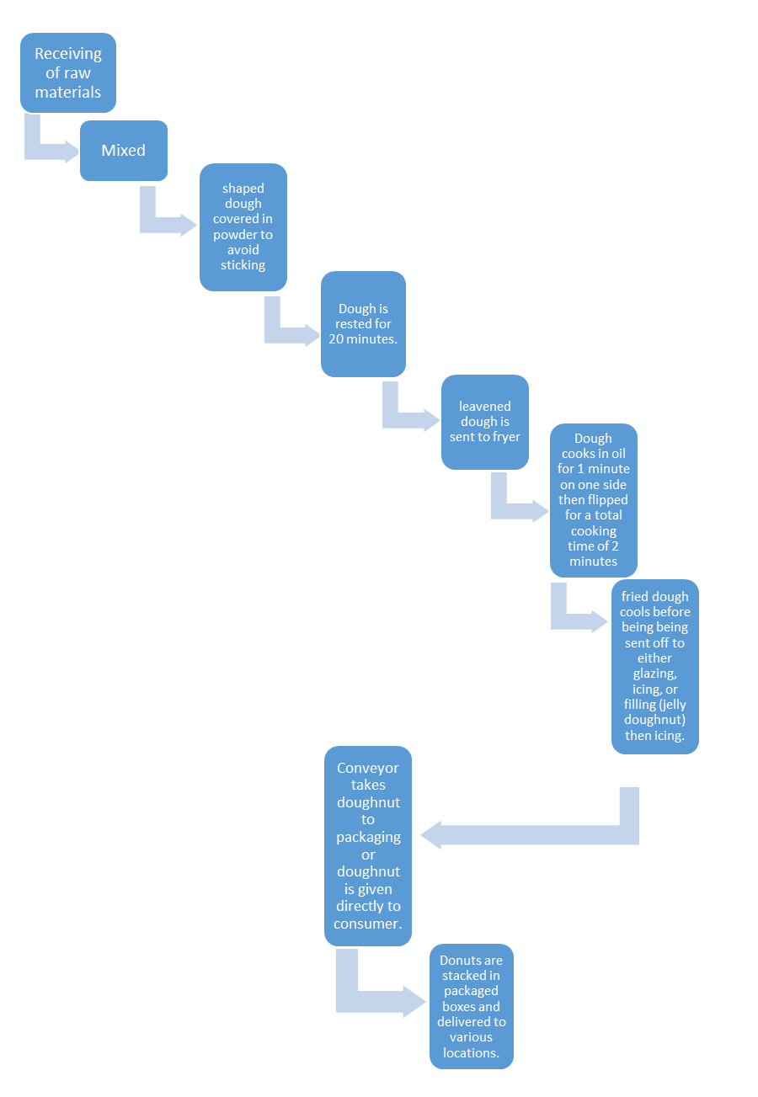

References
Business.com: Article [Internet]. Purch Available from: Business.com/articles/pricing-and costs-of-doughnut-equipment/ 2017 [Accessed 2017 May 09]
Donutedvd.com
Chefsteps.com/activities/how-to-make-bulletproof-fluffy-yeasted-donuts-at-home

