RE: Summary of the Growth Strategies of Alibaba expanding into the U.S. Market
My name is Yiping Peng, I am a marketing researcher in Alibaba’s marketing department. I am presenting to you a summary of the result regarding the potential expansion of Alibaba into the U.S. market in the near future. In my seven pages report, I have analyzed several resources and data in order to evaluate whether your company should expand into the U.S. market as a Chinese company.
In the SWOT analysis that I have included in the report, I have presented both the internal and external factors of the company to figure out how to help increase Alibaba’s presence in the U.S. market. Some of the strengths of the company such as having the leading position as the world’s largest internet market, and being connected with their own payment system Alipay can effectively help Alibaba succeed in this expansion. However, the problems of counterfeits on the sites and having to deal with the U.S government regulations can be challenging for Alibaba.
The opportunity for Alibaba are that it has a faster delivery service compare to Amazon and ebay without any shipping charges. This would be a big opportunity to attract the American customers. The biggest threat for Alibaba in U.S. is competition from Amazon and ebay because Alibaba is not as well known by the American people as Amazon. Therefore it is vital for Alibaba to promote through advertisements. Also, on the issue of competition, I have presented Porter’s Five Forces in the report to show the potential threats o f new entrants and substitutes for Alibaba. I have also included a graph showing the yearly revenue of Alibaba and its competitor to help comprehend when Alibaba should improve in.
At the end, I have presented a few recommendations for the company to successfully expand into the U.S market. I have included a few changes the company should take into consideration for they can help the company overcome its weaknesses and threats.

Sincerely,
Sarah
Executive Summary
Alibaba is a Chinese online marketplace founded by Jack Ma in 1999. Alibaba is considered the world’s biggest and most valuable online commerce company with U.S. IPO worth of $25 billion. The company offers electronic payment services, a shopping search engine and data-centric cloud computing services. Alibaba has three main sites: Alibaba.com, Taobao and Tmall. Some of the key benefits of using Alibaba are the low cost of the products compare to physical stores, access to many suppliers and buyers, quick transaction time, variety of options to choose from, more transparency and security in transaction, and lower risk of fraud. The company mainly operates in China. Foreign trade is welcomed but has to deal with more stringent rules. One of the competitive advantages of Alibaba is the massive size of its industry, which allows it to generate sales more than the sales of Amazon and ebay combined. Alibaba’s mission is to make it easy to do commerce everywhere with their advanced technology, logistics and payment platforms. In this report, Porter’s Five Forces and SWOT analysis will be discussed in order to evaluate the current condition of the company. The data and graph presented in this report will help Alibaba find out whether it should expand into the U.S. market. At the end, there will be professional recommendations given to aid the company to expand into the US market.

Company Analysis
Company Background and Goals:
Alibaba is the world’s biggest online commerce company. This e-commerce market has three main sites: Taobao, Tmall and Alibaba.com. Taobao is the biggest shopping site of Alibaba, containing seven million merchants selling almost everything that their customers may need. The site is free for users, but merchants have to pay commissions and ads if they want to stand out from the crowds. Just last year, Alibaba had transactions of $248 billions on its online sites, which were more sales than ebay and amazon combined. The founder of Alibaba is Matty Ma. He constantly emphasizes on Alibaba’s principles, which put customers before shareholders. The mission of Alibaba is to make it easy to do business anywhere.Since more and more of China’s internet users are migrating to smartphones, Alibaba’s goal is to get more users to use their own payment app Alipay when making purchases. It can be used to make transactions from buying movie tickets to paying for restaurant dining.Another goal of Alibaba is to strengthen their ability to prevent counterfeit products.
Company’s Competitive Position: Sustainability:
As the world’s largest online commerce market, Alibaba handles more business than any other e-commerce company. Because Alibaba operates in China, it has the advantage over its competitors for having millions of users on their site. People shop on Alibaba due to time strain, the variety of product to choose from and discounts the site offers. Unlike its competitors, Alibaba has developed its own payment portal, thus saving on the cost that needs to be paid to the third party payment system.
Company’s Competitive Position: Improving or Getting Worse:
Alibaba’s competitive position is likely to improve. In the fiscal year of 2015, Alibaba reported $5.5 billion profit while Amazon posted a $241 million lost. Alibaba outcompetes its competitors with its own payment app Alipay, which fully protect the seller and the buyer. Alipay allows customers to put funds in an escrow account the product is received and verified, and then the funds will be released to the seller. Also, Unlike its competitors, Alibaba does not require its customers to pay a membership in order to receive free shipping. Alibaba offers free one day shipping when buyers buy over a certain price.
Management Analysis:
The CEO of Alibaba explains that “most companies, when they're doing good, they enjoy today's wonderful life. They don't worry about five years later—but I worry about five years later.” The company focuses on making long term plans that help the company stay steady in the future. Jack Ma also emphasizes about Alibaba’s principle, which was always put customers before shareholders.
Company Profitability:
In 2013, Alibaba sought an IPO in the US. The price of the IPO was rising from $21.8 billion to $25 billion, making Alibaba the largest IPO in the history. Alibaba has become the world’s leading e-commerce business and one of China’s most valuable company. Transactions on the sites of Alibaba totaled $248 billion in 2016, which was more than the sales of eBay and Amazon.com combined. Therefore Alibaba is highly profitable.

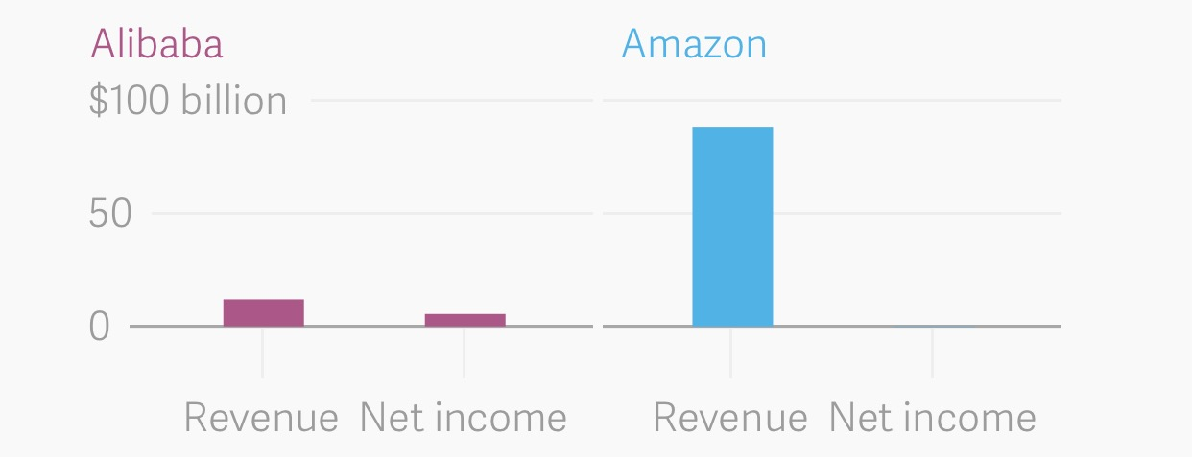
Graph:Revenue in fiscal year of 2015

SWOT Analysis:
Alibaba has several strengths that help it stands out in the e-commerce market. It has the leading position as the world’s largest internet market. The company has good relationship with the Chinese government. Also, Alibaba is connected with their own payment system Alipay. The brand popularity and increasing trust from the investors are also the strengths of Alibaba that help the company flourishes. Alibaba’s weaknesses are that its sites contain many counterfeits, which gives the company a bad reputation. Also, the company has to deal with many rules and regulations from the Chinese government. Some opportunities for the company are that it has a huge customer base. Chinese population is enormous and the demand for online shopping is also increasing. Also, Alibaba has strong support from the Chinese government, which views Alibaba as the most valuable company in China. Some of the company’s threats are that it constantly faces lawsuits from brand holders for counterfeits on the site. Another threat that it has a business model that is quite easy to imitate, therefore it constantly have to face competition from other players.

Industry Analysis
Bargaining Power of Suppliers:
The bargaining power of suppliers is relatively low in Alibaba. This is because there are many small suppliers. The bargaining power of suppliers are relatively low when they are reliant on high volumes. Another reason is because there are more diverse distribution channels.
Bargaining Power of buyers:
The bargaining power of buyers are high in Alibaba. When a customer receives a product, the product can be returned or refunded is not satisfied, or even with no reasons. The buyer does not have to pay the commissions for the traction because the seller pays for it. Because there are many merchants that sell the same items, buyers have the opportunity to compare prices before ordering.
Threat of Substitutes:
The threat of substitutes is extremely high for Alibaba. The rapid development of offline retail, social commerce and M-commerce are considered threat to Alibaba because they offer some of the same service that Alibaba provides.
Threat of New Entrants:
The threat of new entrants is low for Alibaba. Because Alibaba has strong support from the Chinese government, the government puts heavy control avoiding new entry into the e-commerce market in China. Also, to develop a huge company like this requires abundant of capital, therefore it is extremely difficult to enter and compete with Alibaba. And Even if a company enters successfully, it would not have a strong brand name like Alibaba. Also, customers tend to be loyal to existing brands.
Competitive Rivalries:
Competitive rivalries for Alibaba are relatively low. There are just a few competitors, which means fewer rivalries competing for the same customers. Also, companies are less likely to compete when the industries are growing revenue quickly because the industry size is also growing. Therefore, fast industry growth rate will have a positive impact on Alibaba.
Impact of Government:
Alibaba has developed good relationship with the Chinese government. Since the Chinese government has banned access to sites such as Youtube and Facebook, Alibaba was able to succeed in investing in internet television company Youku. The government has helped kept out the aggressive competitors for Alibaba. Even though the Chinese government doesn’t ban companies such as Amazon and Walmart in China, the regulators are always stricter when it comes targeting them for illegal events and violations.
Company’s Relationship to its Community:
Alibaba is highly committed in charitable events, creating job opportunities, and alleviating poverty. Alibaba believes it is important to implement the elements of social responsibility in its business model.
Company’s Industry Growth Rate:
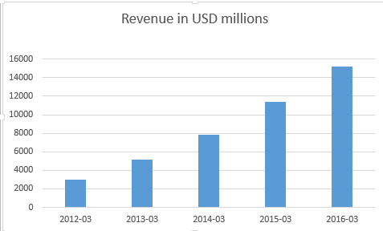

The chart above shows the steady growth rate of Alibaba for the past five years. The company has greatly expanded its revenue over the past few years. The average growth in the last five years was 53%. The company’s revenue is expected to grow by 50% in 2017.
Industry Size:
Alibaba has more sale than ebay and amazon combined. This is due to the massive Chinese population and a hug demand for the e-commerce market. Alibaba reported $5.5 billion profit while Amazon posted a $241 million lost in fiscal year of 2015.
Industry Profitability:
Alibaba is highly profitable because it does not have a highly competitive environment. Therefore it has a relatively high profit margin. Transactions on the sites of Alibaba totaled $248 billion in 2016, which was more than the sales of eBay and Amazon combined.

Recommendations for Expanding into the US Market:

Alibaba is making a huge profit in Chinese e-commerce market. However, when it comes to expanding into the US market, there are several recommendations the company should consider. Since competitors like Amazon is charging their customers for a yearly membership fee of $99 in order to receive free two days shipping. Alibaba can attract the customers in the US by offering them free one day shipping. Customers do not have to pay any membership fee. They can enjoy the fast shipping experience by purchasing over a certain price. This helps Alibaba to quickly stand out in the U.S e-commerce industry even though people are unfamiliar with this company. Another recommendation is for Alibaba to strengthen its payment portal Alipay. This allows the company to avoid to pay any fees to third party payment system. Also, Alipay allows merchants to do business globally when the currencies are exchanged automatically in the system. Another recommendation is for the employees of Alibaba to receive professional training to improve their skills, especially language skill since the company is aiming to expand globally. Offering training can generates feedbacks and directions to staff, so the employees can reach their potential. Also, Alibaba should come up with a more expedited system to remove any counterfeit products on its site. This can help avoid lawsuits from brand holders and gain the trust from customers worldwide. Also, in order more foreign customers, Alibaba should implement a better customer service to foreign clients. This may include hiring online chat agents who will be able to give assistance in English and offering product instructions in English. Another recommendation is to issue funds in online advertisements on American websites such as Facebook and Youtube, so more Americans are aware of this company.

