PRODUCT DESCRIPTIONS

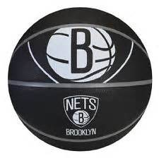 Wholesale Cost: $12.00
Show off your love for the Brooklyn Nets
with this official Nets branded basketball.
This ball is constructed from rubber for
maximum bounce, making it ideal for street
ball. It has an exclusive dual-density cover
for a soft, cushioned feel with wrap-around
channels designed for outdoor use. The ball
measures 29.5 inches and is slightly lighter
than an official NBA ball.

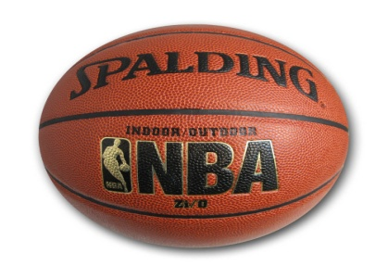 Wholesale Cost: $25.00
Built using a composite leather cover, the
Spalding official-size NBA basketball looks
and feels like an official NBA ball. The ball
also includes a foam-backed design with
full ball pebbling, helping it stand up to the
challenge of competitive play while
maintaining a soft, tacky feel. Best of all,
the ball is designed for use both indoor and
outdoor use, so you can bring it to the
YMCA or the playground.

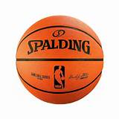 Wholesale Cost: $8.00
Look and feel like a pro with this NBA
official game ball. This is the exact same
ball used in NBA games night after night,
complete with the NBA log and twitter
handle. It has a full grain horween leather
cover, for superior texture and feel.
Designed for indoor use only. If you’re
looking for the real deal, look no further –
this is it!

_________________________________________________________________________________

CUSTOMER PROFILE

• Target customer age: 15-35 years
• 70% male
• Median household income of $55,000
• 90% of customers live within a 5 mile radius
• 80% of customers actively participate in sports; of
those, 50% play basketball at least once a week
• There is a YMCA one block away with an indoor
basketball court; many customers are members
• There are 14 outdoor basketball courts within a 10 mile
radius of the store; many customers play in pickup
games regularly
• 40% of customers consider themselves “strong
supporters” of the Brooklyn Nets

POTENTIAL BUYER SURVEY

Target customers %

strongly disagree disagree Neither agree strongly agree

I value
convenience
over being 18 36 21 17 8
able to touch
and feel products
before purchasing

When I shop, I
usually know 8 28 38 14 12
exactly the product
I want

I don’t like
to wait for a product 12 16 23 32 17
when decide I need it

I like to investigate
numerous options 12 14 18 21 35
prior to purchasing

I prefer to see,
touch and test a 16 14 18 21 31
product

Prior to
purchasing I 32 22 14 18 14
typically remain
attached to one
product versus
shopping for
alternatives

____________________________________________________________________________________________________________________________
POTENTIAL PROMOTIONAL OFFERS

Promotion 1

20% OFF Normal Price
Sale Ends Sunday!

Promotion 2

Brooklyn Nets
Buy a Ball, See a Game!
For every ball purchased,
you will enter a raffle to win
2 tickets to a Nets game

Promotion 3

For every ball sold,
we’ll donate $10 to local
youth basketball programs.
___________________________________________________________________________________
PRICING OPTIONS
Pricing Mix 1
SPAULDING INDOOR/OUTDOOR SPAULDING OFFICIAL NBA BASKETBALL $29.99 BASKETBALL $89.99
WILSON COURTSIDE BROOKLYN
NETS OUTDOOR RUBBER
BASKETBALL $29.99

Pricing Mix 2
WILSON COURTSIDE BROOKLYN SPAULDING INDOOR/OUTDOOR SPAULDING OFFICIAL NBA NETS OUTDOOR RUBBER BASKETBALL $39.99 BASKETBALL $129.99
BASKETBALL $19.99

Pricing Mix 3
WILSON COURTSIDE BROOKLYN SPAULDING INDOOR/OUTDOOR SPAULDING OFFICIAL NBA
NETS OUTDOOR RUBBER BASKETBALL $44.99 BASKETBALL $179.99
BASKETBALL $9.99

________________________________________________________________________________________________________________________________

BRAND VISION: WILSON
STREET

BRAND COMPONENT DESCRIPTION

PURPOSE Our vision is to be the leading brand for outdoor, street ball enthusiasts by providing basketballs
specifically designed to meet their needs.

DEMOGRAPHIC 14-25 MALES

CHARACTER Passion, authenticity and grittiness, spontaneity

ESSENCE By players, for players

REASON TO BELIEVE Most brands design basketballs for indoor and light outdoor use. Few brands have designed basketballs around the outdoor, street ball culture embodied in many American cities and emulated across the country.

Brand Direction 1
REC LEAGUE (LET’S BALL)

Rec League represents the wide array of informal basketball cultures and
captures the essence of impromptu basketball games all across America.

Brand Direction 2
RUCKER PARK (WE GOT NEXT)

Inspired by the famous court in Harlem, Rucker Park embodies the iconic
culture of pick-up games and their influence on basketball culture.

