CHAPTER 1: DATABASES AND DATABASE USERS

- Figure 1.2 shows the database structure and a few sample data records (in five different files or tables) for a University database that has the goal of maintaining information on students, courses, and grades in a university. (Total for que 1 is 10 marks)

- Provide 2 informal queries from this database with their answers. Each query should involve at least 2 of the files in the database and your answer should indicate the files (e.g., Student, Course) needed to answer each query and specify what fields are being retrieved as the result (e.g., Course_name, Course_number). Please, provide your solution in the 3 column table below. (3 marks)

Solution :
Query | Answer | Files involved
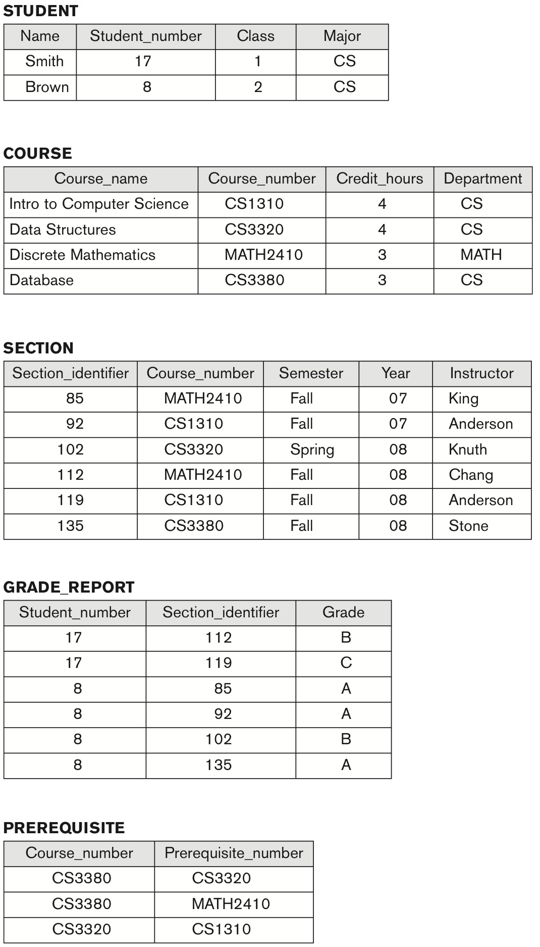

Figure 1.2 A database that stores student and course information.

ii) Provide 2 informal update operations that can apply to the database of Figure 1.2. Provide for each update query, your answer to the query and the files (e.g., Student) and fields (e.g., involved in the update. Please, provide your solution in the 3 column table below. (3 marks)
Solution :
Query | Answer | Files involved
iii) Specify at least 4 relationships (for each of at least 4 database files) among the records of the database shown in Figure 1.2. For each file (e.g., Student) list any relationships it has with other files through its fields (e.g., Student_number). Provide your solution using the table below. (4 marks)

Solution :
File | Relationship to Other Files in the Database
STUDENT
GRADE_REPORT
SECTION
COURSE

- Recall that a database has many types of users, each of whom may require a different view of the database. For example, one user of the database of Figure 1.2 may be accessing and printing the transcript of each student frequently and thus a view for this user is created. Another view for this database is checking that students have taken all the prerequisites of each course they are registered in. (Total for que 2 is 10 marks)

- Using Figure 1.2 database, give 2 additional views that may be needed by other user groups for the database shown in Figure 1.2. (5 marks)

Solution :

ii) Give 5 examples of integrity constraints that you think can apply to the database shown in Figure 1.2. (5 marks)

Solution :

CHAPTER 2: DATABASE SYSTEM CONCEPTS AND ARCHITECTURE

3. Think of the following different users (a. Student, b.Registration office user, c. Transcript office user) for the database of Figure 1.2. What type of application queries would each user need (provide at least 3 queries for each user group? To which user category would each of these users belong and what type of application interface would they need? Note that the transcript office is responsible for printing transcripts, checking for student academic and graduation standing in order to decide the status of student such as good standing, academic probation, ready to graduate.
Use a table for your solution. (Total for que 3 is 10 marks)

User Type | User Application Queries | User Category | Application Interface type
a. Student
b. Registration Office User
c. Transcripts Office User

CHAPTER 3: DATA MODELING USING THE ENTITY-RELATIONSHIP (ER) MODEL

- Consider the following set of requirements for a UNIVERSITY database that is used to keep track of students' transcripts. This is similar but not identical to the database shown in Figure 1.2: (Total for que 4 is 20 marks)
(Note : 5 marks for correct entity and relationship identifications, 5 marks for correct symbol usage, 5 marks correct edge labellings, 5 marks for correct attribute representations).
For this question, you may draw clearly on paper, scan and add to your file.

(a) The university keeps track of each student's name, student number, social security number, current address and phone, permanent address and phone, birthdate, sex, class (freshman, sophomore, ..., graduate), major department, minor department (if any), and degree program (B.A., B.S., ..., Ph.D.). Some user applications need to refer to the city, state, and zip of the student's permanent address, and to the student's last name. Both social security number and student number have unique values for each student.

(b) Each department is described by a name, department code, office number, office phone, and college. Both name and code have unique values for each department.

(c) Each course has a course name, description, course number, number of semester hours, level, and offering department. The value of course number is unique for each course.

(d) Each section has an instructor, semester, year, course, and section number. The section number distinguishes different sections of the same course that are taught during the same semester/year; its values are 1, 2, 3, ..., up to the number of sections taught during each semester.

(e) A grade report has a student, section, letter grade, and numeric grade (0, 1, 2, 3,
4 for F, D, C, B, A, respectively).

Design an ER schema for this application, and draw an ER diagram for that schema.
Specify key attributes of each entity type and structural constraints on each relationship type. Note any unspecified requirements, and make appropriate assumptions to make the specification complete.

Solution :

