- Specification
Part 1
Design and implement a class Menu which uses a doubly linked lists as main data structure. A Menu object consists of a set of menu items, organized as a circular doubly linked list. Each menu item has an associated name (string) and is represented as a list node (see an example of a Menu object below).

The class Menu should define a default constructor which builds an empty menu and the following methods:
- addMenuItem for adding a new menu item at the end of the list: public boolean addMenuItem(String newItem)
- insertMenuItemBA, for inserting a new menu item before or after an existing menu item. If parameter ba is true the newItem will be inserted before the existingItem and if ba is false the newItem will be inserted after the existingItem. public boolean insertMenuItemBA(String newItem, String existingItem, boolean ba)
- deleteMenuItem, deletes the menu item specified by name (supplied as method parameter)
- toString, traverses the linked lists data structure and generates the string representation of a menu object and the total number of menu items.
If necessary, additionally methods may be defined for the class Menu. Give reasons for the new added methods. The class Menu.java should compile without errors.
Part 2
Write a driver program TestMenu.java to test the Menu class. In the driver program, do the following tasks:
a) Read menu items from the input file Menu.txt and build a menu object which includes the specified items. Each menu name in the file is separated by the semicolon character. The menu should be built node by node with the values taken from the input file. After reading the file and building the menu, display the menu using the toString method. Below is an example of the content of the input file Menu.txt: File;New;Open;Save;Close;
b) Ask the user to enter from the keyboard a new menu item to be inserted into the existing menu. The new menu item should be inserted before or after an existing menu item which will be also specified from the keyboard. Display the new menu using the toString method.
c) Delete a menu item specified by the user from the keyboard then display the menu using the toString method.

Notes.
1. The input file Menu.txt will be created by the students using a simple text editor (such as Notepad).
2. Where appropriate, Part 2 tasks a – c should be accomplished by invoking the Menu class methods defined in Part 1.
2. Submission requirements
1. Source files Menu.java and TestMenu.java and input file Menu.txt. The source code should use Java code conventions and professional code layout regarding white space management, indents and comments.
2. The solution description document SolutionDescription (.pdf or .doc / .docx) containing:
(1) assumptions, main design decisions, error handling;
(2) a test plan that includes the test cases that you have created indicating what aspects of the program each one is testing;
(3) two relevant screenshots of program execution;
(4) lessons learned.

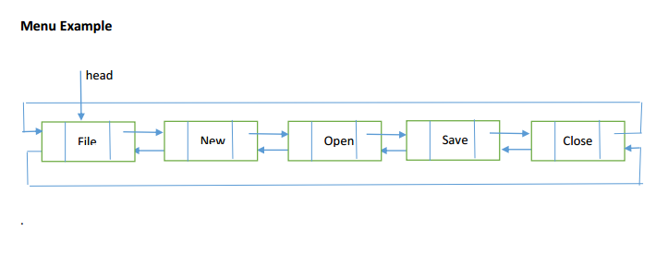
- What are the Big-O performance estimates for those algorithms?

