Fact Sheet
New Heritage Doll Company:
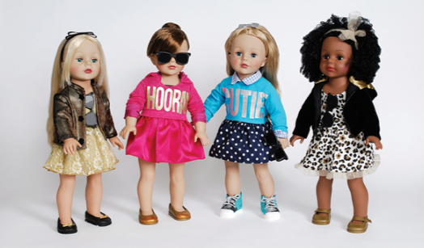
Capital Budgeting
New Heritage Doll Company is an innovative company that manufactures and sells girls’ toys since 1985. The company had grown to be one of the medium sized doll companies with revenues of up $245 million and operating profit of $27 million. The company had 450 employees spread between production and value chain distribution. The company’s vice president Emily Harris is expected to make a capital budgeting decision that will determine the next frontier in the company’s expansion program in the periods to come. The first proposal was Match My Doll Clothing Line that involved an establishment of a clothing line in which a child will get attires that matches their dolls’. The second proposal was Design Your Own Doll that involved web-based doll-design software that allows the users to customize their dolls to their unique tastes. The company has a capacity to introduce only one project at the moment. This paper will analyze the company’s financial information and capital structure to determine the ideal proposal that the company president should adopt. In my analysis, the company should opt for the Match My Doll Clothing Line as it is less capital intensive and due to the fact that the company has already rolled off the project with plausible results expected.
The company has been on a growth trajectory since its establishment. The company revenue has grown to $245 million in 2010 and a profit of $27 million in the same period. A close inspection on the expected trends in the company production costs against the profits. We can tell that company production costs are on the rise and thus lowering the profits. Thus, investment decisions should be made such that the new product will not put so much strain on the production costs.

As demonstrated in the case, creation of a website will require additional maintenance costs that will inflate the production costs. There are literally thousands of customer and thus potentially thousands of tastes for each one of them. If they were to request for unique designs in each case, the production unit will be forced to change the production technique in order to accommodate the unique tastes of all the customers. Thus, in line with the company aim at maintaining low operational costs and optimizing the profit, the Match My Doll Clothing Line is more plausible. As noted in the report, the toy and game section of the US retail market was projected to grow at 3% in the subsequent period. There is stiff competition in that section as companies produce largely similar products and market them through the same medium. This creates a need for the companies to be innovative and offer unique products that will gain a competitive edge over the rest. Although the two methods offer the ability to be unique, customization is very costly and might lead to inefficiencies in the production as the costs goes up.
The toy and game industry was worth $42 billion in 2008 and was expected to grow by 4.6%. The market is broadly classified into video games section and traditional toys and games section with a market share of 48% and 52% respectively. The traditional toys and games is further divided as shown in the chart below.

From the above table, it is clear that the other toys and games have the largest market share in that category. In order to increase the market share in that section, the company will create new products that will increase the value of the existing customers and attract new ones. The potential in that section is immense.
In addition, if the company opts to go with the Design Your Own Doll proposal, there is a huge risk that the current sales will decline. Most customers will opt to get customized dolls at the expense of buying the company selection. There is a risk that the company will face liquidity issues as it strives to meet the demand for the new dolls amidst declining sales. If the company had better cash flow or the production costs were lower, then the Design Your Own Doll would have been the ideal proposal in this case.
Notable constraints are that the United States toy’s market is limited with numerous companies offering similar products and advertising in the same media. Chances are that a launch of a new product will be replicated by the competitors such that the company will not be able to recoup its investment. The large players in the industry have better resources and thus are able to compete effectively. There is thus a need for the smaller players to find a niche and a unique preposition that can help them stay competitive.
Ms. Harris should sell an argument about the initial investment costs that are high in the Design Your Own Doll preposition and amidst rising production costs. In addition, she should argue that the new product will cannibalize on the current sales and reduce the experienced growth. The finally, she should argue that the Match My Doll Clothing Line is relatively simpler concept in the implementation and has already started to gain popularity following the efforts of the marketing managers.

