Homework
- Q6 Describe the different types of project slack and how each is calculated?

- Q 14
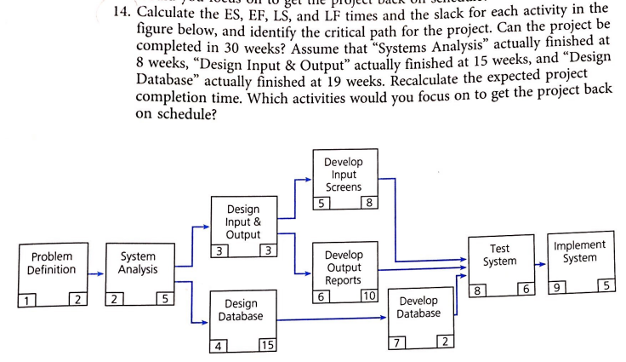

- Q15
