In APA format, submit a paper detailing the negotiation and bargaining strategy you will employ during business negotiations with your chosen country. Justify this approach with supporting evidence from research on the country and on the international negotiations strategy. Include your reasoning for choosing this strategy, including supporting research from previous milestones. Explain how the strategy will be used and how it will increase the likelihood of a successful transaction. What is your BATNA in this particular negotiation? What is your negotiation strategy? How does the strength of your BATNA influence your approach to the negotiation? Address the following questions using Australia as the country of choice.
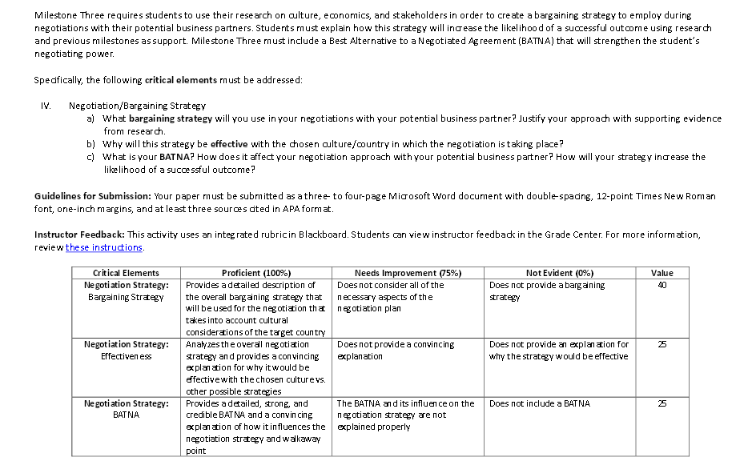

Part 2:
Answer the following questions in APA format. What are the main features of principled negotiation? In the context of international business negotiation, what are the strengths and weaknesses of this approach? What are some considerations that might influence your strategy choice for an international negotiation?

