ACCT3013 Financial Statement Analysis Workshop
Credit analysis

[For enquiries please contact zihang.peng@sydney.edu.au]

Tutorial assignment
Exercise W10E1: Noble Group credit analysis
An important technique in credit analysis is to compare the cash available for debt service with the debt service requirement.
Cash available for debt service = Free cash flow – Net dividends
Debt service requirement = Payments to existing debt holders regarding financial debt at the beginning of the period
Noble Group reported its statement of cash flows as follows:
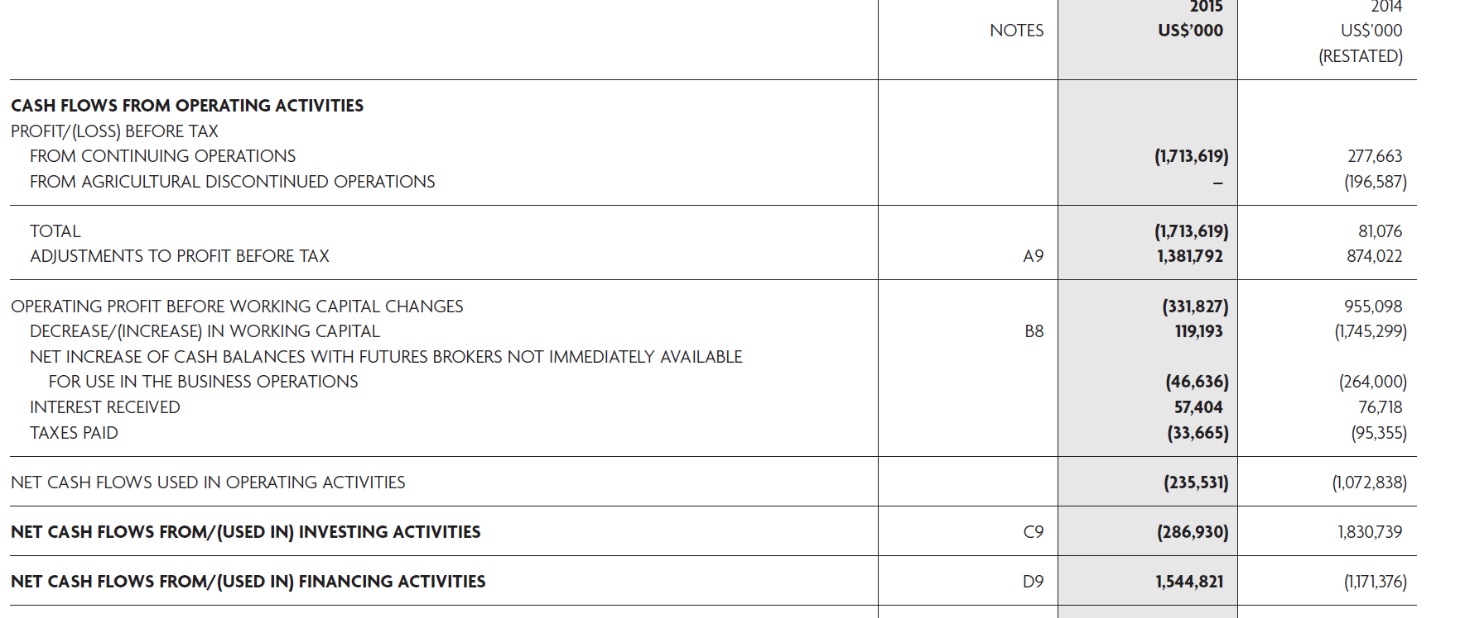
The details of “NET CASH FLOWS FROM INVESTING ACTIVITIES” and “NET CASH FLOWS FROM FINANCING ACTIVITIES” are provided in the notes and replicated here: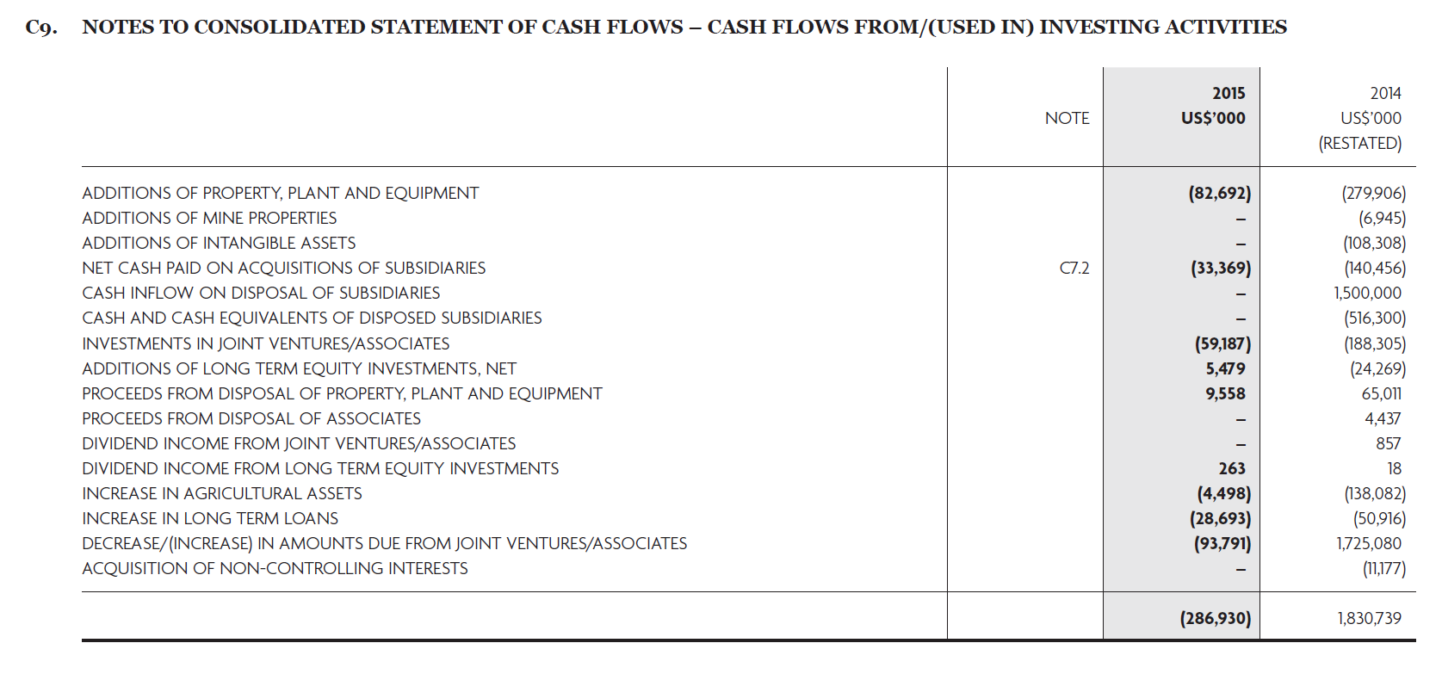
In response to market concerns over its liquidity, Noble raised $9,461,966 new bank debt financing to boost its cash holding.

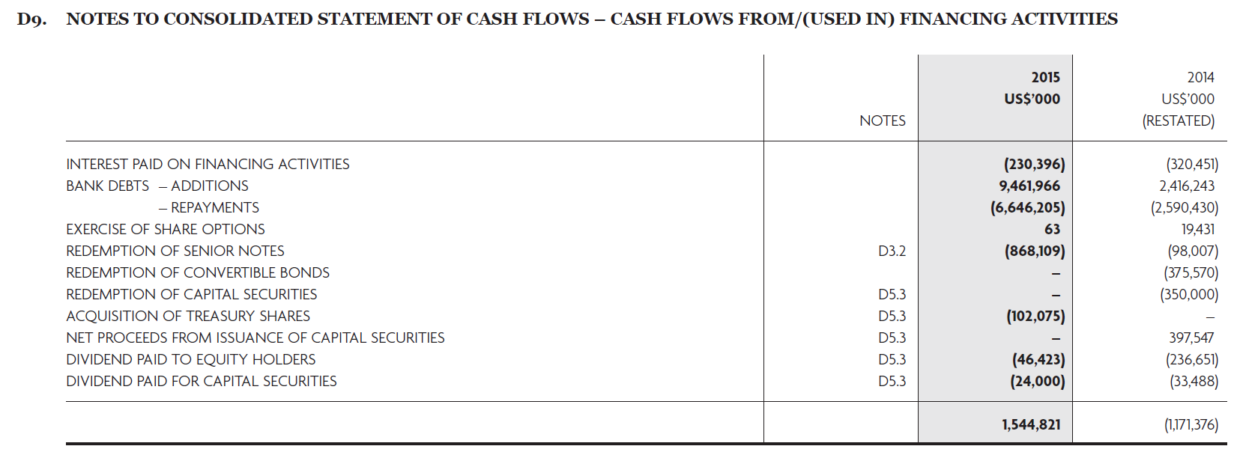
Required [SHOW ALL WORKINGS]
- Compare the actual cash available for debt service with the debt service requirement for the fiscal year 2015.
- Compare the would-be cash available for debt service with the debt service requirement for the fiscal year 2015, if Noble’s new bank debt raised in 2015 were only 2/3 of its actual amount.
Note: Noble’s cash flow statement follows an unusual “semi-direct” method, whereby the capital charges are listed directly.

