Details and Requirements of the assignment:

There are two transfer functions as shown in Figure 1. transfer function 1 has an equation (τ_{m}s+1)/(k_{m}s+k_{m}) transfer function 2 has an equation k_{m}/(τ_{m}s^2 + s) whenever the parameters k_{m} and τ_{m} in transfer function 2 in the SIMULINK BLOCK CHANGES, the parameters k_{m} and τ_{m} in transfer function 1 should also change at the same time with the same values automatically and accordingly in the Simulink.

By default, the transfer function blocks parameters k_{m} should be equal to 0.4 and τ_{m} should be equal to 2.7763 in both block and then when user change the defaulted values to a new value in the Transfer function block 2 in Simulink (NOT IN THE MATLAB COMMAND MANUE as shown in figure 2 in the second page), the parameters values in the transfer function block 1 in Simulink should also be updated with the same values. So, it is like user is actually dealing with the transfer function block 2 (which is a motor connected to a dynamic load). As it is a motor connected to a dynamic load, it means when the load changes the parameters values will change inside the block, so in order to assume it as interfacing this with the hardware the user should change the values in the transfer function not in the Matlab command manue.

This assignment should be done using the knowledge shown in the below link.
https://www.mathworks.com/matlabcentral/answers/93681-how-do-i-model-a-transfer-function-with-coefficients-that-vary-with-simulation-time-in-simulink-7-5

To do this assignment correctly please follow the above link. These are the ONLY ways for this assignment to be accepted.

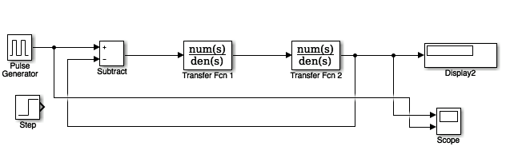
Figure 1

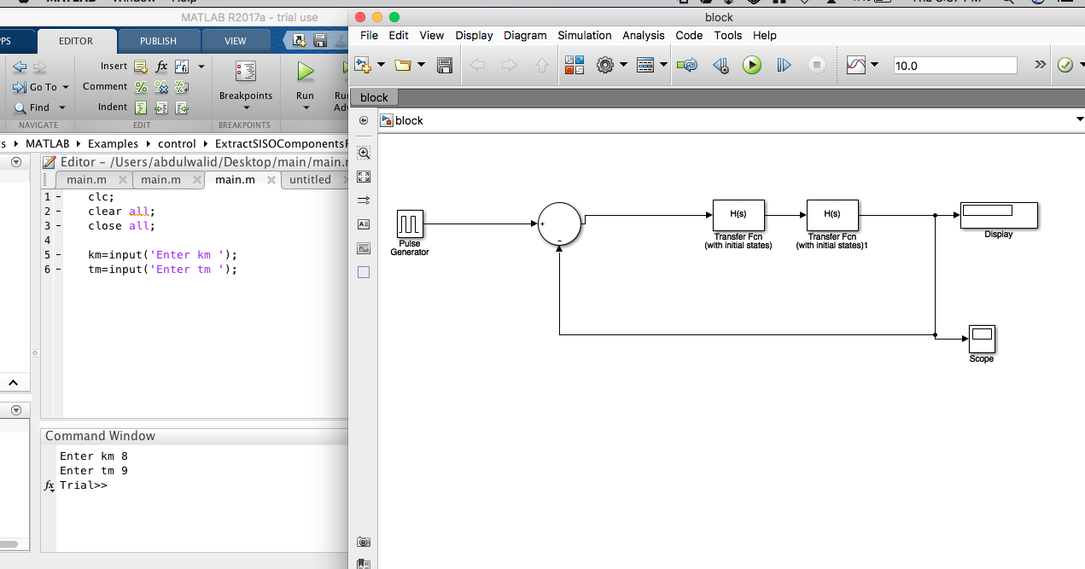
Figure 2

“the solution shown in figure 2 is not the correct way of doing this project and will NOT BE ACCEPTED”.

Main Requirements of The Assignment:

- whenever user want to change the parameters km and tm in transfer function 2 in the SIMULINK BLOCK, the parameters km and tm in transfer function 1 should also change at the same time with the same values automatically and accordingly IN THE SIMULINK NOT IN THE MATLAB COMMAND MANUE.

- This assignment should be done using the knowledge shown in the below link.
https://www.mathworks.com/matlabcentral/answers/93681-how-do-i-model-a-transfer-function-with-coefficients-that-vary-with-simulation-time-in-simulink-7-5

