Complete the Excel file to find the least amount of time required to go around the circuit without skidding for coefficients of friction (0.8, 0.2, 0.6, and 1.0).
Make sure to use the values (gravity, Vmax_car, etc) in the spreadsheets.

*Please only enter formulas into the green boxes. Do not type in numbers. *
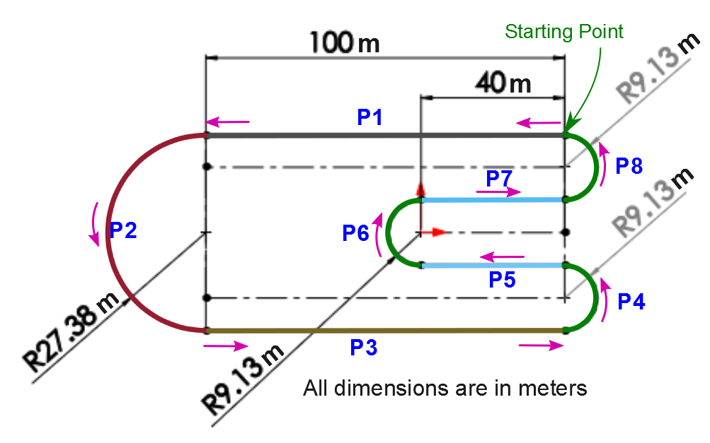
Also,Calculate the race on Mars using a coefficient of friction of 0.8.

