Assessment
Unit Test, Part 2: Thermal Energy
Show all work for each question, including initial equations before substituting values. Your final answer(s) must be clearly marked with proper units.
25 points possible
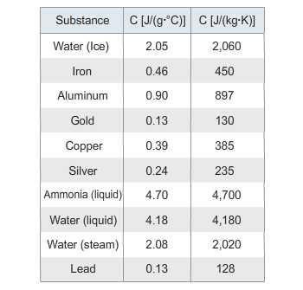
- (7 points) A 550.00 gram iron block absorbs heat to raise its temperature from 20.0 degrees Celsius to 195.0 degrees Celsius. Using the table above, find the amount of heat energy in Joules that was required. Show your work.
Answer:

- (9 points) A 0.600 kg unknown substance absorbs 5.260 x 10⁴J of heat to raise its temperature by 100 degrees C. What is the specific heat of this substance? Show your work.
Identify it using the table above. Explain your answer.

Answer:

- (9 points) You have a 1.55 kg block of silver at room temperature of 20 °C. Silver melts at 962°C. How much heat energy would be needed to just melt the silver? (H_{f} (silver) = 111 kJ/kg). Show all work.
Answer:

