LR
Click to run the simulation below:
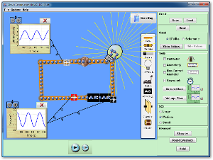
Click to Run

Attributed to:
PhET Interactive Simulations
University of Colorado
http://phet.colorado.edu (Links to an external site.)Links to an external site..

Directions
- Construct the circuit shown to below
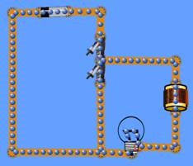
- What is the unit of the quotient of inductance and resistance? Show your work below.
- The quotient of L and R is called the time constant. Adjust the time constant of the circuit to one second. Record the value of inductor and bulb’s resistance.
- An inductor will be fully charged/discharged in a time of 4 to 5 L/R. How long will it take your LR combination to fully charge or discharge?
- Add the necessary meters and sketch the graphs of i vs t, and VResistor vs t, on graphs when the inductor is charging and discharging.
- Add the necessary meters and sketch the graphs of i vs t, and VInductor vs t, on graphs when the inductor is charging and discharging.
- When is the brightness of the bulb increasing?
- When is the brightness of the bulb decreasing?
- When does the battery supply the potential to light the bulb?
- When does the inductor supply the potential to light the bulb?
- Does the direction of charge flow change through the inductor? If yes, explain when.

