Due Date 5/13/17

Homework #6

PLANETARY GEAR TRAIN ANALYSIS
- In the gear train shown, gears 3 and 4 form a compound gear. Gear 3 is the smaller gear which meshes with gear 2, and gear 4 is the larger gear and meshes with gear 5.
(a) Determine fixed carrier train ratio.
(b) Assume gear 5 does not rotate and the angular velocity of gear 2 is ω₂ = 100 rpm CCW, then determine the angular velocity of the carrier.
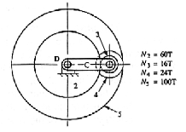
- A typical bevel gear differential for rear wheel-drive vehicles is shown in the figure below.
(a) Determine the fixed carrier train ratio of this system.
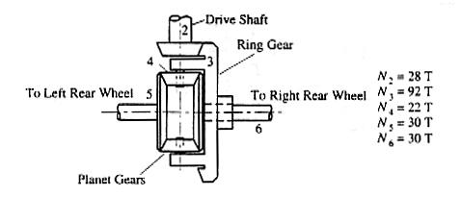
(b) Assume gear 2, attached to the drive shaft turns at 900 rpm and that the diameter of the driven wheels is 24”. Determine the speed of the vehicle for the situation when the right and left wheels have the same angular velocity, that is the vehicle is not turning and neither wheel is slipping.

- The figure below shows the planetary gear trains that form the semi-automatic transmission from a Model-T. This was the forerunner of today’s automatic transmissions. A plate clutch and two band clutches were engaged and released by a system of pedals and levers to shift gears. The proper sequence is shown in the table below.
(a) Determine the fixed carrier train ratios for the two planetary gear trains that make up this system.
(b) Determine the output/input speed ratios for each of the settings in the table.
