Implementing a Dominican Model of Leadership

Background of the Study
Effective and ethical leadership, as practiced by scientists, statisticians, businesspeople, doctors, and politicians, is necessary to solving today’s vexing and knotty crises. Individuals who continually answer the following questions, whether or not they consider themselves social justice leaders, persist in unravelling some of the thorniest issues of our times:
• Who am I and who can I become?
• What are the needs and opportunities of the world?
• What is my role in building a more just and compassionate world?
These questions are part of the Dominican ethos which provides one way to conceptualize leadership for social justice. The current study examines the implementation of a Dominican model of leadership on leadership identity for students in a higher education leadership program.
Statement of the Problem
Leadership theories that rely on personal traits, situations, and actions were developed for an industrial world and have become less effective as the world becomes more globalized, networked, and collaborative (Komives et al. 2005). Values-centered models of leadership highlighting collaboration, inclusiveness, empowerment and ethics have influenced new models of leadership (Komives et al. 2005; Kouses and Posner 2003; Rost 1993). There also exists an increasing interest in leadership identity development (Komives et al. 2005; Guthrie et al. 2013). Therefore, continued, rigorous study and application of ethical leadership models and the development of ethical leadership identity are vital because ethical leadership and effective leadership are interconnected and interrelated (Brown and Trevino 2006).
Theoretical Framework
This study is grounded in three paradigms: constructivism (Bagnoli 2011), authentic leadership theory (Avolio and Gardner 2005), and the input-environment-outcome (I-E-O) model (Astin and antonio 2012) for measuring growth in college students. The first two frameworks—constructivism as operationalized by the Dominican ethos (Bouchard et al. 2012) and Authentic Leadership—both contribute to the definition used here for ethical leadership and to inform the outcome of the I-E-O model.
In addition, two common approaches from this special issue, Recognition and Human Capabilities, are applicable to this study. The Recognition approach aligns with the Dominican ethos because the recognition and consideration of all individuals, especially vulnerable individuals, regardless of their identity or their place on the continuum of recognition, is part of the normative values of the Dominican ethos. The Dominican ethos mirrors constructs of the Human Capabilities approach, especially the consideration of individual well-being, the examination of social and political systems, and the dialogue and participation on all level of community decision making. This study also employs the Human Capabilities approach through the values of partnership, community, and justice.
Constructivism and the Dominican Ethos
The Dominican framework for leadership is just one example of a value-based approach to leadership education and development. For the purposes of this study, constructivism as a theoretical framework is operationalized as the Dominican ethos. This ethos consists of three main constructs: the Dominican values of truth, community, justice, compassion, and partnership, the studium, and the motto, cor ad cor loquitur. These three components of the Dominican ethos form the basis for the Dominican model of ethical leadership and are illustrated in Figure 1.

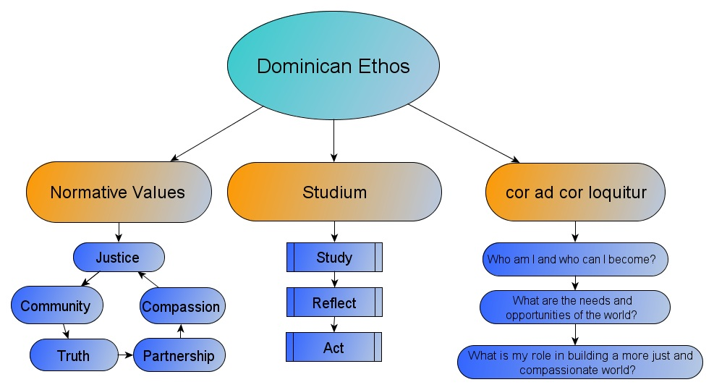
Figure 1: The Dominican Ethos
The Dominican normative values create the backbone for Dominican leadership, precisely because they are normative. Normative truths are a moral belief in which actions can be good or evil, and holds that some things are more valuable than others (Bagnoli 2011). The values are briefly described in Appendix A. The Dominican values are a vital component of the Dominican ethos and Dominican leadership.
The studium is a commitment to study, reflect, and act or share the fruits of that reflection. The studium is a process, a “union of study and contemplation in the service of truth, wherever it leads” (Bouchard, Caspar, Hermesdorf, Kennedy, and Schaefer 2012, 6). The studium is also a call to engage with the rest of the world “to read, write, speak, listen understand and think critically and respectfully, to reckon, measure and manipulate matter … to act in partnership with others and to share what has been gained through careful contemplation and listening…” (Leonard n.d., 1). The studium provides a foundation for contemplative action and is a cornerstone to Dominican leadership.
The motto cor ad cor loquitur is Latin for heart speaks to heart and is manifested in three questions: Who am I can who can I become? What are the needs and opportunities of the world? What is my role in building a more just and compassionate world (Edgewood College n.d.)? These three simple questions provide a framework for action and growth. To continually ask them requires a building awareness, not only of the self, but also the world, and demands an examination of the potential for change. The answers to these questions also require a belief in the responsibility of the individual to play a role in the goal of social justice. By continually asking these questions, using the studium as a reflection model and the Dominican values as the backbone, one becomes a de facto leader for social justice.
Constructivism, Authentic Leadership, and the I-E-O Model
In this study, a constructivist theoretical framework was operationalized by the Dominican ethos and authentic leadership theory. Authentic leadership is viewed as a root construct (Gardner et al. 2005) from which ethical, transformational, or other types of leadership can emanate. Avolio and Gardner (2005) define authentic leadership and designate authenticity and a positive moral perspective as the two foundations that underlie four main constructs: self-awareness, relational transparency, internalized moral perspective, and balanced processing. Figure 2 illustrates this relationship.
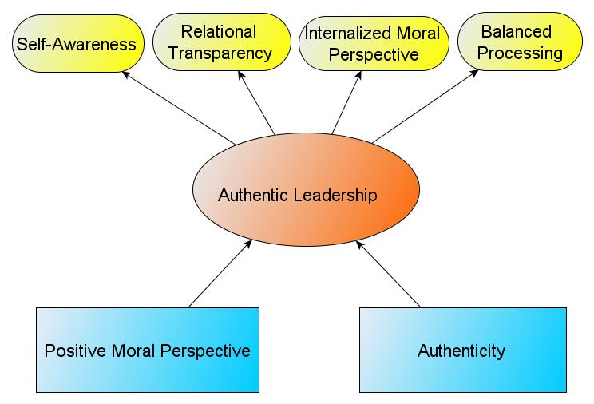
Figure 2: Authentic Leadership Constructs
The four main constructs of authentic leadership theory provide a validated, empirical conceptualization of leadership, grounded in constructivism. The final theoretical framework employed in this study is Astin’s (1993) input-environment-outcome (I-E-O) model for measuring growth in college students. This model describes a framework for a talent development approach to assessment, as opposed to a resources and reputation model or the use of only one point in time data capture.
Purpose of the Study
This sequential mixed methods study extends research on ethical leadership by examining the relationship between authentic leadership and the Dominican ethos in Ed.D. graduates’ professional lives. The main focus of the study was an exploration of the effect of an implementation of an ethical leadership curriculum on doctoral students’ acquisition of a leadership identity based in a Dominican model of social justice leadership. Using both components enabled the researcher to connect the graduates’ use of the Dominican ethos and Dominican Leadership to student acquisition of the Dominican ethos and the Dominican leadership model.
Method
The study employed a sequential explanatory strategy. The first phase was a quantitative study which examines the extent to which graduates of a doctoral program in Educational Leadership incorporate the Dominican ethos into their decision making in professional settings; and it examines the relationship between the Dominican ethos and Authentic Leadership. Based on the recommendations of this quantitative analysis, a leadership curriculum was implemented in the Ed.D. program. As part of the leadership curriculum, students complete formative reflections at three different points in time during their coursework. Phase two of the study utilizes a qualitative approach to analyze these formative, longitudinal reflections.
Procedures
The target population for phase one of this study consisted of graduates of the Ed.D. program. The target population was relatively small, approximately 180. An electronic survey was sent to graduates. The survey produced a return rate of 43%. The demographics of the respondents (N = 77) were similar to the proportion of graduates from each concentration (50 in k-12 and 27 in higher education); the mean age was 48; 40 were female and 37 were male. Approximately 56% of respondents graduated between 2009 and 2013. Ninety-one percent of respondents identified themselves as White, Non-Hispanic (Otte Allen 2014).
Phase two, the qualitative portion of the study, consisted of students currently enrolled in the program. Of the 26 students in Cohort A, 18 were female and 8 male, nine self-reported as students of color, the mean age is 41, and nine elected to participate in the study. Of the 36 students in Cohort B, 26 were female and 10 were male, 10 self-reported as students of color, the mean age is 38, and nine elected to participate in the study. The demographics of the participants were similar to the overall population.
Instrumentation
In phase one of the study, the researcher, with assistance from the research team, created the survey instrument to be deployed to participants electronically. The survey instrument was named Leadership Values Survey and included questions about the Dominican values and the Authentic Leadership Questionnaire (ALQ). The ALQ instrument had been validated independently (Walumbwa et al. 2008).
In phase two of the study, student reflections were analyzed. These student reflections were completed at three different points in time as part of a program assessment. Reflection one was completed prior to admittance into the program. At the end of the first course, the same students completed their second reflection. A different cohort of students completed the third reflection mid-way through their content courses. Students also complete a fourth and final reflection immediately prior to the research and dissertation phase, however, that reflection was not part of the current study.
Data Analysis
In phase one of the study, the primary means of data analysis was quantitative, the secondary means of data analysis was qualitative. Both the Authentic Leadership Questionnaire and the Leadership Values Survey were tested for reliability using a confirmatory factor analysis and an exploratory factor analysis, respectively. A correlation coefficient was conducted using Pearson’s r to determine which factors interacted significantly with each other (Burke 2009; Plackett 1983; Spearman 1904). A Pearson’s r was used to compare the data from the Leadership Values Survey and the Authentic Leadership Questionnaire. Further correlations were conducted with the independent variables and the dependent variables. A correlation matrix was created with the resulting information. The secondary means of data analysis in phase one consisted of completing open, axial, and selective coding (Strauss and Corbin 1990) of the responses from two open-ended questions. Through constant, comparative analysis (Glaser 1965; Corbin and Strauss 2008), each participant’s response was connected to other responses, categories, properties, and dimensions.
In phase two of the study, student reflections, completed at three different points in time, were analyzed qualitatively. The first two reflections were completed by the same cohort of students, the third reflection was completed by a different cohort. First, coding categories were created by synthesizing the Dominican model of leadership and reflection research, particularly with works of Bell et al. (2011), Bouchard et al. (2012), and Kember et al. (1999) (see Appendix B). Second, the reflections were analyzed using open, axial, selective coding, and constant, comparative analysis (Glaser 1965; Strauss and Corbin 1990; Corbin and Strauss 2008). Further, the axial coding was double checked for veracity by experts in qualitative research.
Limitations
The Dominican model of leadership is embedded in a constructivist foundation because it uses normative values. Therefore, some individuals or groups will not be willing to ascribe to these normative values for a variety of political, philosophical, religious, or personal reasons. The sample size was small, and although the researcher used experts to reduce bias, the interpretive nature of the data analysis, if conducted by multiple people of diverse backgrounds may have yielded different results. Further, reflections completed by the same group rather than using both cross sectional and longitudinal samples would have provided better data. Despite these limitations, the potential for implementing social justice models of leadership like the Dominican model of leadership are worthy of continued examination and refinement.
Results
In phase one of the study, findings indicated that the Dominican values of truth, community, justice, compassion, and partnership were internalized by respondents. Furthermore, respondents reportedly overlapped and integrated the values and the studium in their professional roles. The findings also yielded a moderate, positive correlation between reflection (.46) and decision making based on the Dominican ethos (.50) and the internalized moral perspective of Authentic Leadership, as illustrated in Table 1.
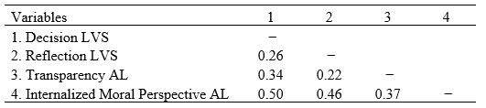
Table 1: Correlation Matrix
This table shows that respondents tended to use the normative, Dominican values as a framework for their moral perspectives. The qualitative analysis of two open-ended questions likewise supports the notion that graduates of the program incorporate and internalize the Dominican ethos.
In phase two of the study, the analysis of respondents’ reflections uncovered that in reflections one and two students were in the process of deepening their understanding and application of the Dominican values. They also showed a strong commitment to the question, “Who am I and who could I become?” In reflection three, students began to internalize the Dominican model of leadership by demonstrating a more intentional use of the studium and the Dominican values in their leadership identity and a Dominican leadership framework.
Studium
Respondents demonstrated a difference in their understanding of the studium. In their first reflection, they had not been introduced to this construct, and their reflections did not communicate an implicit or explicit use of the studium as a means for decision making. In the second reflection, they made cursory mention of the studium, but no application of the construct to the course, decisions, or identities. In the third reflection, students provided evidence of integrating the studium into their thinking. One student wrote,
This course made me think about access to higher education, how higher education is funded, and who benefits the most from that funding system. It is easy to lose sight of big picture issues like this on a day-to-day basis, but we have a responsibility to students to stay focused on these bigger, important issues while making our day to day decisions.
This respondent has studied particular issues of higher education, has reflected upon the relative importance of those issues, and intends to act in a manner that demonstrates commitment to equal access.
As part of the studium’s study and reflect components, the researcher examined the extent to which respondents were questioning their own attitudes and assumptions. Only one respondent questioned their own attitudes or assumptions in the first reflection. However, three respondents did so in their second reflections. In the third reflections, respondents applied a nuanced perspective by, for example, “examining personal biases and beliefs through on-line discussions.” One respondent indicated that “content and discussions challenge my beliefs” and another was “beginning to understand the role of diversity in a homogeneous society.” Although respondents were applying parts of the studium, they did not yet exhibit cohesive and consistent use of the studium.
Cor ad Cor Loquitur
The cor ad cor loquitur question, “Who am I and who can I become?” was addressed heavily in the first reflection. Respondents recalled their leadership experiences, and they indicated a desire to grow as leaders. They also connected the ideal of the normative values to their leadership experiences. For instance, one respondent wrote, “I want to continue to improve on becoming a leader of these core ideals;” another wrote, “the Dominican Values connect to my ambition of creating a better leader in myself.” Respondents indicated a strong sense of their own leadership identity by using words like “I already possess leadership skills”, yet indicated a strong desire to grow in their leadership capacity. The second reflection did not indicate a continued focus on this question. Respondents could have discussed this question as part of their leadership identity, but often focused on the Dominican values instead.
The question “What are the needs and opportunities of the world?” was addressed in the third reflections thorough tackling diversity and inclusion issues, as well as issues of access, shared governance, and finance. However, the discussion of these issues sometimes lacked complexity and depth. The question, “What is my role in building a more just and compassionate world?” was only vaguely addressed by respondents throughout all reflections.
Dominican Values
When considering the Dominican values as part of a social justice leadership identity, analysis revealed a deepening understanding and internalization of the Dominican values. Respondents writing their first reflections often addressed the values without complexity. Some respondents did, however, begin to address the values from a retroactive perspective and used examples from their professional lives. In the second reflection, respondents begin building a framework Dominican leadership primarily through their experiences in the classroom and with cohort members. They wrote, “it is encouraging to utilize the discussion board posts to develop relationships with others in the cohort.” And, “the Dominican values moved me forward in my thinking.” Respondents indicated a continued attention to the values, but were also reflecting on the behaviors, attitudes, habits, and beliefs espoused by the faculty and staff indicating a change in a retrospective approach to the values to one that is grounded in their experiences in the classroom and in their evolving leadership framework and identity.
In the third reflections, respondents illustrate the dynamic process of identity development. One respondent underscored the strength of the community based, cohort model, noting that “while these learning opportunities were provided to me by my instructors, it was the dialogue that took place between our cohort members that really made me open my mind to understanding the issues from a different angle.” In a more abstract way, one respondent reflected on applying the values, “infusing the values in our personal leadership can facilitate individual growth in our professional life and scholarly endeavors.” This quote indicates that respondents were in the process of internalizing the Dominican ethos as it related to their professional lives.
Other respondents were in the process of internalizing the Dominican values as part of their leadership framework, including issues of diversity. One respondent wrote, “I can identify how the values transcend into our reflections and coursework.” In the reflections, respondents increased their awareness of issues of diversity and inclusion in higher education and begin to connect those issues to ethical leadership. Only two respondents mentioned issues of diversity or inclusion in their first reflections, and seven did so in their second reflection, showing a dramatic increase. In the third reflections, seven respondents wrote about issues of diversity, and they connected those issues to leadership. For example, one respondent wrote, “acknowledging the necessity for inclusion, especially as it relates to racial and gender diversity, is a foundational principle essential to becoming successful leaders in our global culture.”
Dominican Leader Identity
Respondents’ reflections were analyzed to determine if respondents were cultivating their identities as academic writers, scholarly researchers, and Dominican leaders. The analysis found that respondents reportedly gained technical skills in writing and research, but much of the demonstrated growth occurred as respondents wrote about the Dominican Leader identity. In their first reflections, respondents generally wrote about the values in generalized and global ways. In addition, the values were often applied retrospectively. For instance, one respondent wrote, “…the Dominican values connect to my ambitions of creating a better leader in myself.” Although respondents increased their attention on issues of diversity and began to question their own attitudes, they also began “reflect on where my leadership ideals originate, how I want them to evolve, and which areas need development.”
In the third reflection respondents began to demonstrate their incorporation of the Dominican ethos as part of their leadership identity. One respondent noted, "As a student I had the opportunity to practice or apply these values and the content knowledge for courses in my work--specifically in decision making, problem solving, working with campus governance, strategic planning, motivating staff and in academic program development." This respondent applied both the values and the content knowledge to their professional work. Another wrote, “throughout each of the content courses, I have been continually reflecting on the principles and practices that guide the vision and everyday work of an ethical leader and ask questions such as how is the Dominican tradition of study, effect, and act embodied in meaningful scholarly research and writing” In this reflection, the respondent incorporated the Dominican values and the studium in her leadership identity. While not all of the properties of the reflections in this category showed this level of growth, most all indicated applying the Dominican model of leadership in their coursework and professional work.
Discussion and Implications
The analysis of data suggests that respondents were in the process of building a social justice leadership framework from which they can operate in their professional roles. It is evident that graduates of the program both internalized the studium, with its emphasis on reflection and study, and the Dominican values. Phase one of the study provides some evidence to support empirical studies connecting self-reflection to Authentic Leadership (Branson 2007; Nesbit 2012; Park and Millora abstract only 2012). Further, a moderate positive correlation between the parts of the Dominican ethos and the internal moral perspective component of Authentic Leadership indicates that the Dominican model of leadership may be helpful in expanding the construct of the internal moral perspective of Authentic Leadership. The Dominican ethos can provide the veracity necessary to develop the internal moral perspective component of Authentic Leadership (Otte Allen 2014), and therefore, each are needed to provide a firm foundation for a constructivist theoretical framework. Moreover, this study supports the notion that ethical and effective leadership are interconnected and interrelated.
In phase two of the study, it was evident that respondents were involved in a dynamic process of internalizing the Dominican ethos and Dominican model of leadership. Although this internalization may happen at different paces and intensities, respondents in the program increasingly used the studium; built and internalized the values as part of their leadership framework; and began to ask the cor ad cor loquitur questions (Who am I and who can I become? What are the needs and opportunities of the world? What is my role in building a more just and compassionate world?).
The studium’s emphasis on study and reflection connects to literature which indicates a positive relationship between reflection and decision making (e.g. Campitelli and Labollita 2010; Cokely and Kelley 2009; Frederick 2005; Toplak, West, and Stanovich 2011). Vital components of this reflection scheme (content reflection, process reflection, and premise reflection), all served as particularly useful measures of the type and quality of student reflection. For example, respondents demonstrated a deepening ability to question their own attitudes and assumptions, a vital component of the Dominican ethos. Questioning ones attitudes and beliefs through reflection and study can propel individuals toward the Dominican values. Therefore, deep reflection and decision making components of the studium may help to guide practice when implementing a social justice model of leadership.
Respondents began to expand their conceptualization of leadership as they internalized the Dominican values and the cor ad cor loquitur questions to build their leadership identities. Since these Dominican values may be more gender inclusive than traditional, ubiquitous values, and since they have an emphasis on paradigms of leadership that are more cooperative and collaborative (Otte Allen and Best 2013), the Dominican values may be useful in building a non-gendered, social justice framework for leadership. In addition, as respondents built their leadership identities, they were increasing their awareness of issues of diversity and inclusion, with its direct connections to the values. This Dominican model of leadership may be particularly useful for students from diverse backgrounds whose experiences and identities may be quite different from a traditional model of leadership.
The Ed.D. program under study incorporates features of programs that build leadership identity in diverse students. Guthrie et al. (2013) identified program elements and features that cultivate leader capacity and identity in students from diverse backgrounds. These programs focus on identity development, incorporate diverse perspectives of leadership, and create a meaningful program; they also feature consideration of language use, experiential learning opportunities, and structured and unstructured reflection (68). The Dominican model of leadership mirrors these recommendations through its focus on identity development as writers, researchers, leaders, its use of periodic reflections, and emphasis on inclusion and diversity and the Dominican values. Furthermore, building a leadership identity through developing self-awareness was evident in student reflections, and supports Komives et al.’s (2005) study detailing leader identity development in undergraduates. Therefore, an intentional curriculum focused on Dominican ethos and the Dominican model of leadership identity can be a vital component of programs whose intent is to foster social justice leadership.

Appendix A
Dominican Values
• Truth – Life, Dignity, and Equality of the Human Person. Every person is created with infinite value, equally worthy of care and respect. Relationship to the Universe. All of creation is in a sacred relationship; humans have a special call to live that relationship in reverence and humility.
• Community – Social Nature of the Human Person. The dignity and worth of human persons are most fully realized in the context of relationships with others in the community. Solidarity of the Human Family. Human beings are part of one family and share responsibility for one another.
• Justice – The Common Good. The social systems and institutions of a just community evolve to pursue the common good: that which benefits all people. Human Development and Progress. True development enhances the human spirit while respecting and promoting the dignity of all creation.
• Compassion – Concern for the Poor and Vulnerable. Those who are most vulnerable or who benefit least from existing social institutions merit first consideration in our circle of concern.
• Partnership – Sacredness of Work. Work is the expression of each person’s gifts and achievements, through which each contributes to the common good. Role of Leadership/Governance. All people have the right and the responsibility to participate in political life in pursuit of the common good. Subsidiarity. Dialogue and participation are necessary at all levels of community decision-making, with decisions entrusted at the most elemental level of responsibility and authority are appropriate. (Edgewood College Mission, Values, and principles)

