Practice Problems - Questions 1-6
- The read access delay for an I/O system is defined as the time required for the device to acquire the requested data and prepare to start transmitting the data. The data transfer rate for an I/O device is defined as the number of bytes per second that it can transmit. Suppose that there are two different I/O systems A and B. System A has a data transfer rate of 5120 bytes per second and has an access delay of 5 seconds. System B has a data transfer rate of 3072 bytes per second and has an access delay of 4 seconds. How long will each system require to complete a 3145728-byte I/O request?

- Consider system in which a program polls the device for requests every 0.2ms. If this program is the only code running on the processor and each poll requires 200 cycles, how many cycles per second will the program spend on polling alone?

- Assume that the 4 data strips (i.e. data blocks) within a certain stripe on a RAID 5 system are designated B0, B1, B2 and B3. The corresponding parity block P for this stripe is computed as the cumulative XOR of the 4 data strips. Block B2 is to be updated and its new contents is designated as B2’. Write down an expression for the corresponding new parity block P0-3’.

(Using equation similar to what is stated below)

Suppose drive containing bit3 fails:
P0-3 = bit0 ^ bit1 ^ bit2 ^ bit3 (^ denotes XOR operator)
bit3 ^ P0-3 ^ P0-3 = bit0 ^ bit1 ^ bit2 ^ bit3 ^ bit3 ^ P0-3
bit3 = bit0 ^ bit1 ^ bit2 ^ P0-3

So bit3 can be reconstructed from the parity and remaining data disks
(entire contents of failed disk can be reconstructed this way)

- Shown below is the diagram of a RAID system.
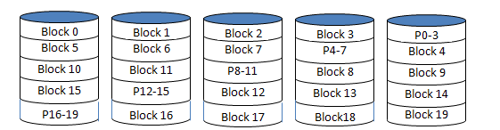

- What level RAID system is this? RAID0, RAID1, RAID2, RAID3, RAID4, RAID5 or RAID6?

- Writing a new block 8 requires reading some number of disk blocks (=R), writing some number of disk blocks (=W) and performing some number of XOR operations (=N). For example, computing Axor B xor C would be considered 2 XOR operations. What are the values for R, W and N? Explain your answer.

5. A disk system is to be constructed using some number of identical disk drives each of which can store up to T terabytes of data. A large database of size 4×T terabytes is to be stored on the disk system. What is the minimum total number of disks that would be required for the system if the disk system is a:

  - RAID4 system?
  - RAID5 system?
  - RAID6 system?
  - RAID1 system?

6. For a direct-mapped cache design with a 32-bit address, the following bits of the address are used to access the cache:
Tag – 31-10
Index – 9-5
Offset 4-0
- What is the cache block size?

- How many entries does the cache have?

- Starting from power-on, the following byte-addressed cache references are recorded.
0, 4, 16, 132, 232, 160, 1024. For each reference, give the index and tag, and indicate whether it is a hit or a miss.

