Strategic Plan Part 2
Elisha Scrogum
BUS/475
February 1, 2017
Clark McCarrell

Strategic Plan Part 2
Stay and Relax is a unique company that provides massage therapy in a mobile relaxation room, in home, or in the office. Stay and Relax is working towards dominating the mobile massage therapy market within the next few years. The SWOT analysis presented in this paper will analyze the strengths, weaknesses, opportunities, threats, and trends that the company is facing today. This is divided into two groups; internal factors, which occur within the company and external factors which occur outside of the company. The SWOT analysis gives us the opportunity to evaluate the company while creating our strategic plan. Stay and Relax’ s SWOT table is illustrated below.

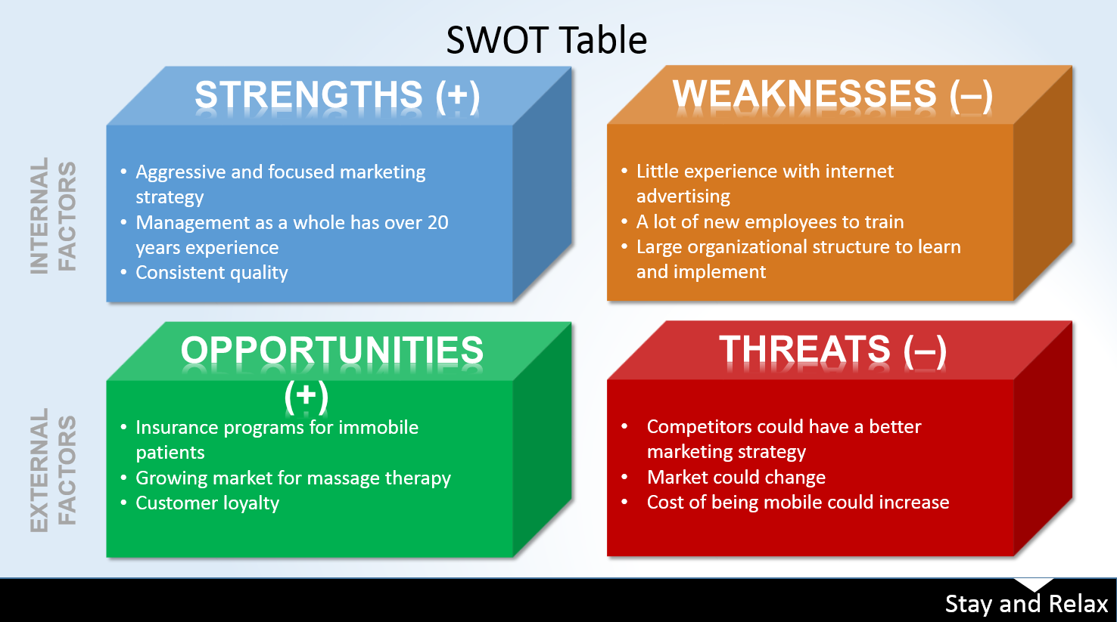
External Factors
There are many external forces and trends that Stay and Relax will have to face sooner or later. These external factors will have an effect on the strategic planning of the company. Some of the more threating external factors include legal and regulatory issues. Especially because we provide a mobile therapy service, legal issues could arise easily. Our industry is driven by customer service and our relationships with customers and vendors. It is a must that we protect our employees and our customer’s safety physically and legally. We are also obligated to protect the privacy of our clients as well. If we didn’t do everything we can to protect our clients privacy it could lead to class action lawsuits and major fines and penalties. To prevent such things from happening, Stay and Relax will be forming a team of professionals which includes attorneys and successful business executives. This elite team will handle all legal issues no matter how big or how small the issue may be.
Another external factor that has the potential to drastically alter our business plan is the cost of fuel. We are a mobile service that provides our services at a competitive price, if the cost of fuel increases we would be forced to increase our prices. This could cause many issues with our loyal customers who expect the same price each time they book a service and customers that are looking for a “good deal” on mobile massage. We have committed ourselves to competitive pricing and have directed our marketing towards 100% complete customer satisfaction. If the fuel prices increase, we will be forced to increase our prices and take the hit from unhappy customers.
Internal Factors
With any new company comes many obstacles and challenges to overcome. Stay and Relax is no exception to this. With the launch of our new business plan we will have to overcome the challenge of training all new employees and learn and implement a large organizational structure. We will first take on this task by training our highly educated managers and teach them the ins and outs of the company. Our managers were hand-picked from a select pool of well qualified business majors. We will expect them to know the structure of the organization as a whole and each individual department. Once the managers are trained, they will be responsible for the training of each employee in their department. This will cut down on the cost and time for training. It will also give the managers an opportunity to build a relationship with the new employees.
Stay and Relax has a strong marketing team that has created and implemented a marketing strategy that will keep us on top and ahead of the competition. The marketing team will be responsible for staying up to date with the newest marketing techniques and implementing them into our business plan. Our marketing team has well over 20 years’ experience, but little experience in internet advertising. We foresee this being an issue because the internet has become one of the best places for advertising. We plan on educating out marketing team on social media and internet marketing. We are in the process of building a Facebook page, Twitter account, Pay Pal account, Instagram page, and our very own web page. Our clients and vendors will be able to reach us on these accounts and see what the company has to offer. Implementing these accounts and getting our team in the “know” we will be building an entire on-line community for Stay and Relax.
Conclusion
Stay and Relax has built a strong team and will have all the necessary tools to overcome and get through many threats and obstacles in the business and marketing world. We are confident in our staff and strategic business plan. The marketing team has a well put together plan that will build the companies relationships with current customers, vendors, and the community. We look forward to the challenges and the satisfaction on seeing our company getting built from the ground up and making an impact on the mobile massage industry. Stay and Relax will be a well-known business in the community shortly after its official launch date.

