SEC 6080 - ICS Risks
Today's exercise will illustrate the importance of proper security on Industrial Control Systems. We'll use government resources to discover potential hazards in our own back yard.
Exercise: Toxic Chemicals managed with Industrial Control systems
- Open a browser and go this this location
http://www.epa.gov/enviro/facts/topicsearch.html#toxics
- Type the location (zip code or City, State) into the TSCA search field and click the search icon
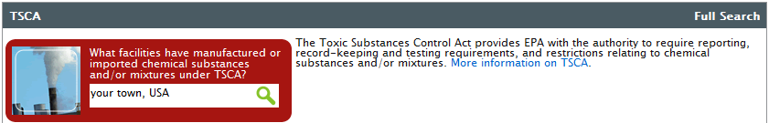
- Click the button labeled List and Map…

- Zoom in or out, move around until you find an area you’re interested in, then click Update facilities on map button
- Find a facility with toxic chemicals and hover over the orange square to pull up facility information link, click on the facility name
- Click on the TSCA chemical you want to know about. Do some research to find out the toxicity of a chemical used in the facility.
- To score 40 points for this activity, be prepared to report the following information:
Facility | Location | Chemical Name | Toxicity of Chemical

