Case 1: Due by 2/19 at 11:59 p.m. on Blackboard
Directions
Please provide a case analysis in no more than two pages single spaced. Submit the case analysis through the assignment link in BLACKBOARD ONLY. The case analysis should have the sections listed below in order.
Name:
Course:
Term:

Heading 1: Overview of the Case
**You should write a paragraph or two for the Overview of the Case.**
Heading 2: Human Resource Management Challenges
**Numbers or bullet points are acceptable for listing the Human Resource Management Challenges. One or two sentences for each challenge is acceptable.**
Heading 3: Recommendations
**Numbers or bullet points are also acceptable for the Recommendations section. However, the recommendation section should include well thought out answers in complete sentences. Simply making recommendations to 1. Recruit personnel or 2. Provide a one-day training program are not sufficient to answer the question. Mr. Hernandez already knows that he needs to hire and train new personnel. It is your job to add value by making meaningful recommendations that help him solve the PPC’s problem.**
Panama’s Human Resource Challenges
You are a human resource management consultant that is being sent to the Panama Ports Company located in Panama. A meeting is scheduled with Mr. Jose Hernandez the Human Resource Manager for the Panama Ports Company (PPC) to discuss recommendations for solving the human resource challenges the PPC faces as a result of the Panama Canal expansion. Mr. Hernandez already provided you with the human resource challenges he faces as a result of the expansion. Mr. Hernandez wants you to make specific recommendations at this meeting to help solve these human resource challenges.
Background
Overview of the Business Environment in Panama
Panama's economy is largely based on the service sector. More than three quarters of GDP comes from services such as the Panama Canal, logistics, and tourism (Central Intelligence Agency, 2014). In order to increase revenue in the service sector, the Panama Canal is currently undergoing an expansion. The expansion is expected to be complete in 2015 and cost approximately $5.3 billion dollars (Central Intelligence Agency, 2014). Panama's economy is not without its challenges. Panama also has approximately one-fourth of its population living in poverty (Central Intelligence Agency, 2014).
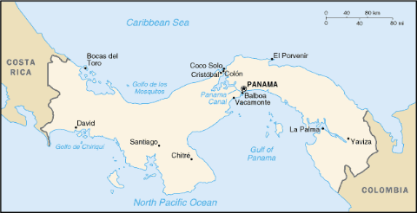
Figure 1. Map of Panama Reprinted from the U.S. Department of State website.
Overview of the Business Environment at the Port of Cristobal
The Port of Cristobal is a commercial port on the Atlantic side in Panama that has been in operation for over a century (Panama Ports Company, 2014). The Port of Cristobal is currently going through a modernization. The modernization project includes 660 meters of deep-water quays, warehouse expansion, and cranes to handle containers (Panama Ports Company, 2014). This is all in an effort to better handle the volume of containerized cargo that passes through the Panama Canal. The Port of Cristobal is managed by the Panama Ports Company.

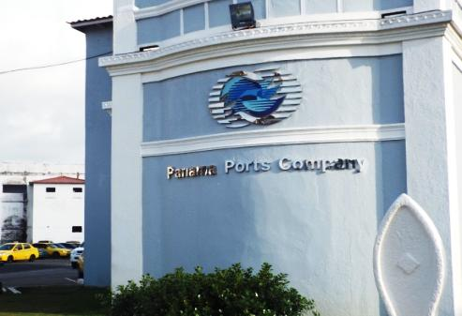
Figure 1. Photo of the Panama Ports Company at the Port of Cristobal.

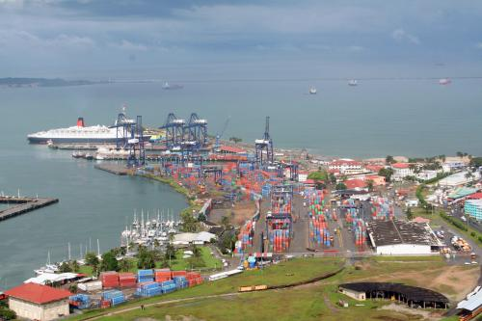
Figure 2. Photo of the Port of Cristobal Reprinted from the Panama Ports Company website.
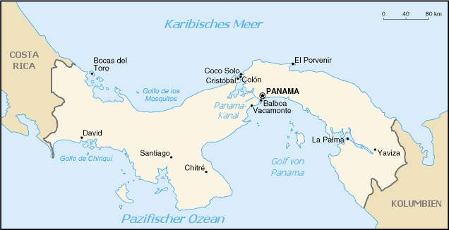
Figure 3. Map of Panama with Location of Panama Ports Company in Colon

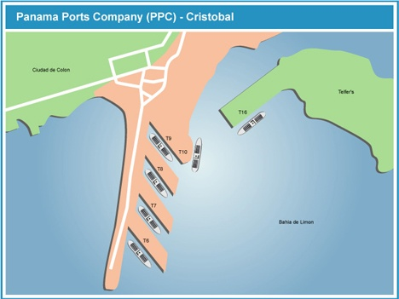
Figure 4. Map of the Panama Ports Company (PPC)-Port of Cristobal
Human Resource Challenges
Details of the Panama Ports Company (PPC)
The Panama Ports Company (PPC) is a very unique company that operates the Port of Cristobal in Panama. First, the Port of Cristobal is strategically located on the Atlantic side in Panama allowing it to manage cargo that passes through the Panama Canal. Second, the Panama Ports Company’s mission is to become a world leader in port operations and logistics in America (Panama Ports Company, 2014). The PPC plans on becoming a world leader in logistics in several ways. The Panama Ports Company’s plans include an investment in the modernization of the port’s facilities to accommodate larger containerized cargo vessels (Panama Ports Company, 2014). Figure 5 is a photo of the cargo facilities at the Panama Ports Company in Colon.
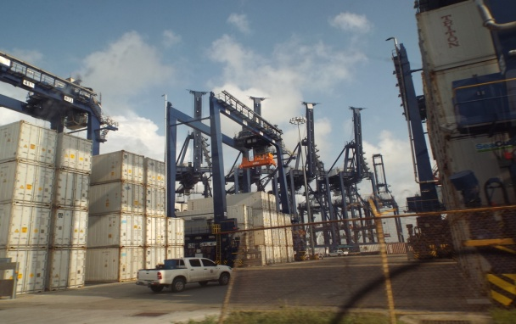
Figure 5. Photo of the cargo facilities at the Panama Ports Company (PPC)-Port of Cristobal
The PPC also uses technology in port operations. The technology used at the port includes Electronic Data Interchange (EDI) services that provide container and transaction data around the clock in real time (Panama Ports Company, 2014). Technology also helps the employees monitor refrigerated cargo. The REFCON electronic system monitors refrigerated containers by alerting the container controller if there is a failure in the refrigeration equipment (Panama Ports Company, 2014). Figure 6 is a photo of refrigerated cargo awaiting shipment at the Panama Ports Company in Colon.
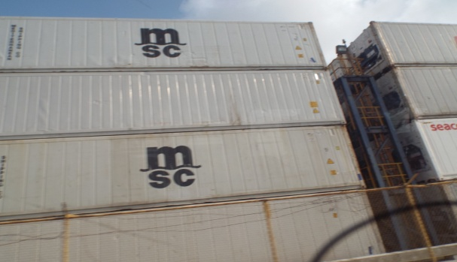
Figure 6. Photo of refrigerated cargo at the Panama Ports Company (PPC)-Port of Cristobal
In addition to investments in physical capital, the PPC is also committed to investments in human capital. However, the modernization of the Port of Cristobal created several human resource challenges for the Panama Ports Company. First, the PPC will need to recruit additional personnel to handle the higher volume of containerized cargo that will pass through the Panama Canal. Second, they will need to train the new employees with the right skills to be successful. New employees will need training on the inventory management system, electronic refrigeration controls, and gantry crane operation. Third, the PPC will need to evaluate the new employees. Figure 7 is a photo of gantry cranes loading cargo at the Port of Cristobal.
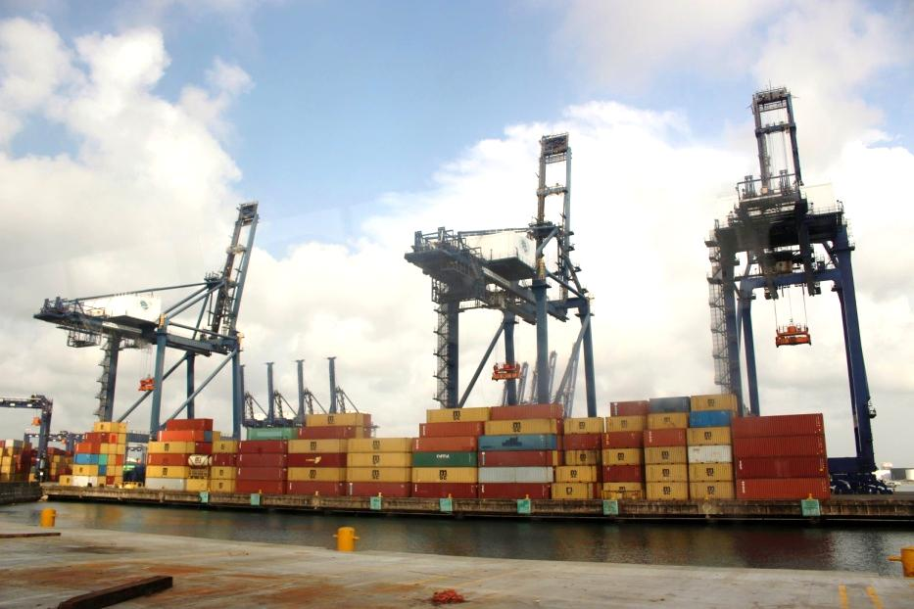
Figure 7. Photo of gantry cranes loading cargo at the Panama Ports Company (PPC)-Port of Cristobal
Mr. Hernandez also stated in the initial consultation several concerns he had about solving the PPC’s human resource management challenges. Mr. Hernandez and the PPC would like to recruit and hire local personnel with a commitment to careers in logistics. Additionally, many new hires do not have prior training on inventory management systems or crane operation. Mr. Hernandez also thinks that training programs are important, but doesn’t know how to evaluate the programs. Upper management has concerns about training program Return-on-Investment (ROI) and evaluation. Also, who will provide the training (internal vs external trainers) and the duration of the training period. Mr. Hernandez mentioned that crane operation training might take longer than inventory management training based on his previous experience with training programs. Probationary periods have been used in the past to evaluate employee performance after a training program. Mr. Hernandez thinks that a probationary period is a waste of time, but is open to hearing suggestions on the implementation of a probationary period for new hires. Mr. Hernandez gave you a list of items that he would like to see recommendations on.
Action Items
- Make recommendations for recruitment of new personnel
- Make recommendations for training of new personnel on the inventory management system and crane operation (program duration, delivery method, potential problems)
- Make recommendations for evaluation of new personnel after completion of the training program

