Project Overview
You are to develop an application that is intended to help keep track of the inventory for a coffee shop. The application will ensure that prior to an order being placed, there is sufficient inventory to fulfil the order. The application will also keep a history of all past orders.
This project will be a team project. Teams must consist of a minimum of 3 members and a maximum of 6 members.

Interface
You must design an interface that meets the needs of the project. You may use something similar to the following or you may create your own interface. You must provide the same level of functionality.

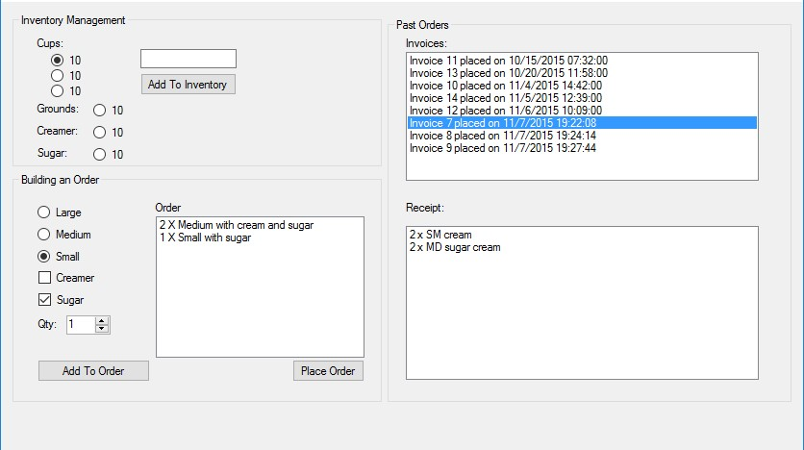

Application Usage
When the application starts, your inventory and past invoices must be loaded from the database.
The user may add three different sized cups, grounds, creamer, and sugar to their respective inventories, build an order, or place an order. The user may build an order containing multiple coffee configurations. If a coffee is being setup to be added to the order that will exceed the inventory available, the Add To Order button must be disabled. Coffees that will exceed the available inventory should not be added to the order.
Once the order has been built, the Place Order button will be used to actually decrement the values from the inventory. The Building an Order form must then be rest for a new order to be made.
All orders must be tracked within a database so that they will not be lost when the program closes. You must also allow the user to view past orders details.
All inventory amounts must also be stored within the database so that they will not be lost when the program closes.

Programming Requirements
- All code must be commented.
- The application interface must be intuitive.
- All inputs must be error checked and validated.
- Your application must not crash and must not provide invalid results. Be aware the instructor will try to crash the application as well as get the application to provide invalid results by using the interface. The instructor will not modify, add, or delete code to achieve this.
- You must use a database to store the details of all past orders as well as the inventory.

Additional Project Information
For each order of coffee, the following number of units are required
- Coffee Grounds: small = 2 units, medium = 3 units, large = 4 units
- Coffee Cups: each size is 1 of its respective units
- Creamer (if selected): 2 units (regardless of size)
- Sugar (if selected): 1 unit (regardless of size)
- Price per cup: small = $3.25, medium = $4.25, large = $5.25

Grading Criteria
Your application will be grade based on the following criteria:
- You met all of the application requirements
- You met all of the programming requirements
- Your variables and controls follow a well-structured naming convention

