GROUP PROJECT

In a recent Project, many of you noted that Siskiyou County still has unmet FOOD/RESTAURANT needs. As a group, you are charged with developing a specific business to help serve this unmet need. Brainstorm ideas on how you would approach the four components of the marketing mix (product, price, place and promotion). How will your business create an identity and capture the interest of potential customers? You may use your group’s Discussion area to plan and organize your group work. Only members of your group can access this part of the Discussion area. The chat room is also available. With organization, you should be able to complete this activity entirely through online communication.
You have tremendous leeway to be creative in developing this marketing mix. There is no right answer. A quality marketing mix will incorporate key concepts and terminology (from this class) and will reflect the dynamic needs and desires of today's customers. Please note that your business must reflect that of a FOR-PROFIT business. Make sure that your pricing is realistic for Siskiyou County customers AND that your pricing is adequate to support a potential profit. You don’t have to do research on the costs or expenses your business will incur. Rather, use prices charged by potential competitors as a guide for your pricing strategy. Do not assume access to grants or government funding in developing your idea. Focus on identifying a business that customers desire and would be willing and able to pay for!
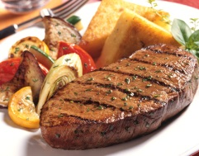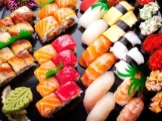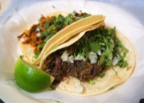
Ultimately, each group will prepare and post a single 1-2 page summary outlining your marketing mix (by December 13th at 9:00 a.m.).
The group project is worth a total of 50 points.
Potential of 35 Points - Group Grade (All group members will receive the same grade.)
Potential of 15 Points - Individual Grade (Based on instructor review of postings within the Discussion area. Individual postings will be assessed by noting the timeliness, level of contribution and effective participation of each individual group member.)

