Sales

- Identify and record the most current three years’ sales (in dollars) for both companies using their financial statements. Be sure the financial statements come from the company's annual report. Do not use statements provided by third parties, like Yahoo Finance or others.

Linear Technology Corporation (in thousands)

7/3/2016 | 1,423,936
6/28/2015 | 1,475,139
6/29/2014 | 1,388,386

Microsemi Corporation (in millions)

2015 | 1245.6
2014 | 1138.3
2013 | 975.9

- Using the data in question 1, predict both companies’ sales activity for the next two to three years. Hint: use trend analysis (Chapter 13). If possible, compare your predictions to actual sales figures for those years.

Shown on the Excel spreadsheet

- Use Excel to compute profit margin for both companies for the two most recent years. Comment on your findings.

Profit Margin shows on the Excel spreadsheet

For the Linear Technology Corporation, the gross profit remained similar in years 2015 and 2016. In 2015, the profit margin was 75.89%, while in 2016; the profit margin ratio only decreased about 0.03%. The Microsemi Corporation had a gross profit of 53.72% in year 2014. In the year 2015, the profit margin increased to 54.94%.

Linear Technology-Income Statement 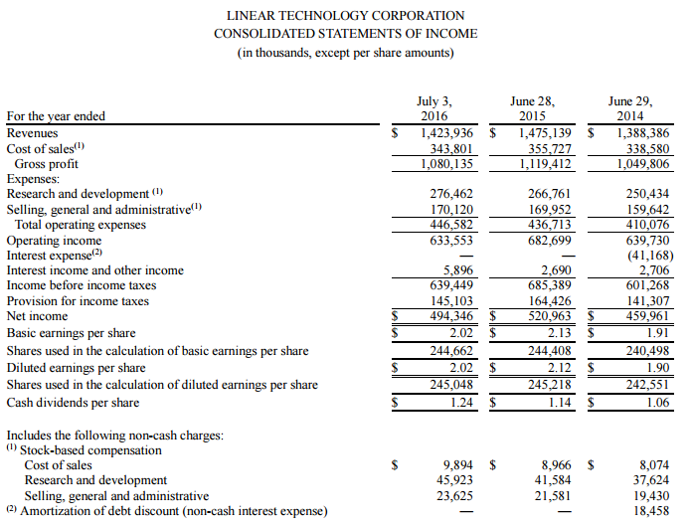

Microsemi Corporation-Income Statement
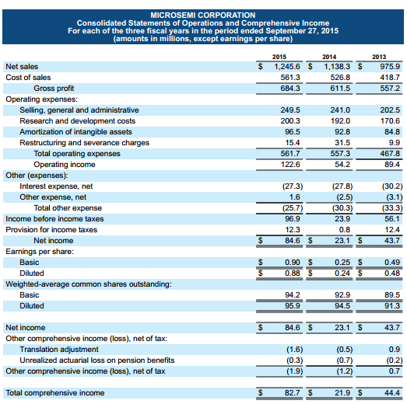

Cost of Goods Sold (COGS)

1.) Use Excel to compute the ratios of cost of goods sold to total expenses (see formulas below) for both companies for their two most recent fiscal years.

See excel document

2.) Comment on the similarities and/or differences in the ratio results across both years between the two companies.

Both companies experienced similar cost of good sold ratios (COGS) during the year 2014, but had slightly different ratios in 2015. During the year 2015, Linear technology experienced a COGS ratio percentage of 44.9% while Microsemi Corporation had a higher COGS ratio percentage of 50.0%. In 2014 the Microsemi Corporation had a COGS ratio of 48.6% while Linear Technology had a similar ratio percentage of 47.5%

3.) Which company has a higher ratio of costs, defined as COGS plus total operating expenses, to revenues?

The Microsemi Corporation had a higher ratio of cost during the years 2015 and 2014, with a ratio of costs equaling 90.2% in 2015 and 95.2% in 2014. Linear technology had significantly lower ratios of cost experiencing 53.7% in 2015 and 54.0% in 2014

4.) How might the use of activity-based costing help the less competitive company become more competitive?

The use of activity-based costing helps the less competitive company become more competitive by allowing the company to allocate the cost of its product with accuracy. If a less competitive company adopts Activity based costing they would have a more accurate dollar amount on their cost allowing them to better control their profit margin.

Linear Technology-Income Statement

Microsemi Corporation-Income Statement

Inventory

- Identify the impact on operating cash flows (increase or decrease) for changes in inventory levels (increase or decrease) for both companies for each of the three most recent years. Use Excel for your analysis. See Chapter 12-Reporting Cash Flows for review if necessary.
For Microsemi Corporation the inventory in 2012 was $ 159.1 million and the inventory increased in 2013 to $ 162 million. This is a 1.82% increase. This resulted in a cash outflow in the operating activities. In 2014, the inventory increase to $205 million. This is an increase in 27.16%. In 2015 the inventory increased in $ 227.5 million. This is 10.83%. All the above caused cash outflow in the company due to increase in the inventory. Nevertheless, there is an increase in the net working capital. So with the entire increasing inventory, there is a decrease in the cash flow translating to cash outflow.
For Linear Technology Company, the inventory in 2015 has increased to $ 99.861 million from $ 91.310 million in 2014. In 2016 the inventory reduced to $ 97.251 million. The decrease causes the net operating cash flow to increase.
- What impact would a JIT inventory system have on each company’s operating income? (Increase/Decrease/No Change and by how much? Explain!) Link this answer to your response in question 1 above.

Just in time (JIT) is an inventory management system, where the inventory to be used for production is purchased only when they are need or demanded. It provides an efficient system in terms of cost management as it does not require a firm to maintain inventory but only when the consumers place demands. In the production companies, demand is only sought after as is need for the production process. The challenge that faces the firms is do an accurate forecast for the demand to avoid shortfall.

Disadvantages
The main disadvantage is that a company faces the risk of production disruption and may reduce the supply when it is needed. If a supplier fails to deliver raw materials on time, it can cause the production of another manufacturer. Another disadvantage is the risk is in most cases the demand forecast cannot be done accurately.
The use of Just-In-Time inventory management will lead to a decrease in cost of production and holding stock cost. Due to lack of costs associates with holding stock, the cost of production will reduce. This will lead to increase in the gross profit and eventually there is increase in the operating profit.
- Would the move to a JIT system have a one-time or recurring impact on operating cash flow? (This is a theoretical question, but use one or both of your companies as an example in your answer. Explain!)

The Advantages over other conventional models is that a firm has short production runs and thus a company can change from one product to another without much hustle. It also reduced the storage costs of both raw material and finished goods as production is only on demand. Companies also spend less money on raw materials because they buy just enough to make the products.
It will thus have a recurring effect on the operating cash flow as it will reduce due to reduction in the inventory cost. If Microsemi Corporation shifts to JIT, the cost of production will reduce causing the reduction in the inventory cost and in the end there will be increase in the net cash flow from the operating activities and eventually an increase in the net cash flow for the firm.

Reference

Neil Kokemuller “Just in Time Inventory Definition”, Retrieved November 28, 2016 from the World Wide Web:http://smallbusiness.chron.com/just-time-inventory-definition-23475.html
FINANCIAL STATEMENTS

