FIN 310
11/22/2016

Carnival

Carnival Inc. (CCL) is engaged in operating of luxury cruise ships which is operating in the North America Cruise Brands, EAA Cruise Brands, Cruise Support, and Tour and Other. The North America Cruise Brands Segment include Carnival Cruise Line, Holland America Line, Princess and Seabourn. The EAA Cruise Brand Segment offers AIDA, Costa, Cunard, P&A Cruise (Australia). The tour and other segment comprises of hotel and transportation operations. The joint venture of Carnival Inc. with China state shipbuilding corporation and Italy based corporation has signed a non-binding memorandum of agreement to order the first Chinese-made cruise ships built for Chinese market. Further, the two ships will operate as part of a multi-ship cruise brand in China, with the first ship expected for delivery in 2022. The joint venture has the option of ordering two additional ships.
The table1 shows that Carnival Inc. has $462 million in excess cash to invest and company has the option to choose between the two investment option between Cash Deposit with checking accounting earning 1.75 per year with life of 6 years or Cash Deposit without fee with interest rate 5.25% (as shown in table 2). Based in this analysis below, if Carnival invested in Cash deposit without fee is the better option because it will have $628,021,631.20 million in six years, whereas if Carnival Inc. deposits the cash into a CD with checking account, it will only have $512,683,487.6 million in six years. Therefore, we recommend Carnival Inc. to choose the option-1 because it will earn $115,339,143.6 million more in the option two over the next six years. [Show calculations and/or charts below]
Table 2: Investment Options
Option -1 |  |  | Option -2
CD without Fee |  |  | CD withCheking Account
N= | 6 |  | N= |  | 6
I= | 5.25% |  | I= |  | 1.75%
PV= | $(462,000,000.00) |  | PV= |  | $(462,000,000.00)
PMT= | - |  | PMT= |  | -
FV= | $628,021,631.20 |  | FV= |  | $512,683,487.6

Table 1: Consolidation Balance Sheet
Further, Carnival Inc. needs $2.000 billion to invest to construct three new ships and it is assumed that Carnival Inc. cannot utilized its excess cash due to utilization of this cash on other places. Now, Carnival Inc. supposed to move towards “wells Farego” as it is providing low EAR (as shown in table 3 below). Further Carnival Inc. should move towards fully amortization option due to least amount paid by the company during loan life irrespective of the loan installments.
Table 3: Annual Effective Rate:
Below table 4 shows the detailed breakup of the loan with option of Fully amortization methods where Annual payments, Principal amount of payment as well as interest is mentioned.

Table 4: Fully Amortization method:
On the basis of the Carnival Inc. data taken from the SEC website form 10-K Forms predicts the company financial positon which is far better. Company is less dependent on the debts and company has net profit margin 11.18% which is not sufficient to meet the short term obligation where company should have focused. Beside this, company fixed assets turnover is 2 times of sales which means company can utilize its assets to increase production (data shown in table-5).

Table 5: Financial Ratios:
We analyzed Carnival Inc.’s CCL.GC143658AF9 bond issue. The bonds were issued on 04-01-1994 and mature 10/01/2023. The bonds pay a coupon rate of 7.20% and coupons are paid semi-annual. Each semi-annual coupon payment is $7.20. The bonds are callable at any time. The bonds are rated BBB+ (S&P) and Investment Grade (TRACE) which shows that Carnival Inc. has adequate capacity to meet its financial commitments. However, adverse economic conditions or changing circumstances are more likely to lead to a weakened capacity of the Carnival Inc. to meet its financial commitments. The bonds are currently trading at a premium with a current yield of 5.71% and the yield to maturity is 0.83% as the bond is selling more than its face value, therefore, it has premium values [Calculation are shown below].
Current Yield Rate:  Here, Annual Coupon payment is the benefit company paid to the bond holders and market price is the per unit bond price in market. As the coupon rate is higher than yield rate, therefore, bond will sell on Premium. | Yield to Maturity:  In YTM calculation, C is Coupon payment, F is face value of bond which is $1,000, P is the price of bonds, n is number of time period.

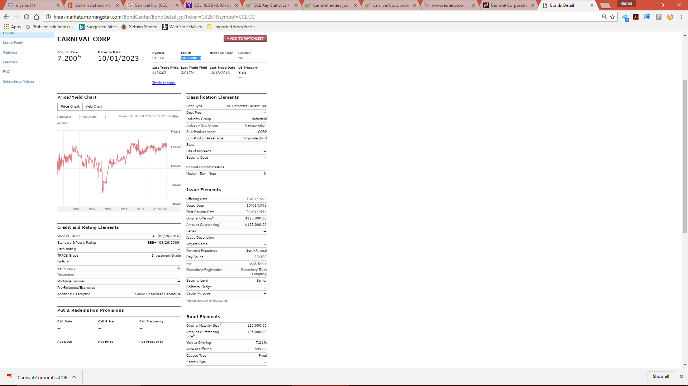
Further, if we analyze the Shareholder’s equity section of Carnival Inc. we will find that Carnival Inc. stock is currently trading at $49.82 with market rate of return is 11.82% , the risk free rate is 1.18% and the beta of the stock is 0.91 which shows that stock is risker. The Cost of Equity with CAPM approach is 10.86% [as calculation is given below].
Moreover, the last dividend paid on these share was $816 (M) and according to analysis it is expected to grow by 9.80% over the next five years the dividend will be:
In addition, the Price (P₀) based on Divided Growth Model when the growth is constant for 5 years.
And, if it is supposed that after 7 years the company growth declined from 9.80% to 7.5% then then the company share price (P₀) is calculated as under:
Based on the above scario, the stock value of Carnival Inc. is under value because the market rate is higher than issuing rate and the stock annual yield is more than its market rate. Hence, it is recommended that company should focused its sales revenue, production and expected earning growth and trying to increased.

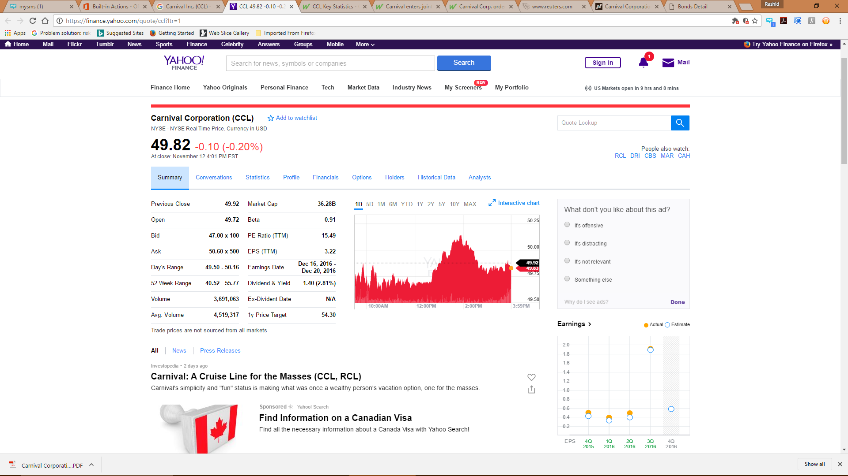

Beside this, as aforementioned, Carnival Inc. was to invested $ 2 billion in the construction of three new ships where company will sale per unit will be 1400 which will expect to grow 3% and company will pay the variable cost per unit $200 and fixed cost as well in the shape of administrative cost.
And, Carnival Inc. further Net Capital Spending, Working Capital and Operating Cash flows are hereunder:
The above analysis show the following statistics regarding NPV value, IRR, Discounted Payback period and Carnival Inc. Profitability index (P.I).

On the basis of the above analysis, it is can be predicated that as the Net Present Value of the new investment is less than "Zero" and the IRR is below than company WACC. Further, company profitability index is below than "1". Hence, it is recommended that Carnival Inc. should not invested in the new shipment.

