Hong Kong Business Manual
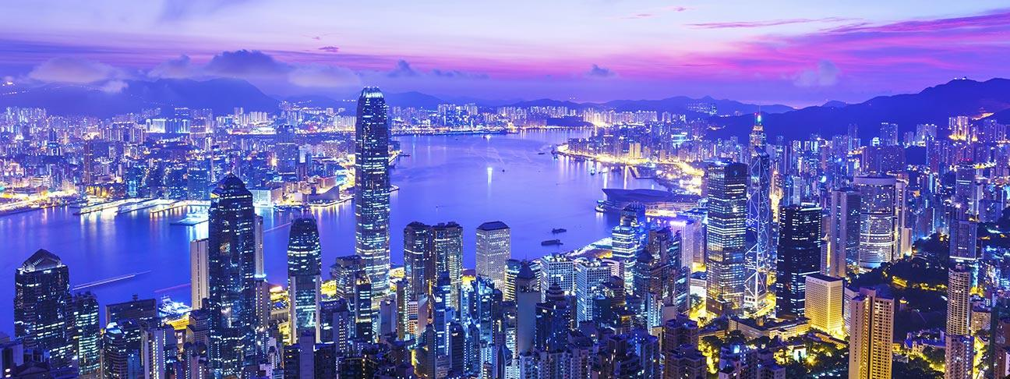

Overview of Hong Kong

Hong Kong has been a part of Britain for many years and was recently transitioned back into the control of China. Hong Kong is one of the largest areas of economic progress as well as success in Asia. Hong Kong has a huge population and is a beautiful area that has many natural resources that are a part of everything that happens with the world. Hong Kong is 1106 miles and has a population of over 7.3 million people. It is one of the most populated areas of the entire world for its size.

The area is also known for being one of the best areas of the world for finances and it is one of the world’s main financial centers. What that means is that it has an amazing economy and it is very attractive to people who come there from all over the world. The country a very competitive economy and also has the 13th leading currency in the world. In addition to that there is a very low tax rate which makes it one of the most attractive areas in the world for business. In addition to that, there is also another amazing thing about it in the fact that it is one of the leading locations as well for the legal proceedings and the contracts that are a part of all of the business transactions. This is also one of the largest economies in the world with the highest standards of living. There is a huge divide as well between the wealthy and the poor here.

Hong Kong also has an incredible harbor which is one of the things that has made it such an economic powerhouse. In addition, too that it has many of the highest high rises in the world. There is a very long life expectancy here as well as amazing public transportation which means that people are able to get around very easy and quickly and over 90% of the people who are in the region take advantage of the public transportation.

The Financial Center in Hong Kong

The area has one of the largest financial centers and it has been that way for thousands of years. It is the largest service economy in the world and it has very low taxes as well as a lot of free trade in the region. It has been one of the leading locations since the 19th century and that means that it is the largest and one of the most respected economies in Asia. Hone Kong also has a very important place in the IFC that has been important to them since the 1950’s. What that also means is that there are many ways that it has become a huge center of trade as well as one of the largest locations for companies to make their headquarters for many years. In addition to that there is a huge stock exchange in the area which continues to have about 22% of the total offerings in the world. It is known by all who travel to the region as one of the places where people go to raise money.

When it comes to the Hong Kong dollar it is one of the most traded currencies in the world and it has been a part of the dollar for many years. What that also means is that there is an establishment that ensures that there is a very real presence of capitalism in the region. However, there are very strict ways that everything also functions to ensure that there is a minimum standard of living. There is one of the freest indexes there in the world as well and there are many ways that the economy has continued to grow with unparalleled levels since the 1960’s.

International Trading in Hong Kong

Hong Kong continues to be one of the largest locations in the world for international trading and that means that there is a huge value of imports and exports out there. It also has the world’s largest re export center which means that there are many ways that it will be able to continue to have a great way to trade with others. There are many things about tit too that with its location as it is part of China that allow it to be one of the busiest ports and also ensure that there is a very busy place for all of the cargo that will go in and out of this location. Hong Kong has a huge trade network and there are also many places where all of the investment from China is going. Since 2007 there have been over 3.46 million people who are working simply in the area.

Tourism in Hong Kong

When it comes to the tourism that is out there it is one of the most popular locations in the world. There are over 27.8 million people who come to the location every year and there are many revenues that come in because of the tourism. What that also means is that tourism continues to be one of the best industries in the world. It remains one of the most popular cities for people all over the world to visit and continues to delight people who come.

Hong Kong is also one of the most expensive cities in the world for people who move there from other locations. It also has some of the richest families from all over the world. Hong Kong also has the highest number of billionaires who live there right behind Monaco. Hong Kong continues to be one of the number one locations in the world as well for the economy.

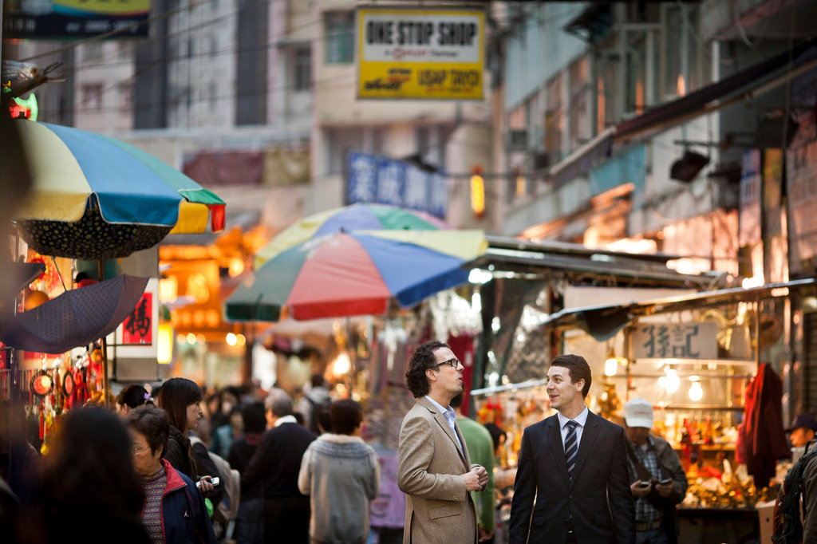

Policies in Hong Kong
When it comes to the way that the government has played a role in the lives of the people it is important to see that the lives of the people have very little policy that has affected them. There is almost no kind of regulation and that means that it is possible to see Capitalism at work in an amazing way. When it comes to the way that the market works it has become capitalized very quickly and that means that there are many places that are driven by imports and exports and it continues to be a center of transition that has a huge service base. It has been known as a center for finances, IT, consulting, and all kinds of professional services all over the world.

Labor Force in Hong Kong
The labor force in Hong Kong is one of the best and most professional in the world and that means that some of the best talent from all over the world comes to Hong Kong to work. With some of the best salaries out there, people come to Hong Kong for the best salaries as well as the best benefits. Some of the best schools in the world are also available there and that means that there is a great quality of life for many people who are there.

What is the Lifestyle Like in Hong Kong?

The lifestyle in Hong Kong is relatively relaxed and that means that it is very possible for people to be very happy with the result. There is a work week that is between 40-60 hours completely dependent on the lifestyle as well as the career choices that are made for everyone. There are not too many holidays that are celebrated across the board which means that there are many people who are able to have access to business on a regular basis.

II. Doing Business in Hong Kong
When it comes to the systems and the market they are completely open which means that it is possible to see capitalism in action in a way that is not normally able to be seen by many people. The market is an amazing thing that has leant itself to becoming one of the largest in the world.

Hong Kong Foreign Investments
When it comes to foreign investments it is very important to know what the currency is. It is the Hong Kong dollar which means that there is going to be a continued trade in the market as it is one of the best choices out there for investment. In addition to that it is ranked the 8th best currency in the world.

There are many locations as well for site selection as well as for incentives that will mean that it is possible to ensure that there will also be a great way to ensure that there is the right location as well as the right choices out there. When planning all of the options that are out their options that are available ensure that you will be able to find the best location for business and know that it is possible to have choices that will be perfect for business.

Labor and Employment in Hong Kong
There are many things about the economy of Hong Kong that are perfect for industry and that means that there are many new people who are coming from all over the world to be a part of the market every year. When it comes to people who are in the market there are many things that need to be considered such as what is the industry and what is the climate like. There is an average growth of the entire market around 20% per year.
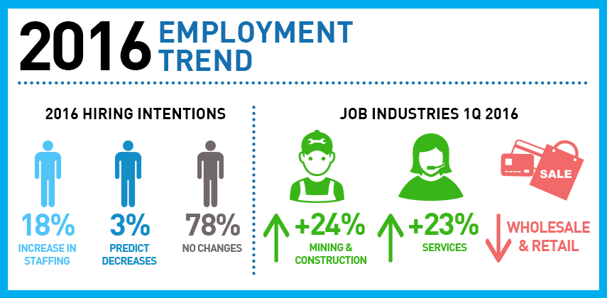
There are NO limitations on exports and imports which means that it is necessary to see the way that things play out in the long term and that companies are able to have access to many new options that will continue to empower companies to succeed in the environment.

Part III. Business and Cultural Environment
When it comes to the business practices in Hong Kong they are an interesting mix of eastern and western which means that it is important to see how everything fits together. When it comes to the choices that are made in business it is important to see that there are many customs that need to be adhered to so that it is possible to have access to the best choices. When it comes to the choices it is important to know that you are going to be able to meet all of the expectations out there so it can also be the choices that will empower the companies.
What is Appropriate Conduct in Hong Kong?
In Hong Kong, it is important to see that there are many choices that are out there that need to be made when adhering to the customs. That means that it is necessary to be able to be a part of the business and trade associations that are there because it will continue to empower as well as to help your company to find its footing in a new environment. In addition to that, it is also very important to make sure that there is going to be an adherence to the entire process as well to ensure that there is acceptance in the process of being in business in such a location. What that means is that appointments must be strictly adhered to so that timing is something that will always ensure that people are on time. In addition to that it is very important to make sure that there will also be practices that are also very strictly followed.

When it comes to the cultural influences that are out there it is important to ensure that you are able to be a part of everything that will help the practices of the country that you are living in. Hong Kong is a unique mix of east and west and there is a very large British presence as well as a Chinese presence that is a part of the equation which means that it is important to ensure that all of those dimensions are considered when doing business there in the country.

What is Religion like in Hong Kong?
When it comes to religion there is a very large mix of people there and that means that it is necessary to make sure that religion is kept relatively personal and quiet. That will ensure that there is no conflict of interest and will also help to have a very diverse work environment that will continue to empower as well as to help others of different faiths to be a part of the environment.

Hong Kong is one of the most diverse countries in the world and it is very important to understand the way that it works out and how all of these elements come together to create a very powerful statement about who the country is and how things fit together. There are many powerful elements in Hong Kong that lead it to being one of the best places in the world to do business and that guarantee that there will be a continued long term presence in the country.

It is a very special location as well that makes it possible for others to do business as it is very welcoming to the western world. When looking at this as a location for success there are many things about it that guarantee that this will be a location of choice for many years to come.

References
Davies, Howard, et al. "The benefits of “Guanxi”: the value of relationships in developing the Chinese market." Industrial marketing management 24.3 (1995): 207-214.
Ralston, David A., et al. "Doing business in the 21st century with the new generation of Chinese managers: A study of generational shifts in work values in China." Journal of international business studies 30.2 (1999): 415-427.
Ralston, David A., et al. "Differences in managerial values: A study of US, Hong Kong and PRC managers." Journal of international business studies24.2 (1993): 249-275.
Ralston, David A., et al. "Doing business in the 21st century with the new generation of Chinese managers: A study of generational shifts in work values in China." Journal of international business studies 30.2 (1999): 415-427.

