Physical -Scanner Used to Dispatch Police -Networking Communications from Police Vehicle
Evidence -University Police Providing Assistance -Pro-Lok
-University Dispatcher Checking Police Report -Hard Copy of Police Report
-University Police Car
Customer Calls in a Report or Requests Assistance.

Caller Gives Officer Statement
Caller Greets Police Officer

Customer

Line of Customer Interaction
Officer Types Police Report and Submits Electronically

University Police Arrive at Scene
Officer Take Corrective Action

Contact (On Stage)

Person (Back Stage) Line of Visibility
Dispatcher Receives, Checks, and Distributes Copies of Report
M - F 7:30 AM – 4:30 PM University Police Dispatcher Answers Phone
University Police Are Dispatched

M – F 4:30 PM – 7:30 AM and Sat. and Sun. City of Troy Police Dispatcher Answers Phone
Support Line of Internal Interaction
Process

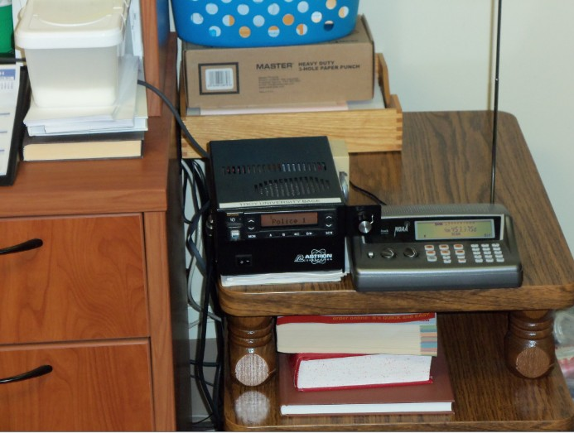
Scanner Used to Dispatch Police

Back to Blueprint

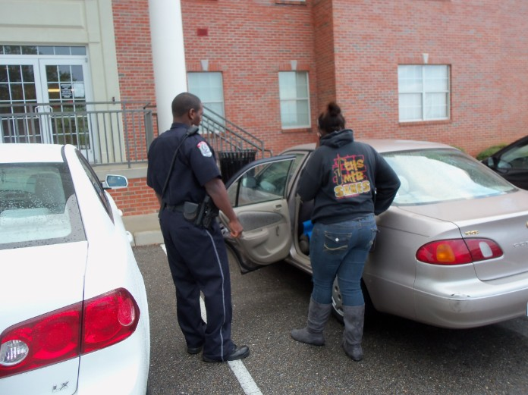
Back to Blueprint
University Police Providing Assistance
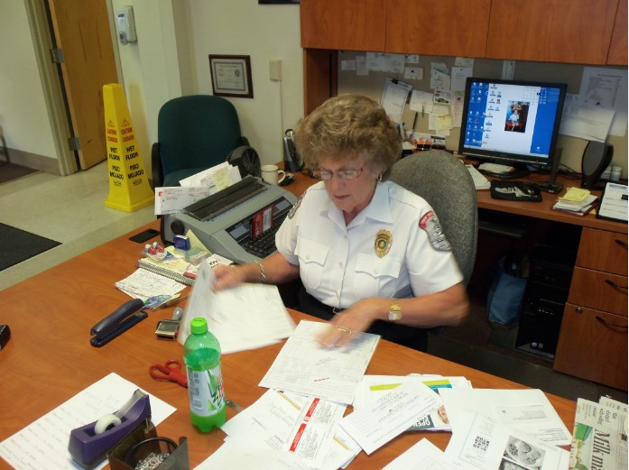
Back to Blueprint
University Dispatcher Checking Police Report

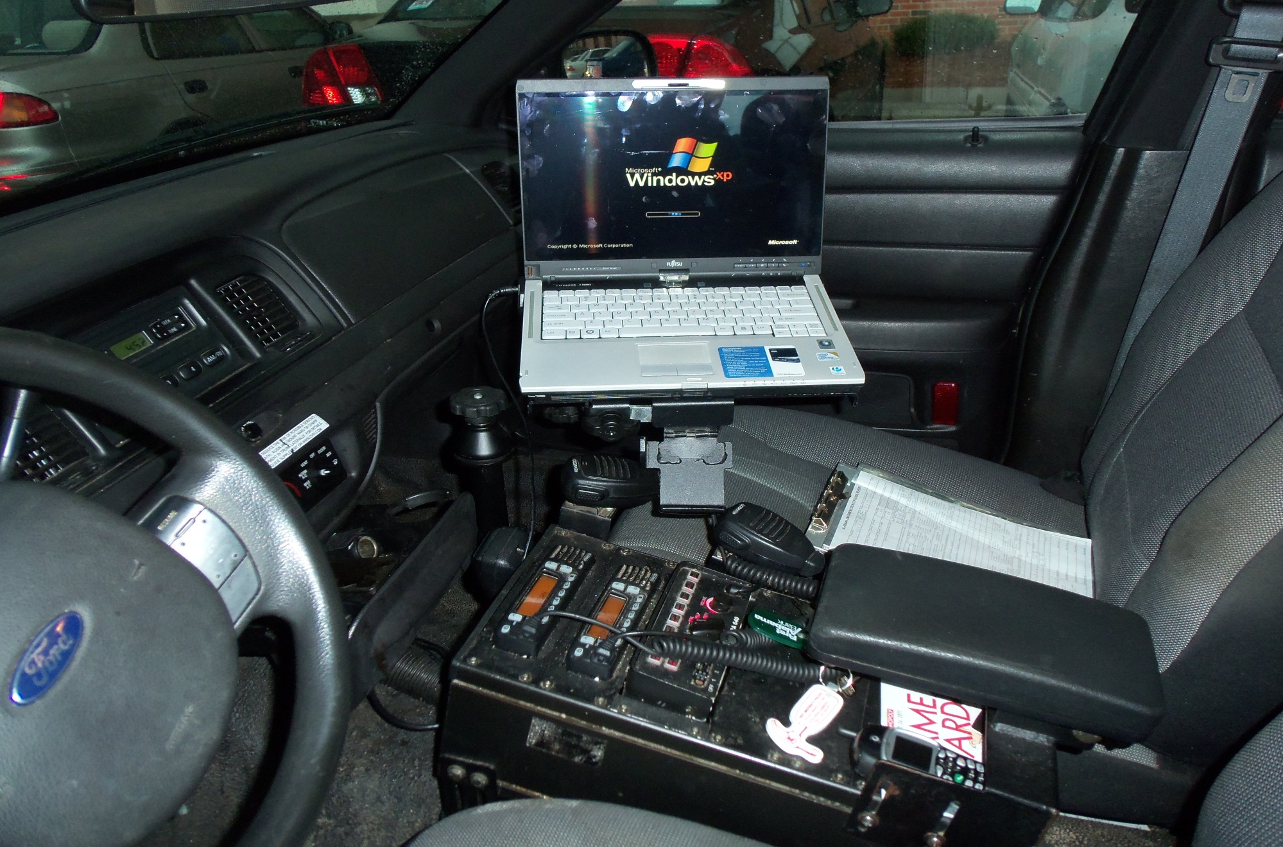
Back to Blueprint
Networking Communications from Police Vehicle
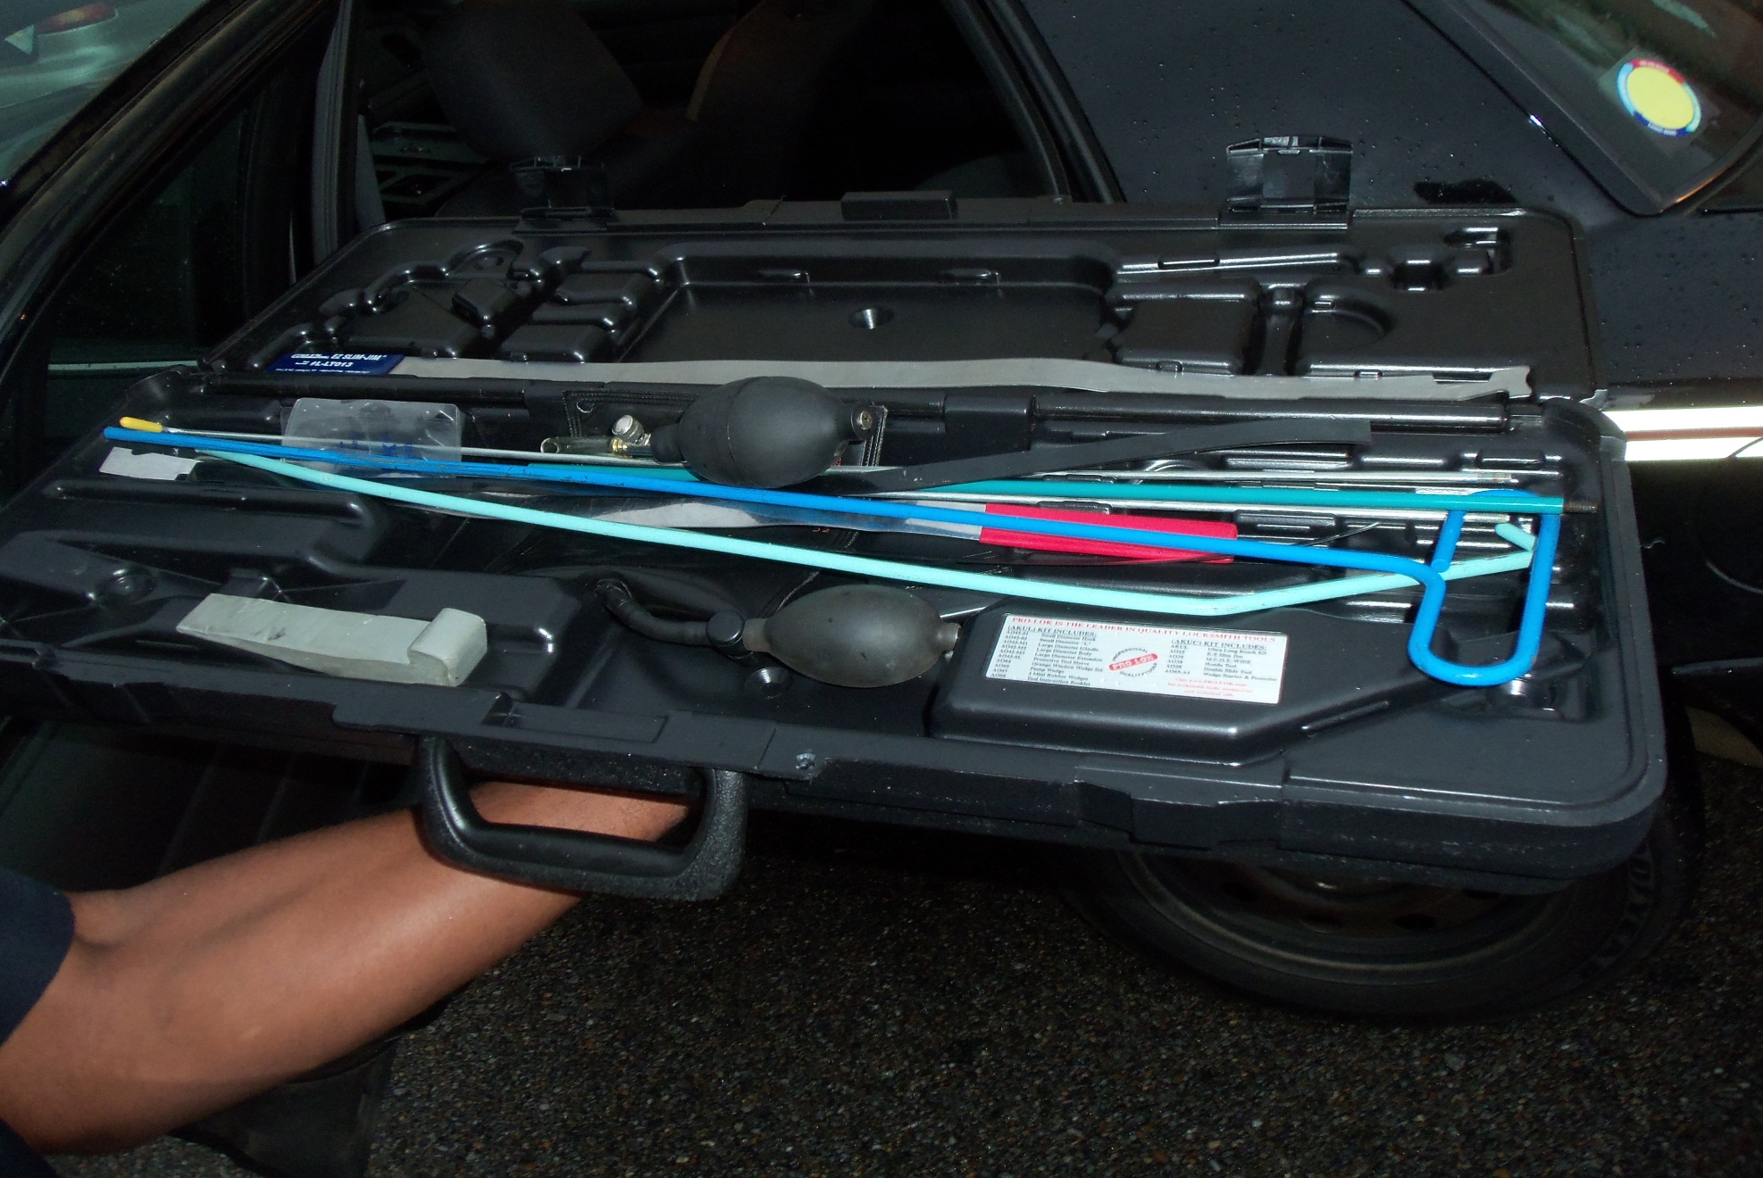
Back to Blueprint
Pro-Lok
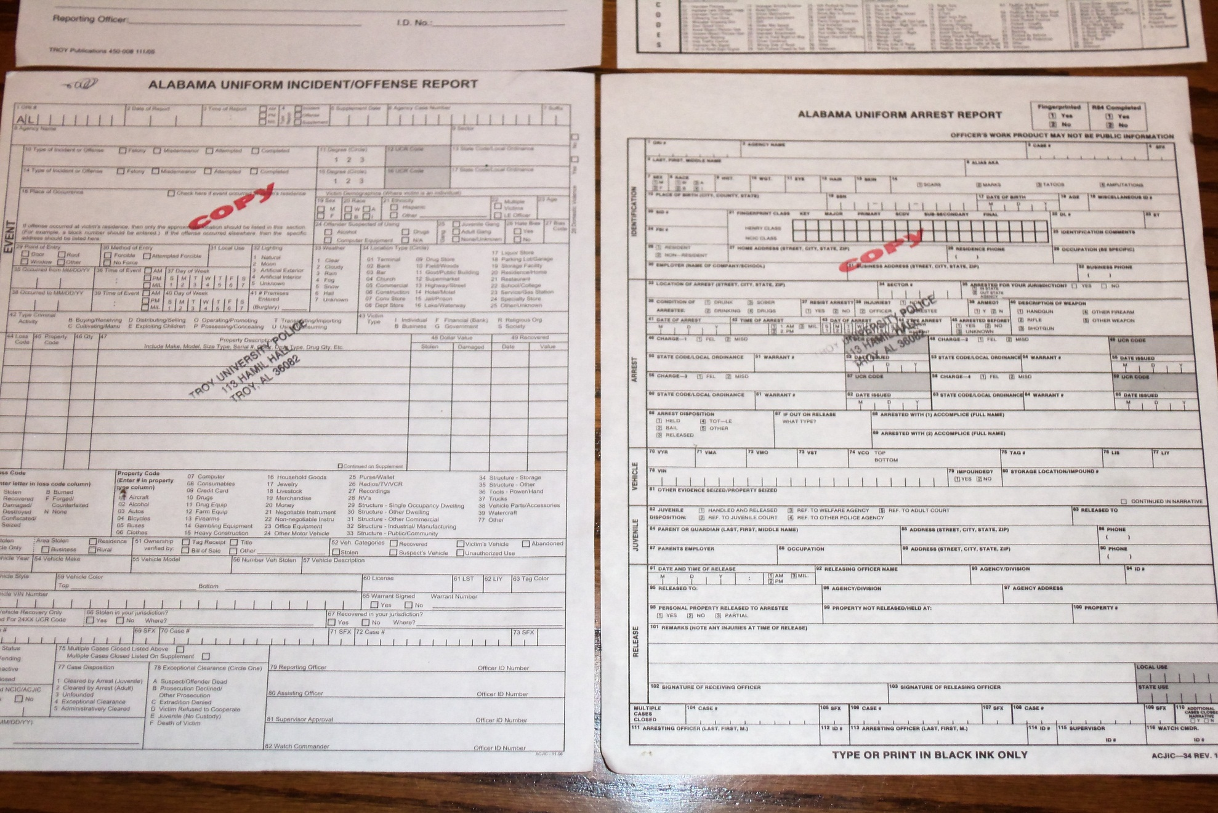
Back to Blueprint
Hard Copy of Police Report
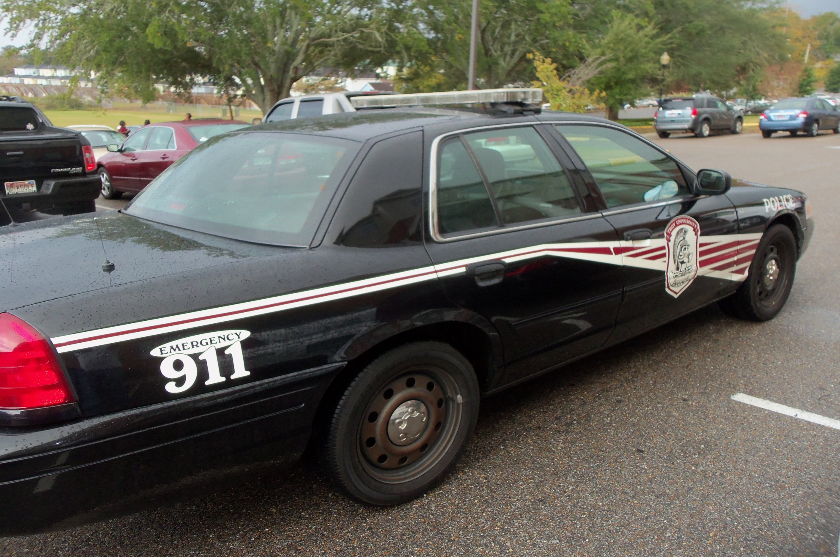
Back to Blueprint

