Why Rwanda?
1. Economy
During the financial year of 2014-2015, ICT segment has kept on energizing the Rwanda GDP development with a commitment of up to 3%.
Three years GDP development rate one of the most astounding among real African economic system and adjacent countries.
Rwanda is a versatile, advancing-looking nation with a dream to lift to a center wage, administration and learning supported economy by 2020. Their accomplishments amid this period incorporate; Flourishing the economy at a normal GDP of 7.5% and they go for accomplishing 12% from 2013 - 2016. The growing of the GDP per capita in 2013 $693 from $644 in 2014, a three crease increment from 2000. Their GDP target is $1,140 by 2017. Rwanda's uninterrupted operation is determined by the development of the management area. The part gives around 40% of GDP contrasted with 30%, and 14% chipped in by agribusiness and mechanical areas individually. Inflation in have been maintained at a solitary value from 2008(Barro,2013). Fitch Ltd puts Rwanda's Credit rating at B with an inspirational viewpoint, referring to stable financial development over the previous years and prospects for more grounded development
2.Robust management
According to Transparency International Index 2015, it gave the following values for Rwanda
In East Africa – least corrupt country (Cuervo-Cazurra, 2016)
• In Africa-third
• 44TH on the planet.
3.Financial friendly market
According to WEF Global Competitiveness Report 2016
Rwanda has the most focused place to work together in Africa – third
It takes about 6hrs to enlist a business and maximum of 5 days to setup all procedures required with least procedures.
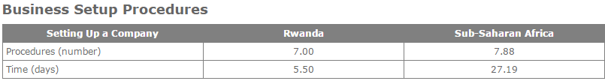
FICO assessment by Fitch appraisals in 2016. Rwanda's Fitch rating is upheld by strong financial approaches and a reputation of auxiliary changes, macroeconomic strength and low government obligation.
Rwanda's Fitch rating is sustained by strong financial approaches and a reputation of basic changes, macroeconomic steadiness and low government debt (22.8% of GDP)
(Gigineishvili,Mauro & Wang, 2014).
4. Access to business sectors
Nearby market of more than 11 million individuals with a quickly developing white collar class(Bundervoet, Maiyo & Sanghi, 2015)
A center for quickly incorporating East Africa: found midway flanking three nations in East Africa, some portion of EAC Common Market and the Customs Union with a market capability of more than 125 million individuals.
5. Investment in ICT
The essential duty regarding drawing in FDI and Communication Technology in Rwanda depends with the ICT office in RDB. Remote Direct Investment was assessed at US$ 110 m in 2013.
LPI analysis
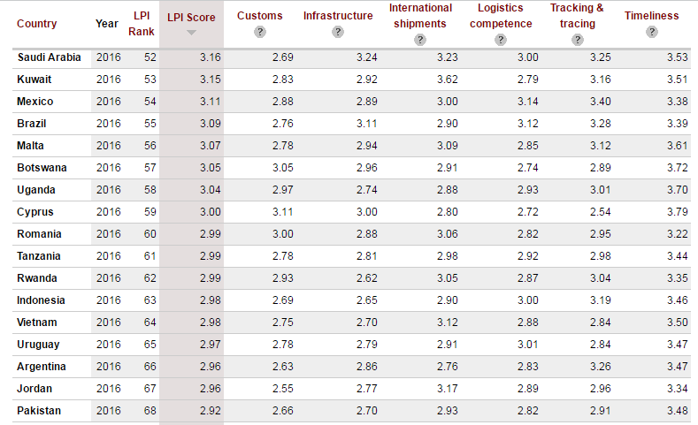
Contrasting Rwanda and different countries on the planet, considering the strategic ability, there are better open doors in Rwanda contrasted with different nations in the district. Same condition for the following merchandise to be conveyed by delivery companies and opportuneness highlight as an essential component for us for time overseeing(Richardson, 2016).

The Information and Communications Technology Department

The ICT Office has the command to encourage and bolster improvement of Rwanda's ICT part towards changing into an ICT center for the district(Uwitonze & Heshmati, 2016). The principle duties of the ICT office are:
Center responsibilities ZTE will contribute in Rwanda
ZTE is an all inclusive driving supplier of Communications and ICT arrangements and has been working in the administration administrator and private system showcase for more than 20 years.
•Taking the Lead: As the administration establishment that most optimized plans of attack Rwanda's improvement, ZTE will initiate Rwanda's advance toward building a develop, information-based economy. ZTE proactively seeks after the most pressing difficulties preventing Rwanda's ICT intensity and guarantees that the most elevated esteem openings are caught by(Mascagni,Monkam & Nell, 2016).
•Laying the Foundation for Economic Growth: ZTE concentrates on creating and conveying the basic ICT framework with the aim to establish the framework for maintained financial development.
•Building a Hub of Information and Communication Technology: ZTE will lead the endeavors to build up Rwanda as a territorial center point for data and correspondence innovation (ICT) with a hearty ICT industry, including and to encourage web-based business, e-administrations, applications advancement, and computerization. ICT will be bridled to create riches and be a key financial driver.
•Contribute to ICT Policy Formulation: ZTE will lead Policy definition, coordination, and execution for other division improvement and monetary growth. Its need is strategy support and guaranteeing that the best arrangements and practices are set up and embraced to encourage private segment advancement.
•ZTE company can vigorously develop in this department by Catalyzing the improvement of the ICT area for financial development. Encouraging the sending of ICTs to empower development in different parts. Pull in, change over and bolster usage and development of nearby and remote private interest in ICT segment. The Ste contraption can likewise answer for the issues confronted in correspondence innovation of Rwanda.

