Final Project Management Plan
Joshua Patterson, Kayla Peacock, Ray Brooks, Tasha Jones, and
Toni Kimble
CPMGT/305 - Project Management Capstone
Tuesday, November 22, 2016
Dr. Gary Denney

PROJECT PLAN OF FLIP MY HOUSE
Project Background:
The company decided to function in the real estate, therefore, the selection process for the project involves considering various factors associated with the project, using selection criteria to select the project that is most in-line with companies’ goals, and approving the project to be implemented by an enterprise. The project selection board in this scenario applied these criteria in the process of deciding to enter the real estate market to buy, improve, and sell houses for a profit. At last, the project is initiated titled “Flip My House”.
Project Scope Statement:
The scope of the project includes the purchase of a 4 bedroom, 31/2 bathroom, and 2 car garage house to be restored and resold in a 26-week period at a cost not to exceed $ 400,000. The project involves the purchase, renovation, and selling of a house in the current market. The estimated time of completion for this project is 26 weeks, including any permits and improvements to the structure.
Work Breakdown Structure:
The scope of the project will be divided into the manageable task. The work packages and the milestones of the project are defined in the WBS which is attached at the end of the report. Initially, the project is a breakdown in these steps. The first step involves the project initiation phase that includes the designing of a project plan, hiring the project team, predicting the estimated budget, sourcing for the project resources, as well as project approval. The other deliverables involved in this project include taking an inventory of needs, selecting a house for purchase, paying all associated fees, renovating the structure and adding on if necessary, advertising and marketing the house for purchase, and closing out the deal with a sale and a profit. After the house is sold, all documentation must be noted and listed for assistance with future sales.

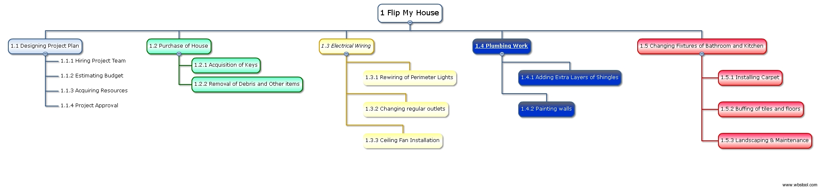

Final Budget Plan

Deliverables | Estimated Cost ( in dollars) | Actual Cost ( in dollars)
Purchase of House, taxes, and permits | 330,000 | -
Removal of debris and other existing structures | 800 | -
Wiring and installations of perimeter lights, 8 safety outlets, and 2 ceiling fans | 1,700 | -
Plumbing in master bathroom fixing leak and 2 sprinklers | 1,100 | -
Roof addition of 500 shingles @ $1.25 a piece plus labor | 1,000 | -
Make-ready Interior touches:  - Paint interior and exterior walls using 4 gallons white and 4 gallons assorted colors on the interior and 6 gallons on the exterior.  - Add 100 cu. ft. of insulation to attic  - Change out fixtures in all bathrooms and kitchen like faucets/sink and light covers  - Install carpet in living room and master bedroom a total of 850 sq. ft. @ $1.25 plus labor  - Buffing of existing tile and wood flooring | - 1,200  - 200  - 2,500  - 1,500  - 400 | -
Total Investment | 362,500 | -
Contingency fund and Projected Utilities for 26 week period
Contingency fund @ 5% of total project for unexpected disasters  Expected lawn maintenance for 26 week period after initial cut | 20,000  1,000
Electric usage throughout renovation and following months until purchase. Figure based on 26 week duration. | 1,000
Water consumption based on 26 week duration | 400

This project budget was estimated for the purchase, renovation, and resale of a 4 / 3.5 / 2 house, within a period not to exceed 26 weeks or a cost of $ 400,000. Using a cost- benefit analysis to estimate time and materials allowed the project to have enough planning room, provide padding for future utilities and lawn maintenance, and a contingency fund for unexpected events. The result is an estimated $37,500 stakeholder reserve to be used at the stakeholders’ discretion for major project needs.

Gantt-Chart View

Task Name | Duration | Start | Finish | Predecessors
Flip My House | 138 days | Thu 12/1/16 | Mon 6/12/17
Designing Project Plan | 5 days | Thu 12/1/16 | Wed 12/7/16
Hiring Project Team | 5 days | Thu 12/8/16 | Wed 12/14/16 | 2
Estimating Budget | 6 days | Thu 12/15/16 | Thu 12/22/16 | 3
Acquiring Resources | 10 days | Fri 12/23/16 | Thu 1/5/17 | 4
Project Approval | 3 days | Fri 1/6/17 | Tue 1/10/17 | 5
Purchase of House | 20 days | Wed 1/11/17 | Tue 2/7/17 | 6
Acquisition of Keys | 2 days | Wed 2/8/17 | Thu 2/9/17 | 7
Removal of Debris and Other items | 17 days | Fri 2/10/17 | Mon 3/6/17 | 8
Electrical Wiring | 23 days | Tue 3/7/17 | Thu 4/6/17 | 8,9
Rewiring of Perimeter Lights | 10 days | Fri 4/7/17 | Thu 4/20/17 | 10
Changing regular outlets | 13 days | Fri 4/21/17 | Tue 5/9/17 | 11
Ceiling Fan Installation | 7 days | Wed 5/10/17 | Thu 5/18/17 | 12
Plumbing Work | 25 days | Fri 2/10/17 | Thu 3/16/17 | 8
Adding Extra Layers of Shingles | 20 days | Fri 3/17/17 | Thu 4/13/17 | 14
Changing Fixtures of Bathroom and Kitchen | 17 days | Fri 4/14/17 | Mon 5/8/17 | 15
Buffing of tiles and floors | 11 days | Tue 5/9/17 | Tue 5/23/17 | 16
Installing Carpet | 3 days | Wed 5/24/17 | Fri 5/26/17 | 17
Landscaping & Maintenance | 11 days | Mon 5/29/17 | Mon 6/12/17 | 18

