Comparative Analysis of Hospitality Firms: Case of Hilton and InterContinental
Insert Name Here
University Affiliations

Introduction
The hospitality industry is one of the biggest and fast growing industries in the world. It has a higher impact on the economic growth of any country. Business and leisure can be the reasons for this industry to grow more. The contribution this industry injects in terms of investment is enormous in any country and as a result it’s everyone endeavor to ensure quality service delivery is offered to the customers at all time.

In this report we are going to analyze the vision, mission and strategic objectives of Hilton and Intercontinental hotel, highlighting on the effects of transactional processing system on the organization through SWOT analysis of both hotels. Core competitive strategies that are used by both companies will be discussed.
Analysis
Hilton Worldwide
Hilton Worldwide is an American based multinational hotel that is owned by Blackstone group. It is one of the largest hotels in the world with over 90 different countries, more than 4000 hotels and more than 650,000 rooms all over the world. It has been rank in the top 50 companies that are doing well in terms of revenue. Both the management and the employees at Hilton Worldwide are working together towards achieving the hotel's mission. The hotel is currently having more than 150,000 employees in all their branches worldwide. In the financial year 2015, the company earned revenue of up to US$10.783 billion. The financial position of the company is stable showing that the company is performing really well. It is trading in New York Stock Exchange where it has very broad and extremely high market share in the security market (Hilton Worldwide, 2016).

Hotel Name | Hilton Worldwide
Headquarters | McLean, Virginia, United States
CEO | Christopher J. Nassetta
Total number of employees | More than 150,000
Total number of rooms | More than 650,000
Number of branches | More than 4000
Number of countries it operating | More than 90

Intercontinental
Intercontinental Hotels was established in 1946 in the United Kingdom. This was founded by the Pan America Airways founder Juan Trippe as part of PanAm. The hotel which is headquartered at Denham has over 742,000 rooms and more than 5,000 hotels in about 100 countries worldwide. Some of its brands include Candlewood Suites, Crowne Plaza, Even, Holiday Inn, Holiday Inn Express, Hotel Indigo, Hualuxe, InterContinental and Staybridge Suites (Intercontinental Hotel, 2016)
Hotel Name | Intercontinental
Headquarters | Denham, United Kingdom
CEO | Richard Solomons
Total number of employees | More than 160,000
Total number of rooms | More than 742,000
Number of branches | More than 5000
Number of countries it operating | More than 100

- Comparative analysis of vision, mission and strategic objectives
  - Vision
The vision of Hilton Worldwide is to fill the whole earth with nothing but light and warmth of hospitality through delivering outstanding experiences in all their branches and for all their guests at all the time. Their vision and mission are rooted in their clients, founders, and employees who are the key stakeholders necessary to propel the company to the next level (The CareerBliss Team, 2012) (Eggleston, 2012).
They are gender sensitive and have female employees of up to 33% in all their worldwide hotels. Their values include; Integrity, Attitude, Innovation, Respect, Passion, Ownership, Recognition and Teamwork (Best Companies, 2015).
1.2 Mission
Hilton Worldwide is founded in its mission that it is trying to perfectly achieve every day. Its mission is to be the most hospitable company in the world through the creation of warm experiences for their clients and great opportunities for the entire team while having high value for owners and impacting the community positively.
InterContinental Hotel’s mission is to create hotels that guest love. Their vision is to build the strongest operating system in the hotel industry that is aimed at the biggest markets and segments where matters scale

  - Strategic Objectives
For any organization to achieve its goals and meet their customers’ needs, they need to have good strategic objectives. Strategic objectives are a combination of three processes which analyze the company’s goals, making decision on those goals and action plans to realize this objective.
Hilton Worldwide has the main objective of ensuring that its growth continues every year. Between 2007 and 2012, Hilton Worldwide recorded a growth by a third as compared to its previous status. Its main goal right now is grow by another one third by 2017. This will be realized through value addition by the introduction of transaction processing systems that will enhance quality service delivery. Focus on customer service and well-groomed employees, expansion into new markets and introduction of new products and services to give customers a wider range to choose from
Intercontinental Hotel has a strategy for high-quality growth that will strengthen the available diverse portfolio of their different brands. It aims at building scale in major markets and creating a strong relationship with guests—a relationship that will last for a lifetime. The achievement of the strategy is through the technology and third-party owners.
- Evaluation of transactional processing system using the SWOT analysis
The aim of transactional processing system is to define and discover the strength, weaknesses, opportunities and threats of a business and what’s surrounding the business. After completing this analysis the company or organization will be able to define what can be affect the delivery of service and the future impact. It’s therefore important for a company to undertake this analysis

  - SWOT analysis of Hilton Worldwide (Peng, 2012);
Hilton Worldwide
Strengths | Weaknesses
- Brand recognition  - Innovation in service delivery  - Low employ turnover  - Wide range of products to cater for everyone’s need  - Vast experience and prowess in the hospitality industry | - Low market share  - Frequent and unnecessary strikes from the staff  - Poor management of their supply chains

Hilton Worldwide
Opportunities | Threats
- Emerging markets  - Customer based innovations  - Advancement in technology and digitalization  - Increase in the number of tourist  - Diversification of their services in events holding and organizing | - Increased competition  - Economic and political turbulences  - Unfavorable industry regulation

  - Intercontinental SWOT analysis
Intercontinental SWOT analysis
Strengths | Weakness
- Strong distribution and sales network  - Highly skilled workforce  - Rapid expansion growth  - High turnover  - Market leader in the industry | - Challenges of accessing funds for expansion  - Low credit score  - Unstable cost structure  - Reduction in profit projection as a result of obsolete products
Opportunities |  | Threats
 | - Room for venture capital  - Wide market | - High cost of production  - Financial challenges for expansion  - Expensive technological advancement  - Price volatility  - Stiff competition  - Increased inflation that has erode the purchasing power of customers

- Five forces analysis
Porter’s Five Forces is an important model having five angles which are vital for a company. The new companies mostly use this model to assess how effective they are in the market as far as expanding their operations is concerned. 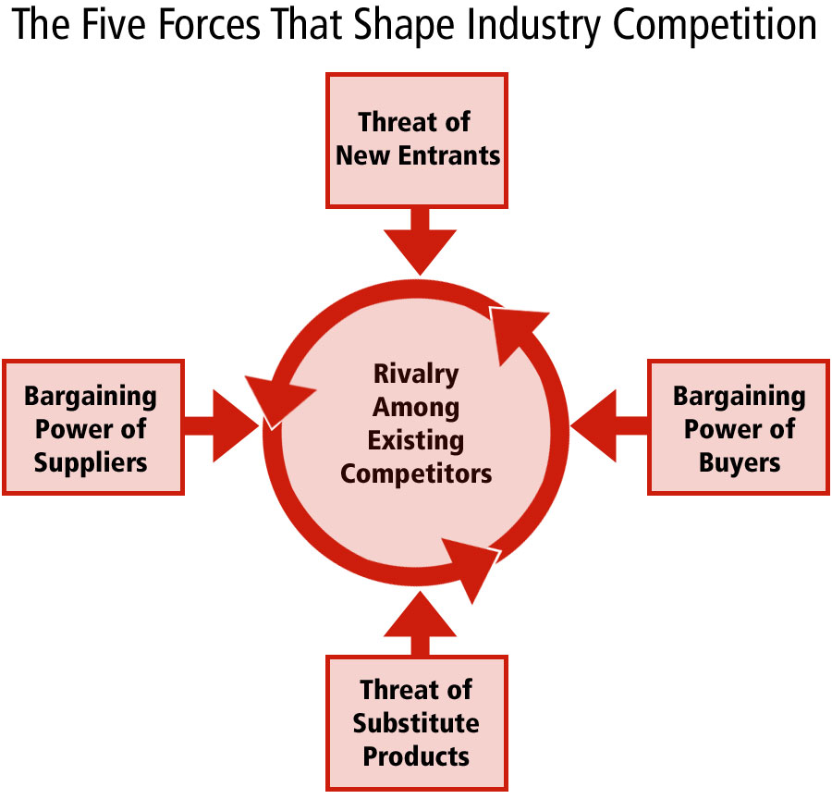 This model has the tendency of analyzing the company’s expansion strategies (Eggleston, 2012) (The CareerBliss Team, 2012).
  - Competitive Rivalry
Competition has increased in all the fields and the growth in technology has even made it increase as there are so many technological elements that attract customers. Being in the hospitality industry, Hilton and Intercontinental are real competitors. Hilton has been in the industry for 9 decades while Intercontinental has been on the market for 7 decades. As a matter of fact, these two hotels have built their brand. They are two big brands that everyone is talking about. The proportion of rivalry between these two hotels is at high stake. They have same standards. This means one would have difficulties choosing whether to go to Hilton or to Intercontinental. They operate in almost the same countries. Hilton operates in more than 90 countries while Intercontinental operates in almost 100 countries. This means in every country that you find Hilton Worldwide, InterContinental Hotel must be present. Both hotels must keep their current status constant in order to counter the competition. They should also maintain the mechanism in order enhance their productivity. In summary, it can be said that the two companies are giving each other very stiff competition in order to outcompete the other (King, 2008).
  - Bargaining power of customers
The customers are the end users of the services and products offered by an organization. The provision of the customers is very vital and extremely important as far as the growth of an organization is concerned. When there is weak and unsatisfied customer base in an organization, it becomes difficult for the organization to grow at the required pace. Due to the current technological world, most companies are perfecting their areas of specialization while at the same time providing customer satisfaction services. Due to the saturation of the industry, it is paramount to have a very strong customer base system. Hilton Worldwide has a very strong customer base with all its activities customer-centered. This is the same case with Intercontinental Hotel which offers quality customer services making them retain their already existing customers. The two companies have a very strong power of customer bargain that has enabled them to remain relevant in the industry for so many decades. Due to the fact that customers can either choose Hilton or Intercontinental to satisfy their needs, every hotel has to have higher customer bargaining power. Hilton and Intercontinental both have perfect brand recognition and customer base. For their growth and competition to win even more customers, these companies should try to pay very keen attention towards the customers (Hilton Worldwide, 2016) (Best Companies, 2015).
  - Bargaining power of suppliers
In every organization, suppliers are one of the most important stakeholders, especially for these hospitality organizations because they require their products and raw materials regularly. Hilton has its headquarters situated in the United States while InterContinental’s headquarters is situated in the United Kingdom. These are countries where getting the suppliers is not difficult because there are a lot of suppliers who are operating in different countries and are willing to supply the companies with as much products as they want. Because of this reason, these two companies have noticed very lower bargaining power from the suppliers. This is an effective sign for these companies.
  - Threats of substitute products
The level of competition in the hospitality industry is ever increasing. Hilton and Intercontinental Hotels are of same class, offering same quality services; this is making each hotel to face very high threats of substitute products. For instance, in the absence of Hilton, Intercontinental will satisfy the customers’ needs perfectively and at the same time, if Intercontinental is absent, Hilton Worldwide will satisfy the needs of the customers perfectly. These two companies, therefore, are a substitute for each other but in the event that one becomes weak even for a day, all the customers will find their way to the alternative hotel. They should be careful and raise or maintain their standards while at the same time paying attention on what others are offering so as not to be left out (LLC Books, 2010).
  - Threats of New Entrants
There are two barriers present for new entrant that is entry and exit barriers. Barriers to entry in initiating and establishing a company in the hospitality industry are very low. This is not an effective sign of both Hilton and Intercontinental since the new entrants have the ability to increase the level of competition and pressure on these two companies. The barriers to exit, on the other hand, are very high, however, this is not in the favor of Hilton and Intercontinental since it is always very difficult for companies to get out easily in the hospitality industry (King, 2008).
- BCG Matrix Analysis
This matrix is also known as Growth Share Matrix which assists organizations and their core business units. It helps in proper allocation of the resources since it is an analytical tool in product management, brand marketing, portfolio analysis and strategic management.
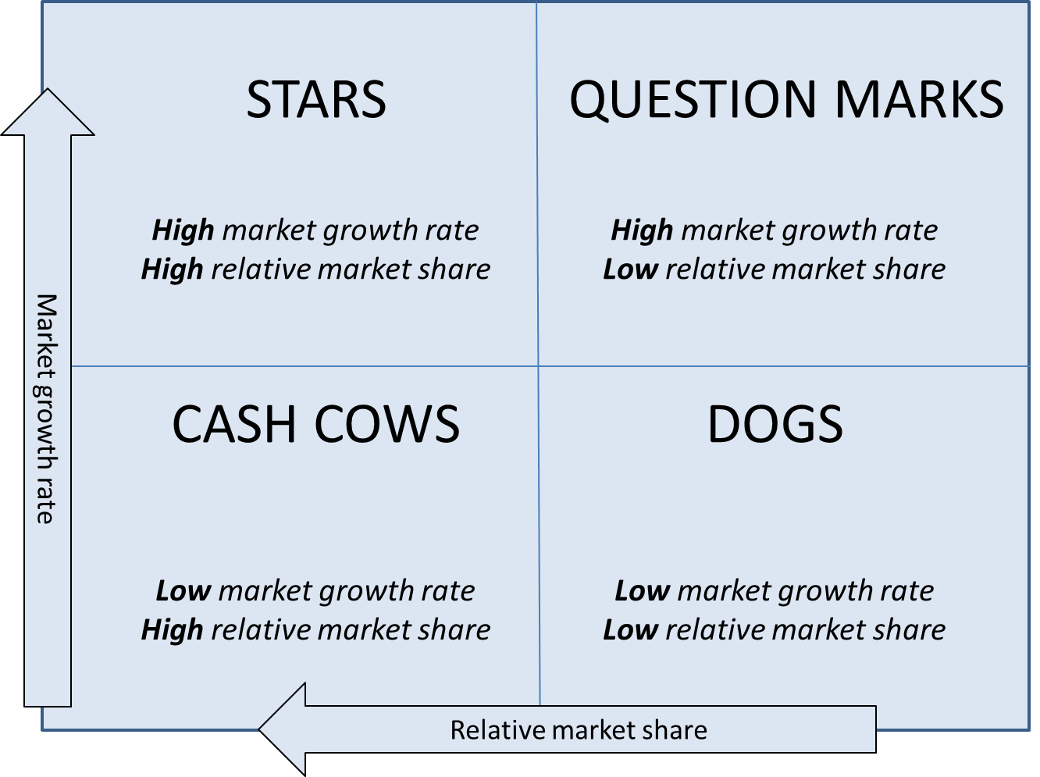 The matrix has four different angles in which its entire productivity depends on (Eggleston, 2012).
- Stars: this represents a high and effective share and growth in the industry that is growing really fast. The startups in the industry require a lot of money in order to counter the competition they receive from the companies that have existed in the industry for long. \
- Cash Cows: this is a company with a very high market share in an industry that is growing slowly. They generate a lot of money that enable them to maintain the business in the industry.
- Dogs: these companies have low market shares in an industry which are both mature and fast-growing. These companies are always unfortunate and at the same time, they are miserable since they are usually unable to keep the pace of the companies that at in the same industry. This hampers their growth.
- Question marks: these are companies with limited market share but are wishing to enter a high growth market.
From this analysis, it can be deduced that hospitality industry is a slow moving industry and companies in this industry has to be patient in order to have their market share. New companies are not effective and cannot offer any competition to the existing ones because they are not effective.
From this analysis, it can be concluded that Hilton and Intercontinental both belong in the category cash cows. This is due to the fact that they have great market shares and also brand recognition. They have to maintain their effectiveness in the industry for a long period of time and stay very competitive. These are the characteristic of Hilton and Intercontinental hotels. The management of these companies is however advised to be cautious and maintain their strategy for the purposes of maintaining market share.
- Ansoff Matrix Analysis:
This analysis method does the arranging and clarification of the development methods that are of substance. This method helps the firms by connecting them to both the key choices and course. 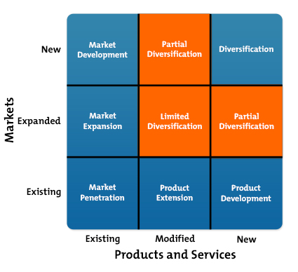 The companies falling in this category are those that are introducing new items in their list (Peng, 2012) (Lowitt, 2015).
5.1 Market penetration
A startup company focus is essential due to the fact that its existence in the industry is necessary to the introduction of new items that will distinguish it from other companies in the same industry. It is however required that any new company should enter the market with existing items. It is important for the company to enter a business with very powerful procedures as regards to the administration and investigators. Comparing Hilton and Intercontinental hotels, it is true that they are not new companies in the industry and they have been operating for so many decades, because of this these companies’ market force penetration would have no effect on their financial and strategic market positions.
5.2 Product Development
This segment is involved with the upgrading the new items as well as the administration in the business presently. Hilton and Intercontinental have both utilized this distinct promotion of network to expand their monetary success. The growth of an item makes the organization to gain and helps in building the measure of the focus on business. Over the years, both companies have been introducing new items in order to satisfy their customers. With this equal competitive behavior, it has been found that Hilton and InterContinental have been growing in the industry at relatively same pace.
5.3 Market Development
This segment deals with the creation or establishing new markets for the already existing items. This builds the scale of production of the company, through diverse systems and methods. This expansion of market makes an organization to increase its sales hence making a lot of profit. Hilton Worldwide has expanded its market territory in more than 90 countries worldwide where it is introducing the same products. Intercontinental Hotel is also operating in about 100 countries. It has also expanded its market through the introduction of their existing items in other countries.
5.4 Diversification
During market expansion, the companies must introduce new items to the new markets. This method is highly risky and unpredicted and should always be embraced by companies when they have no doubts in their skills and assets for doing this. There are different new items that Hilton and Intercontinental have dispatched in their new markets as they expand and increase their market size. They have done this successfully because of the availability of the skills in the industry as well as assets.

- Value chain analysis used to create competitive advantage
Core competencies
Hilton Worldwide
The success of Hilton Worldwide has been made possible by their core competencies in the industries. They are living their values in Hospitality, Integrity, Leadership and Teamwork in their entire daily task. Their power to collaborate has seen them build a strong productive work relation. Customer focus has become part of their DNA and the services they provide is beyond measure which has made them to be in their own class in the industry. Their judgmental skills in decision making as made them to take calculated risks which have made them to top in innovating new products and channels of service delivery. The hotel has embraced relationship based leadership style which puts the interest of its workforce seriously to motive them and empower them to be creative and innovative in their areas of duty and lastly their vast experience and business insights in hospitality industry has enhanced their competitiveness.
Intercontinental Hotels
Intercontinental Hotels’ success is deeply rooted in their core competencies; (King, 2008).Their processes has been tailor made to meet the demands of their customers. Their people agenda can be seen by the kind of service their staffs portray wherever they are handling clients and lastly the amount of resources they have invested in innovation and service delivery is a clear indication of the focus they attached to their clients
Hilton Worldwide Competitive strategies
To be an industry leader and pacesetter in a competitive market is not an easy task and for this reason the Hilton World University was established as a center of excellence in the hospitality industry. The center has produced world class leaders and staff who are part of the hotel family. The institution core philosophy on research of new products and quality improvement has made the hotel offer competitive prices and accessible to customers of all nature. Their continued improvement through in-house training that focuses on brand training has enabled their brand to remain in the minds of its customers and lastly is the effort to integrate their external partner’s contribution in the design and development of their products has proved to work in their favor
Conclusion
Hilton Worldwide and Intercontinental Hotels can only be compared. It poses a challenge contrasting them because they have set strategies that make it difficult for them to be contrasted. This is because they have set the same international standards to an extent that it becomes difficult to differentiate the services offered by either organization (LLC Books, 2010). The strategies, however, make them offer competition of equal measure to each other, as a result every organization is very keen on what their competitor is doing, and should there be any drop in the standard, they will take the advantage of attracting all the customers. A customer who has never been to either hotel would find it difficult choosing the hotel to consider. However, with the ever-changing customer needs, Hilton Worldwide has gone a notch higher by establishing a university of a kind for the purposes of training its members so as to provide quality and professional services. This is opposed to Intercontinental who has also ventured in the training of its team through establishing an academy (King, 2008).

References
Best Companies. (2015). InterContinental Hotels Group (IHG) as a first mention, thereafter just refer as IHG. Retrieved October 19, 2016, from b.co.u: http://www.b.co.uk/Company/Profile/43450
Eggleston, M. (2012, April). Hilton Worldwide: Partnering for a Competitive Advantage. Retrieved October 19, 2016, from trainingindustry.com: https://www.trainingindustry.com/professional-education/articles/hilton-worldwide-partnering-for-a-competitive-advantage.aspx
Hilton Worldwide. (2016, October 2016). Discover a world of opportunity. Retrieved October 19, 2016, from hiltonworldwide.com: http://hiltonworldwide.com/
Hilton Worldwide. (2016, October 2016). Discover our vision, mission, and values. Retrieved October 19, 2016, from hiltonworldwide.com: http://hiltonworldwide.com/about/mission/
Intercontinental Hotel. (2016, September). Vision, Mission, Values. Retrieved October 19, 2016, from geneva-intercontinental.com: https://geneva-intercontinental.com/career/vision-mission-values/
Intercontinental Hotels. (2016, October). hotel history and heritage. Retrieved October 19, 2016, from geneva-intercontinental.com: https://geneva-intercontinental.com/destination-geneva/hotel-history-heritage/
InterContinental Hotels Group. (2005, April). InterContinental Hotels Group Plans To Dispose of Ten Wholly Owned Properties in Australia,New Zealand, and Fiji. Retrieved October 19, 2016, from hotel-online.com: http://www.hotel-online.com/News/PR2005_2nd/Apr05_IHGAustralia.html
King, M. A. (2008). The Implementation of Dspace at the Intercontinental Hotels Group: A Knowledge Mangement Project Success. IGI Global.
LLC Books. (2010). Intercontinental Hotels Group: Intercontinental Hotels, Intercontinental Hotels Group Brands, Holiday Inn, City Stars. General Books.
Lowitt, E. (2015). The Future of Value: How Sustainability Creates Value Through Competitive Differentiation.
Peng, M. W. (2012). Global Business. Boulevard: Cengage Learning.
Swot Analysis 24. (2016, January). INTERCONTINENTAL HOTELS GROUP comprehensive SWOT analysis. Retrieved October 19, 2016, from swotanalysis24.com: http://www.swotanalysis24.com/swot-i/55544-swot-analysis-intercontinental-hotels-group.html
The CareerBliss Team. (2012, May). CareerBliss on Culture: Hilton Worldwide Has Culture of Hospitality. Retrieved October 18, 2016, from careerbliss.com: https://www.careerbliss.com/blog/careerbliss-on-culture-hilton-worldwide-has-culture-of-hospitality/

