
New Perspectives Excel 2016 | Module 10: SAM Project 1a
Hurdy Headphones
WHAT-IF ANALYSES AND SCENARIOS

GETTING STARTED
- Open the file NP_EX16_10a_FirstLastName_1.xlsx, available for download from the SAM website.
- Save the file as NP_EX16_10a_FirstLastName_2.xlsx by changing the “1” to a “2”.
  - If you do not see the .xlsx file extension in the Save As dialog box, do not type it. The program will add the file extension for you automatically.
- With the file NP_EX16_10a_FirstLastName_2.xlsx still open, ensure that your first and last name is displayed in cell B6 of the Documentation sheet.
  - If cell B6 does not display your name, delete the file and download a new copy from the SAM website.
- This project requires you to use the Solver add-in. If this add-in is not available on the Data tab in the Analyze group (or if the Analyze group is not available), install Solver as follows:
  - In Excel, click the File tab, and then click the Options button in the left navigation bar.
  - Click the Add-Ins option in the left pane of the Excel Options dialog box.
  - Click the Manage arrow, click the Excel Add-Ins option, and then click the Go button.
  - In the Add-Ins dialog box, click the Solver Add-In check box and then click the OK button.
  - Follow any remaining prompts to install Solver.

PROJECT STEPS
- Kylie and Derek Hurdy own Hurdy Headphones, a company that manufactures wireless and noise-cancelling headphones and personalized earphones in Pittsburgh, Pennsylvania. As an intern at the company, you are developing a workbook that includes the financial details of each product line. Kylie and Derek have asked you to use the data to analyze scenarios that involve cutting expenses and raising prices. They want you to find the most profitable mix of products using the most cost-effective means of production.
Switch to the Wireless worksheet. Perform a break-even analysis for wireless headphones as follows:
  - In cell B27, use Goal Seek to set cell B27 to a value of 0.
  - Change the number of units sold in cell B26 to break even, or reach a Gross Profit of $0. (Hint: The number format applied to cell B27 will display the value of $0 as $ -.)
- Create a one-variable data table to calculate sales, expenses, and profits based on the number of wireless headphones sold as follows:
  - In cell D5, enter a formula that references cell B4, which is the expected units sold for this product.
  - In cell E5, enter a formula that references cell B19, which is the expected total sales for this product.
  - In cell F5, enter a formula that references cell B20, which is the expected total expenses for this product.
  - In cell G5, enter a formula that references cell B21, which is the expected gross profit for this product.
  - Select the range D5:G10 and then complete the one-variable data table, using cell B4 as the Column input cell for your data table.
- Create a two-variable data table to calculate the gross profit based on the number of wireless headphones sold and the price per unit:
  - For the range D14:K19, create a two-variable data table using the price per unit (cell B5) as the Row input cell.
  - Use the units sold (cell B4) as the Column input cell.
- Apply a custom format to cell D14 to display the text Units Sold/Price in place of the cell value.
- Switch to the Noise-Cancelling worksheet. Create a Scatter with Straight Lines chart based on range D4:F14 in the data table Noise-Cancelling – Break-Even Analysis.
- Modify the new chart as follows:
  - Resize and reposition the chart so that it covers the range D15:H32.
  - Remove the chart title from the chart.
  - Add Sales and Expenses as the vertical axis title and Units Sold as the horizontal axis title.
- Change the Bounds Axis Options as follows:
  - Change the Minimum Bounds of the vertical axis to 1750000 and the Maximum Bounds to 2650000.
  - Change the number format of the vertical axis to Currency with 0 decimal places and $ as the symbol.
  - Change the Minimum Bounds of the horizontal axis to 8500. (Hint: The Maximum Bounds should automatically change to 12,500.)
- Create two scenarios to compare the costs for standard components and green components in the noise-cancelling headphones as follows:
  - In the Scenario Manager, add two scenarios using the data shown in bold in Table 1 below.
  - The changing cells for both scenarios are the nonadjacent cells B11 and B14.
  - Close the Scenario Manager without showing any of the scenarios.

Table 1: Noise-Cancelling Headphones Scenario Values

Values | Scenario 1 | Scenario 2
Scenario Name | Standard | Environmental
Noise_Cancelling_Variable_Cost (B11) | 179.00 | 182.50
Noise_Cancelling_Fixed_Cost (B14) | 300000 | 350000

- Switch to the Earphones worksheet. Create a Scatter with Straight Lines chart based on range D6:I14 in the data table Personalized Earphones – Net Income Analysis.
- Modify the new chart as follows:
  - Resize and reposition the chart so that it covers the range D15:I32.
  - Remove the chart title from the chart.
  - Reposition the chart legend to the Right of the chart.
  - Add Net Income as the vertical axis title and Units Sold as the horizontal axis title.
  - Change the colors of the chart to Color 5 (1st row in the Monochromatic palette). (Hint: Depending on your version of Office, the name of the color may be different.)
- Change the Bounds Axis Options for the new chart as follows:
  - Change the Minimum Bounds of the vertical axis to -100000 and the Maximum Bounds to 620000.
  - Change the number format of the vertical axis to Currency with 0 decimal places and $ as the symbol.
  - Change the Minimum Bounds of the horizontal axis to 10500 and the Maximum Bounds to 14500.
- Edit the chart series names as follows:
  - For Series 1, set the series name to cell E5. (Hint: The series name should automatically update to “=’Earphones’!$E$5”.)
  - For Series 2, set the series name to cell F5.
  - For Series 3, set the series name to cell G5.
  - For Series 4, set the series name to cell H5.
  - For Series 5, set the series name to cell I5.
- Hurdy Headphones wants to determine whether subcontracting the manufacture of their personalized earphones to other electronics companies would reduce the costs of the earphones. Switch to the Earphone Suppliers worksheet, and then run Solver to solve this problem as follows:
  - Set the objective as minimizing the value in cell E10 (Total Costs).
  - Use the range B4:D4 as the changing variable cells.
  - Adjust the number of units produced by each company using the following constraints:
  - E4=12500, the total number of earphones produces
  - E10 <=1200000, the maximum total cost
  - B4:D4 <=5000, the maximum number of earphones produced by a single supplier
  - B4:D4 should be an Integer
  - Run Solver, keep the solution, and then return to the Solver Parameters dialog box. Save the model to the range A14:A21, and then close the Solver Parameters dialog box.
- Switch to the All Products worksheet. Use the Scenario Manager to create a Scenario Summary report that summarizes the effect of the Status Quo, Subcontract, and Raise Prices 5% scenarios. Use cells B17:D17 as the result cells.
- Switch back to the All Products worksheet. Use the Scenario Manager as follows to compare the profit per unit in each scenario:
  - Create a Scenario PivotTable report for result cells B17:D17.
  - Remove the Filter field from the PivotTable.
  - Change the number format of the Profit_per_Unit_Sold_Wireless, Profit_per_Unit_Sold_Noise_Cancelling, and Profit_per_Unit_Sold_Earphones fields (located in the Values box of the PivotTable Field List) to Currency with 2 decimal places and $ as the symbol.
  - Use Wireless as the row label value in cell B3, Noise-Cancelling as the value in cell C3, and Earphones as the value in cell D3.
  - In cell A1, use Profit per Unit Sold as the report title.
  - Format the report title using the Title cell style.
  - Resize column A using AutoFit. Resize columns B-D to 15.00.
- Add a PivotChart to the Scenario PivotTable worksheet as follows:
  - Create a Clustered Column PivotChart based on the PivotTable. [Mac Hint: PivotCharts are not available on Excel 2016 for the Mac, so insert a Clustered Column chart and adjust the data, and the legend and axis formatting to match Final Figure 6.]
  - Resize and reposition the chart so that it covers the range A8:D20.
  - Hide the field buttons in the chart. [Mac Hint: PivotCharts are not available on Excel 2016 for the Mac, so Mac users can ignore this instruction.]
Your workbook should look like the Final Figures below. Save your changes, close the workbook, and then exit Excel. Follow the directions on the SAM website to submit your completed project.

Final Figure 1: Wireless Worksheet
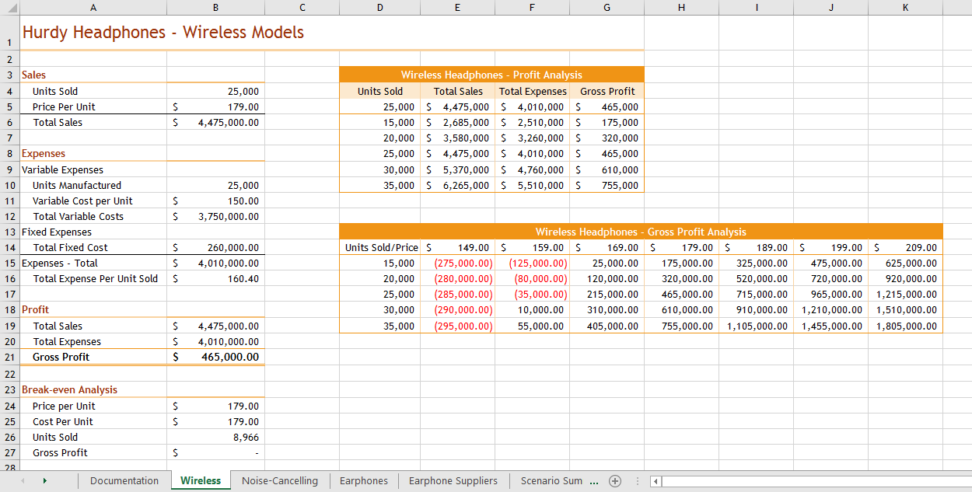

Final Figure 2: Noise-Cancelling Worksheet
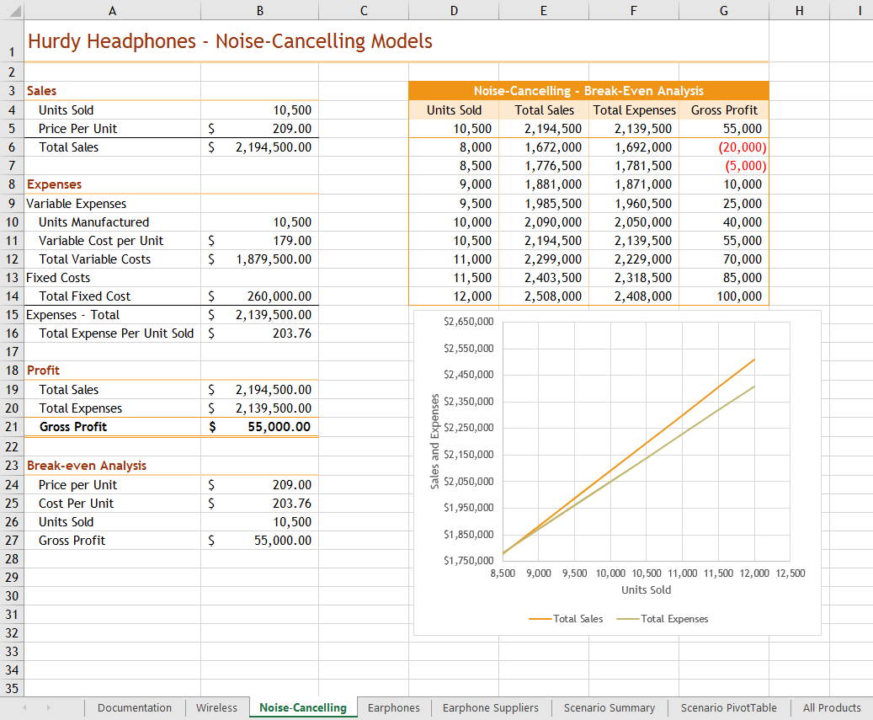

Final Figure 3: Earphones Worksheet
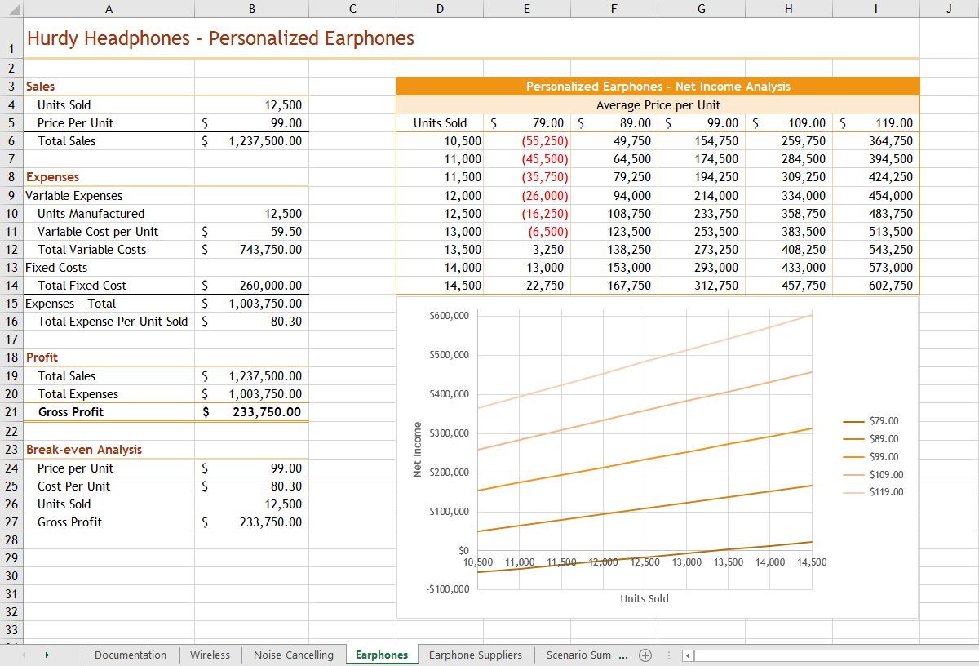

Final Figure 4: Earphone Suppliers Worksheet
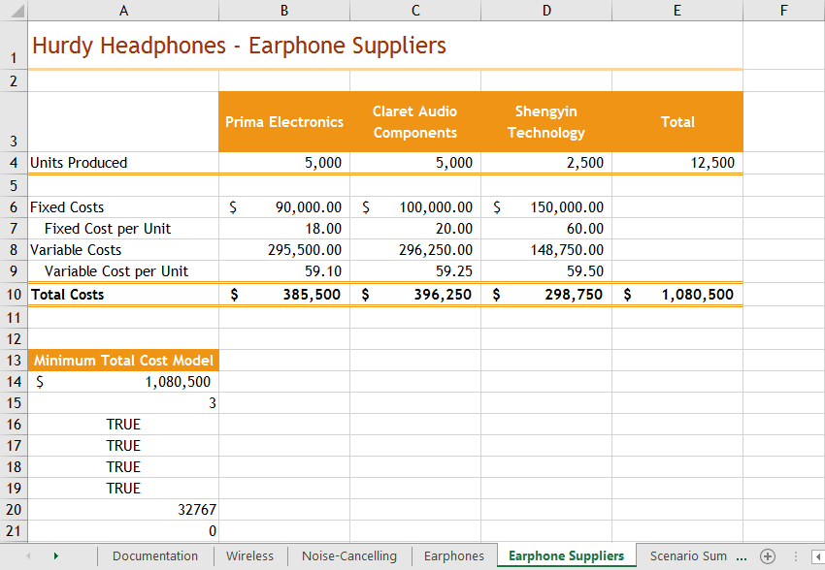

Final Figure 5: Scenario Summary Worksheet
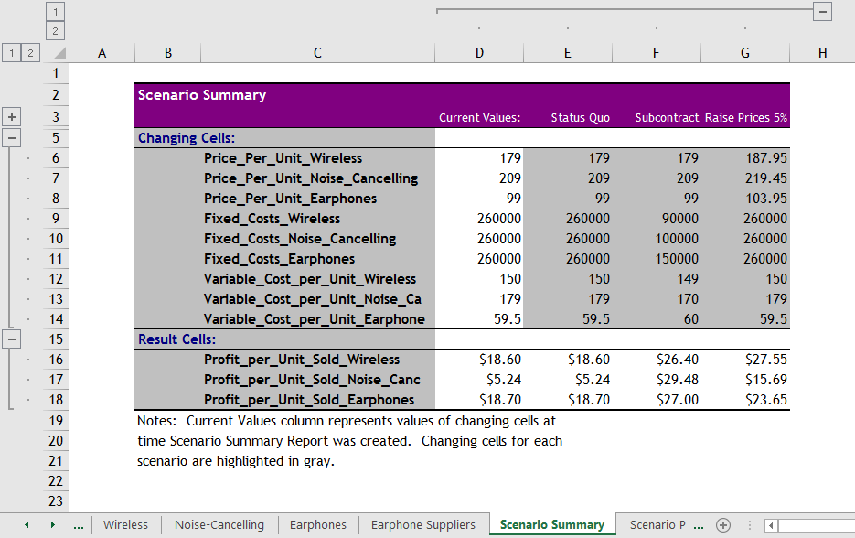

Final Figure 6: Scenario PivotTable Worksheet
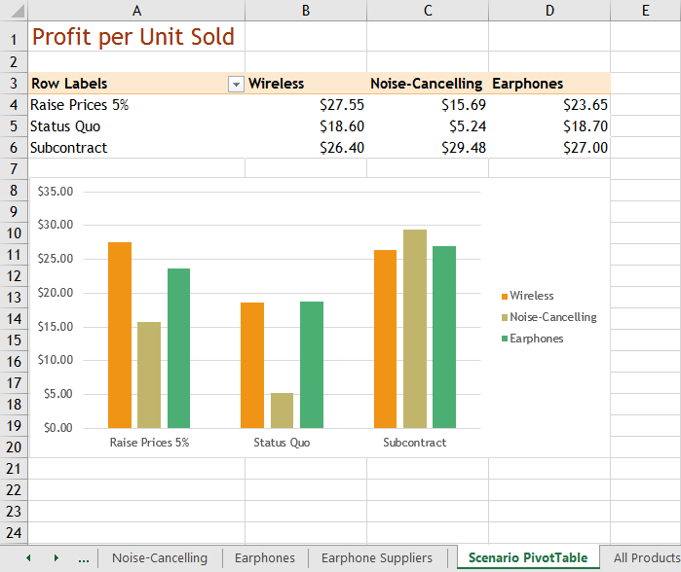

Final Figure 7: All Products Worksheet
