- Describe the major components in computer architecture
- Describe the primary components of the Central Processing Unit
- Explain the states of a digital signal
- Suppose you have a digital signal with a period of 1500 milliseconds. What is the period in microseconds?
- What is the 12-bit BCD binary code for 538₁₀?
- Covert 115₁₀ to its equivalent 8-bit unsigned binary value
- Covert the 8-bit unsigned binary value 11100101₂ to its equivalent decimal value.
- Simplify the following boolean expression.
- Write the Boolean algebra expression for outputs C, D, and E in the circuit 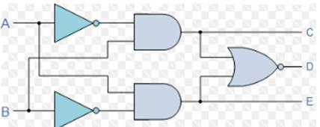below.
- What is the decimal value for the following signed magnitude number, assuming the MSB is the sign bit?
01100100₂
- Calculate the sum of the problem below and leave answer in binary form. Assume the numbers are unsigned magnitude.
01100111
+00010011
- Calculate the two’s complement of the following unsigned binary number.
10001001₂
- Convert 35.5₁₀ to IEEE 754 format.
- Write the Sum of Products expression of the circuit below.
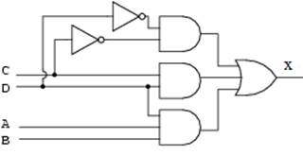
- Write the Product of Sums expression of the circuit below.
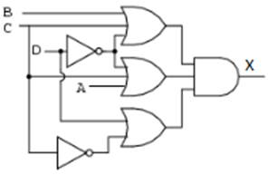
- Explain the purpose of a multiplexer.
- Assume even parity is being used when transmitting 8-bit bytes. What is the value of the parity bit (either 0 or 1) for the byte below, and explain how you arrived at your answer?
11110001
- Explain the different types of ROM.
- Explain the purpose of RAM and how it differs from ROM.
- Assume a computer has the capacity to hold up to 4 memory modules, with each module containing 1G bytes. How many total bits are needed in the memory address?
- What is the purpose of control lines in memory?
- Explain the differences in main memory and long term storage.
- Suppose you have a HDD with an average seek time of 8 msec and a rotational speed of 4800 RPM. How long would it take to transfer 102400 bytes. Assume 500 sectors on a track, and each sector contains 512 bytes.
- Describe the purpose of the Flag register
- Describe the roles of the data and address registers in a CPU architecture.
- Describe the differences in CISC and RISC processors.
- Describe what happens in an instruction pipe when a conditional JUMP instruction is executed and the subsequent instruction is not the next instruction in the pipeline.
- Explain the advantage of Direct Memory Access (DMA) when compared to program and interrupt driven I/O.

