Comparative Analysis of Hospitality Firms: Case of Hilton and InterContinental
Insert Name Here
University Affiliations

Introduction
Hilton Worldwide is an American based multinational hotel that is owned by Blackstone group. It is one of the largest hotels in the world with over 90 different countries, more than 4000 hotels and more than 650,000 rooms all over the world. It has been rank in the top 50 companies that are doing well in terms of revenue. Both the management and the employees at Hilton Worldwide are working together towards achieving the hotel's mission. The hotel is currently having more than 150,000 employees in all their branches worldwide. In the financial year 2015, the company earned revenue of up to US$10.783 billion. The financial position of the company is stable showing that the company is performing really well. It is trading in New York Stock Exchange where it has very broad and extremely high market share in the security market (Hilton Worldwide, 2016).
Intercontinental Hotels was established in 1946 in the United Kingdom. This was founded by the Pan America Airways founder Juan Trippe as part of PanAm. The hotel which is headquartered at Denham has over 742,000 rooms and more than 5,000 hotels in about 100 countries worldwide. Some of its brands include Candlewood Suites, Crowne Plaza, Even, Holiday Inn, Holiday Inn Express, Hotel Indigo, Hualuxe, InterContinental and Staybridge Suites (Intercontinental Hotel, 2016).
Analysis
Hilton Worldwide
Hotel Name | Hilton Worldwide
Headquarters | McLean, Virginia, United States
CEO | Christopher J. Nassetta
Total number of employees | More than 150,000
Total number of rooms | More than 650,000
Number of branches | More than 4000
Number of countries it operating | More than 90

Intercontinental
Hotel Name | Intercontinental
Headquarters | Denham, United Kingdom
CEO | Richard Solomons
Total number of employees | More than 160,000
Total number of rooms | More than 742,000
Number of branches | More than 5000
Number of countries it operating | More than 100

Comparative analysis of vision, mission and strategic objectives
Mission
Hilton Worldwide is founded in its mission that it is trying to perfectly achieve every day. Its mission is to be the most hospitable company in the world through the creation of warm experiences for their clients and great opportunities for the entire team while having high value for owners and impacting the community positively.
InterContinental Hotel’s mission is to create hotels that guest love. Their vision is to build the strongest operating system in the hotel industry that is aimed at the biggest markets and segments where scale matters
Vision
The vision of Hilton Worldwide is to fill the whole earth with nothing but light and warmth of hospitality through delivering outstanding experiences in all their branches and for all their guests at all the time. Their vision and mission are rooted in their clients, founders, and employees who are the key stakeholders necessary to propel the company to the next level (The CareerBliss Team, 2012) (Eggleston, 2012).
They are gender sensitive and have female employees of up to 33% in all their worldwide hotels. Their values include; Integrity, Attitude, Innovation, Respect, Passion, Ownership, Recognition and Teamwork (Best Companies, 2015).
Strategic Objectives
Hilton Worldwide has the main objective of ensuring that its growth continues every year. Between 2007 and 2012, Hilton Worldwide recorded a growth by a third as compared to its previous status. Its main goal right now is grow by another one third by 2017. The growth has been made worldwide due to coming up with new products for their customers.
Intercontinental Hotel has a strategy for high-quality growth that will strengthens the available diverse portfolio of their different brands. It aims at building scale in major markets and creating a strong relationship with guests—a relationship that will last for a lifetime. The achievement of the strategy is through the technology and third-party owners.
Hilton’s External Analysis is as shown below (Peng, 2012);
Opportunities
- Hilton Worldwide is getting the opportunity from the emerging potential of both hotels and resorts
- The opportunities have presented themselves to Hilton Worldwide through the customer based innovations that are emerging in the 21st century.
- Use of technology and digitalization create exceptional opportunities for Hilton Worldwide
- The ever increasing amount of tourists gives the Hilton Worldwide opportunity to grow
- Due to its emergence of the hotel in wedding and birthday planning functions, it has greater opportunities.
Threats
- The competition that comes from other hotels is ever increasing
- There are problems caused by both economic and political issues in most countries making them make losses
- There are regulations on the hospitality industry that hampers the growth of hotels.
Hilton’s Hotel Internal Analysis
Strengths
- The company has very high brand recognition, a good sign for a company since it is the driving force of which the company is competing with big names like Intercontinental Hotel.
- They have very high technical innovation that is aimed at improving the customer experience and satisfaction as far as upgrading the business process is concerned.
- They have perfect employee retention that is enabling them to grow to greater heights
- They have a very strong portfolio of products and hotels that are working worldwide in more than 90 countries.
- It has a very strong and long experience in the industry of more than 93 years. This is a sign showing that they have an exceptional experience.
- The company has a very strong reputation in the market. The reputation is effective.
Weaknesses
- While they have an effective and great brand recall, they have a relatively low market share.
- They have a very big problem managing some of their supply chains for many years.
- They have issues with striking workers and crack down on undocumented workers which are causing a lot of problems with the company.

Intercontinental External analysis
Opportunities
The opportunities that Intercontinental has included;
- They have the capacity of venture capital. The venture capital can enable the company to expand its market even more by introducing their items in other countries that have not yet started their business.
- It also has the opportunity to create global markets and reach all the main economies. There are economies that have grown and expect Intercontinental to have their business there. They have this opportunity to continue expanding their market since they do not only have the assets and finances to do so but also the capability.
Threats
There are however so many threats that InterContinental is facing as a company in different countries (Swot Analysis 24, 2016). These include;
- The ever increasing cost of raw materials makes them increase the cost of their products that is likely to scare away the customers.
- Intercontinental is a multinational company, however, due to the increasing cost, it becomes difficult for them to maintain their financial capacity that can enable them to overcome most financial challenges
- The ever growing technology poses a challenge of keeping with the pace. There is a lot of technological equipment that must be bought and technological personnel must also be employed.
- It has experienced the change in the price of most of its items, when price changes, only loyal customers will continue visiting the hotel, however, the overall number of customers must reduce.
- There is a very stiff competition offered by Hilton Worldwide and other hotels in the same industry
- The increase in the living standards, increases the labor cost hence reducing the profit margin
Intercontinental internal analysis
Strengths
- They have a very strong and stable distribution and sales network enabling them to make sales in all their branches worldwide
- They have highly skilled and qualified workforce. This makes them able to provide quality services that subsequently attract the customers.
- They have a very high growth rate due to their ability to offer quality services and have a strong customer base
- They have high profitability and revenue because of their strong customer base and values
- Because of their size and market share, they offer the market barrier to the new entrants. This lowers the competition
- They rule their domestic market in the UK. This makes them able to expand and grow globally
Weaknesses
- In order to be able to have a strong market expansion strategy, they are most likely to get very high loan rates
- Their cost structure is not stable compared to Hilton
- Their future profitability might reduce if they don’t up their game in the industry
- They might have poor debt rating should they continue to borrow.
Five forces analysis
Porter’s Five Forces is an important model having five angles which are vital for a company. The new companies mostly use this model to assess how effective they are in the market as far as expanding their operations is concerned. 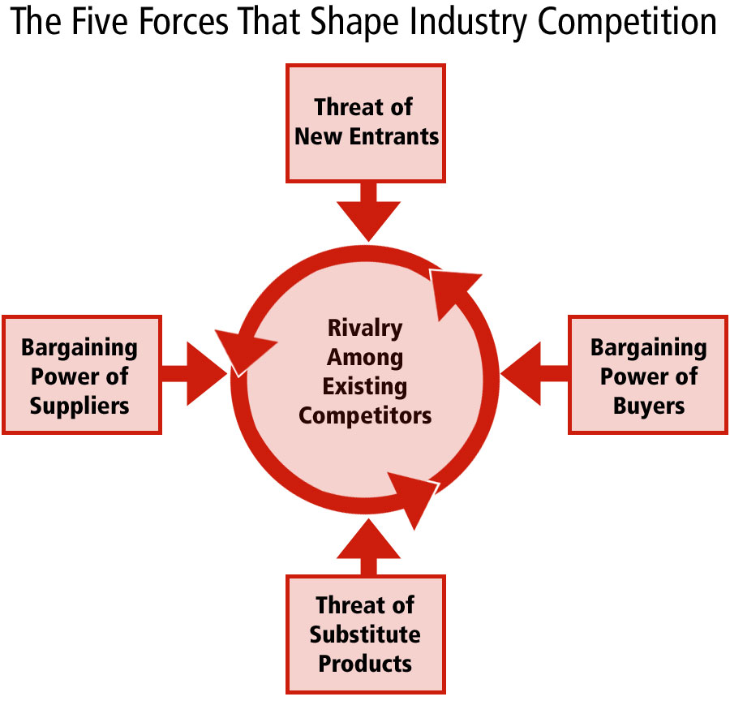 This model has the tendency of analyzing the company’s expansion strategies (Eggleston, 2012) (The CareerBliss Team, 2012).
- Competitive Rivalry
Competition has increased in all the fields and the growth in technology has even made it increase as there are so many technological elements that attract customers. Being in the hospitality industry, Hilton and Intercontinental are real competitors. Hilton has been in the industry for 9 decades while Intercontinental has been on the market for 7 decades. As a matter of fact, these two hotels have built their brand. They are two big brands that everyone is talking about. The proportion of rivalry between these two hotels is at high stake. They have same standards. This means one would have difficulties choosing whether to go to Hilton or to Intercontinental. They operate in almost the same countries. Hilton operates in more than 90 countries while Intercontinental operates in almost 100 countries. This means in every country that you find Hilton Worldwide, InterContinental Hotel must be present. Both hotels must keep their current status constant in order to counter the competition. They should also maintain the mechanism in order enhance their productivity. In summary, it can be said that the two companies are giving each other very stiff competition in order to outcompete the other (King, 2008).
- Bargaining power of customers
The customers are the end users of the services and products offered by an organization. The provision of the customers is very vital and extremely important as far as the growth of an organization is concerned. When there is weak and unsatisfied customer base in an organization, it becomes difficult for the organization to grow at the required pace. Due to the current technological world, most companies are perfecting their areas of specialization while at the same time providing customer satisfaction services. Due to the saturation of the industry, it is paramount to have a very strong customer base system. Hilton Worldwide has a very strong customer base with all its activities customer-centered. This is the same case with Intercontinental Hotel which offers quality customer services making them retain their already existing customers. The two companies have a very strong power of customer bargain that has enabled them to remain relevant in the industry for so many decades. Due to the fact that customers can either choose Hilton or Intercontinental to satisfy their needs, every hotel has to have higher customer bargaining power. Hilton and Intercontinental both have perfect brand recognition and customer base. For their growth and competition to win even more customers, these companies should try to pay very keen attention towards the customers (Hilton Worldwide, 2016) (Best Companies, 2015).
- Bargaining power of suppliers
In every organization, suppliers are one of the most important stakeholders, especially for these hospitality organizations because they require their products and raw materials regularly. Hilton has its headquarters situated in the United States while InterContinental’s headquarters is situated in the United Kingdom. These are countries where getting the suppliers is not difficult because there are a lot of suppliers who are operating in different countries and are willing to supply the companies with as much products as they want. Because of this reason, these two companies have noticed very lower bargaining power from the suppliers. This is an effective sign for these companies.
- Threats of substitute products
The level of competition in the hospitality industry is ever increasing. Hilton and Intercontinental Hotels are of same class, offering same quality services; this is making each hotel to face very high threats of substitute products. For instance, in the absence of Hilton, Intercontinental will satisfy the customers’ needs perfectively and at the same time, if Intercontinental is absent, Hilton Worldwide will satisfy the needs of the customers perfectly. These two companies, therefore, are a substitute for each other but in the event that one becomes weak even for a day, all the customers will find their way to the alternative hotel. They should be careful and raise or maintain their standards while at the same time paying attention on what others are offering so as not to be left out (LLC Books, 2010).
- Threats of New Entrants
There are two barriers present for new entrants. The barrier to entry and barrier to exit. Barriers to entry in initiating and establishing a company in the hospitality industry are very low. This is not an effective sign of both Hilton and Intercontinental since the new entrants have the ability to increase the level of competition and pressure on these two companies. The barriers to exit, on the other hand, are very high, however, this is not in the favor of Hilton and Intercontinental since it is always very difficult for companies to get out easily in the hospitality industry (King, 2008).
BCG Matrix Analysis
This matrix is also known as Growth Share Matrix which assists organizations and their core business units. It helps in proper allocation of the resources since it is an analytical tool in product management, brand marketing, portfolio analysis and strategic management.
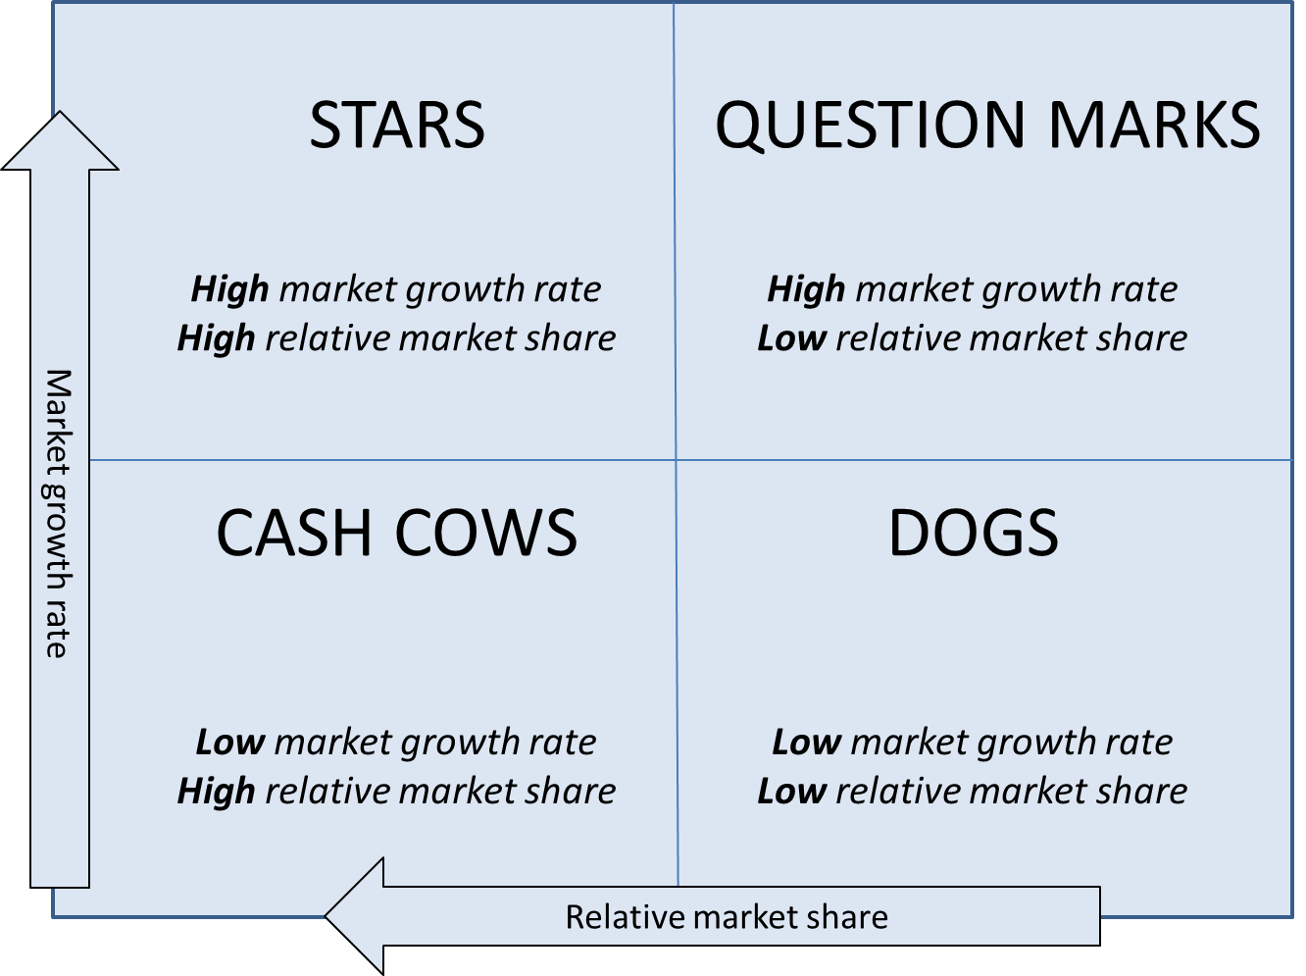 The matrix has four different angles in which its entire productivity depends on (Eggleston, 2012).
- Stars: this represents a high and effective share and growth in the industry that is growing really fast. The startups in the industry require a lot of money in order to counter the competition they receive from the companies that have existed in the industry for long. \
- Cash Cows: this is a company with a very high market share in an industry that is growing slowly. They generate a lot of money that enable them to maintain the business in the industry.
- Dogs: these companies have low market shares in an industry which are both mature and fast-growing. These companies are always unfortunate and at the same time, they are miserable since they are usually unable to keep the pace of the companies that at in the same industry. This hampers their growth.
- Question marks: these are companies with limited market share but are wishing to enter a high growth market.
From this analysis, it can be deduced that hospitality industry is a slow moving industry and companies in this industry has to be patient in order to have their market share. New companies are not effective and cannot offer any competition to the existing ones because they are not effective.
From this analysis, it can be concluded that Hilton and Intercontinental both belong in the category cash cows. This is due to the fact that they have great market shares and also brand recognition. They have to maintain their effectiveness in the industry for a long period of time and stay very competitive. These are the characteristic of Hilton and Intercontinental hotels. The management of these companies is however advised to be cautious and maintain their strategy for the purposes of maintaining market share.
Ansoff Matrix Analysis:
This analysis method does the arranging and clarification of the development methods that are of substance. This method helps the firms by connecting them to both the key choices and course. 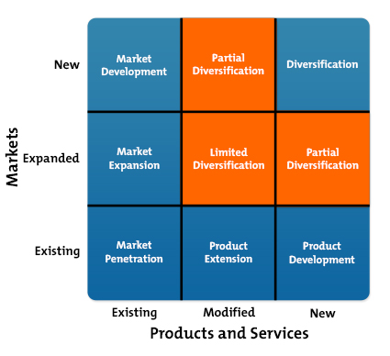 The companies falling in this category are those that are introducing new items in their list (Peng, 2012) (Lowitt, 2015).
Market penetration
A startup company focus is essential due to the fact that its existence in the industry is necessary to the introduction of new items that will distinguish it from other companies in the same industry. It is however required that any new company should enter the market with existing items. It is important for the company to enter a business with very powerful procedures as regards to the administration and investigators. Comparing Hilton and Intercontinental hotels, it is true that they are not new companies in the industry and they have been operating for so many decades, because of this these companies’ market force penetration would have no effect on their financial and strategic market positions.
Product Development
This segment is involved with the upgrading the new items as well as the administration in the business presently. Hilton and Intercontinental have both utilized this distinct promotion of network to expand their monetary success. The growth of an item makes the organization to gain and helps in building the measure of the focus on business. Over the years, both companies have been introducing new items in order to satisfy their customers. With this equal competitive behavior, it has been found that Hilton and InterContinental have been growing in the industry at relatively same pace.
Market Development
This segment deals with the creation or establishing new markets for the already existing items. This builds the scale of production of the company. Through diverse systems and methods. This expansion of market makes an organization to increase its sales hence making a lot of profit. Hilton Worldwide has expanded its market territory in more than 90 countries worldwide where it is introducing the same products. Intercontinental Hotel is also operating in about 100 countries. It has also expanded its market through the introduction of their existing items in other countries.
Diversification
During market expansion, the companies must introduce new items to the new markets. This method is highly risky and unpredicted and should always be embraced by companies when they have no doubts in their skills and assets for doing this. There are different new items that Hilton and Intercontinental have dispatched in their new markets as they expand and increase their market size. They have done this successfully because of the availability of the skills in the industry as well as assets.

Value chain analysis used to create competitive advantage
Core competencies
Hilton Worldwide
The success of Hilton Worldwide has been made possible by their core competencies in the industries. These core competencies include
- They are living their values such as Hospitality, Integrity, Leadership, Teamwork, Ownership, Now
- They have collaborative power that enables them to build a very strong and productive working relationships
- They have customer focus and their services are customer based making them act accordingly to matters pertaining to their customers
- They have good judgment with the ability to analyze data, take risks and make very hard decisions.
- They have good leadership that has the ability to forecast and built strong teams
- They drive the customer value through their ability to remain to focus on the result
- They have the workforce that balances their work and life very well.
- Finally, they have a very strong business insight and integrity that has made them not only to identify their growth but also to identify their work ethics
Intercontinental Hotels
Intercontinental Hotels’ success is deeply rooted in the following core competencies; (King, 2008)
- They have processes that are customer oriented enabling them to attract customers since customer is top on their list
- They have high qualified staff that is caring and hospitable. This enables them to provide quality services that every customer would want to be part of.
- Their management is exceptional. They have the ability to perfectly manage all the resources, forecast into the future and make the right judgment which is customer based.
- They are result oriented and provide the best to meet their customers’ needs.
Competitive strategies
Some of the competitive strategies that have been implemented by Intercontinental Hotels include;
- They have very wide portfolio of their strong brands in most of their key locations
- They have the extensively recognized loyalty program
- They have deep relationship with all their key strategic partners
- Their strategy is well developed and focused.
- They have an academy that recognizes and develop talents
- They have very strong connections to the governments in all the countries where they operate
- They have signed more portfolio deals than Hilton Worldwide

Hilton Worldwide Competitive strategies
- They have an established university, Hilton Worldwide University, that is aimed at educating team members, owners and employees and this has generated improved performance.
- They have a philosophy of delivering the best quality at very competitive prices and making the access of their organization very easy for all the stakeholders.
- They have developed in-house training aimed at focusing on such areas as brand training.
- They have blended all their external partnership with the internal development as well as design
Conclusion
Hilton Worldwide and Intercontinental Hotels can only be compared. It poses a challenge contrasting them because they have set strategies that make it difficult for them to be contrasted. This is because they have set the same international standards to an extent that it becomes difficult to differentiate the services offered by either organization (LLC Books, 2010). The strategies, however, make them offer competition of equal measure to each other, as a result every organization is very keen on what their competitor is doing, and should there be any drop in the standard, they will take the advantage of attracting all the customers. A customer who has never been to either hotel would find it difficult choosing the hotel to consider. However, with the ever-changing customer needs, Hilton Worldwide has gone a notch higher by establishing a university of a kind for the purposes of training its members so as to provide quality and professional services. This is opposed to Intercontinental who has also ventured in the training of its team through establishing an academy (King, 2008).

References
Best Companies. (2015). InterContinental Hotels Group (IHG) as a first mention, thereafter just refer as IHG. Retrieved October 19, 2016, from b.co.u: http://www.b.co.uk/Company/Profile/43450
Eggleston, M. (2012, April). Hilton Worldwide: Partnering for a Competitive Advantage. Retrieved October 19, 2016, from trainingindustry.com: https://www.trainingindustry.com/professional-education/articles/hilton-worldwide-partnering-for-a-competitive-advantage.aspx
Hilton Worldwide. (2016, October 2016). Discover a world of opportunity. Retrieved October 19, 2016, from hiltonworldwide.com: http://hiltonworldwide.com/
Hilton Worldwide. (2016, October 2016). Discover our vision, mission, and values. Retrieved October 19, 2016, from hiltonworldwide.com: http://hiltonworldwide.com/about/mission/
Intercontinental Hotel. (2016, September). Vision, Mission, Values. Retrieved October 19, 2016, from geneva-intercontinental.com: https://geneva-intercontinental.com/career/vision-mission-values/
Intercontinental Hotels. (2016, October). hotel history and heritage. Retrieved October 19, 2016, from geneva-intercontinental.com: https://geneva-intercontinental.com/destination-geneva/hotel-history-heritage/
InterContinental Hotels Group. (2005, April). InterContinental Hotels Group Plans To Dispose of Ten Wholly Owned Properties in Australia,New Zealand, and Fiji. Retrieved October 19, 2016, from hotel-online.com: http://www.hotel-online.com/News/PR2005_2nd/Apr05_IHGAustralia.html
King, M. A. (2008). The Implementation of Dspace at the Intercontinental Hotels Group: A Knowledge Mangement Project Success. IGI Global.
LLC Books. (2010). Intercontinental Hotels Group: Intercontinental Hotels, Intercontinental Hotels Group Brands, Holiday Inn, City Stars. General Books.
Lowitt, E. (2015). The Future of Value: How Sustainability Creates Value Through Competitive Differentiation.
Peng, M. W. (2012). Global Business. Boulevard: Cengage Learning.
Swot Analysis 24. (2016, January). INTERCONTINENTAL HOTELS GROUP comprehensive SWOT analysis. Retrieved October 19, 2016, from swotanalysis24.com: http://www.swotanalysis24.com/swot-i/55544-swot-analysis-intercontinental-hotels-group.html
The CareerBliss Team. (2012, May). CareerBliss on Culture: Hilton Worldwide Has Culture of Hospitality. Retrieved October 18, 2016, from careerbliss.com: https://www.careerbliss.com/blog/careerbliss-on-culture-hilton-worldwide-has-culture-of-hospitality/

