MGT 376 Final Project: Venmo

You will write an 8-10 page analysis of an innovation that has been commercialized in the past decade. Due November 29. For the innovation you will research and discuss:
- A brief history of the industry in which the innovation was developed (Social networks, air travel, etc.) 2 pages
- A detailed description of the product/innovation - what are its major features, and how do they represent a change from previous solutions? 1-2 pages
- An overview of the current dynamics of the industry - who are the major competitors? Does the industry exhibit network effects, standards, increasing returns to scale, etc.? Do complements play an important role? How quickly has the innovation diffused in society? Be sure to use concepts and terminology from the course. 2-3 pages
- Forecast the next decade of competition in this industry. Which companies and products are best positioned for success? Are there other discontinuous technologies on the horizon? Be specific in your discussion. 2-3 pages

Part 1: Venmo, a cashless and paperless digital payment service via mobile app that can be used to replace the traditional methods of cash, checks, or cards within a social network of known friends in addition to people in close geographical proximity, is a growing success in social payments and mobile apps in general. Due to its simplicity in design, ease of use, and social engagement, Venmo is becoming the standard for how millennial customers think about peer-to-peer payments.
Andrew Kortina and Iqram Magdon-Ismail, freshman college roommates at the University of Pennsylvania in 2001, founded this popular and successful mobile app in 2011. In college, Iqram majored in computer science, while Andrew was a double major in philosophy and creative writing. During their senior year, the two built their first real project together; a college classifieds site called My Campus Post. After graduation, Andrew and Iqram spent a few years working at companies such as iminlikewithyou.com, Ticketleap, and Bit.ly. Early in 2009 the two friends, after feeling they had gained infinitely more knowledge and experience, decided to start spending their weekends provoking different ideas together.
While attending a local jazz show they stumbled across an idea that lead to creation of the app. The crowd was able to download live music by sending a text message to the band and then having an mp3 sent it to your email. Here with the Latin roots of vendere, translating to sell, and “mo” for mobile, Venmo was created. Later, while working on this music idea in New York City, Iqram realized he left his wallet at his home in Philly, resulting in Andrew covering his expenses the entire weekend. The two friends contemplated the idea of paying each other back with a check, but everything nowadays is done on a mobile device. Now, instead of pursuing Venmo as a musical app, the two founders pursued a way to pay each other back, including a note so the user could keep track of the reason for each payment. From here on, Andrew and Iqram decided to launch their prototype by meeting with investors. Initially they didn’t have much luck raising money, but in December of 2009, a friend of theirs’ and his father became Venmo’s first investors.
Venmo officially launched in 2011 after remaining in beta testing for about two years. Only after a few months after it was released, the payment processing company Braintree purchased Venmo for 26.2 million dollars. Braintree also owns social startups like Airbnb, Uber, and LivingSocial. Then, in 2013 PayPal acquired Braintree, thus gaining Venmo as a star player on the team. PayPal is an American company that operates a worldwide online payments system through online service transfers of money as an electric alternative to methods like checks. PayPal is already widely known as the most widely known peer-to-peer payment network; however, it charges a transaction fee on each debit or credit payment. Venmo on the other hand, is free when using a major U.S. bank and debit card.
Venmo reached 314 million dollars in payments in Q1 of 2014, the same volume as Starbucks’ mobile payments app during that specific time period. “According to Forbes, Venmo is predicted to reach 90 billion dollars in payments by the end of 2017.” Venmo’s rapid growth is argued to be due to its mix of not only finance, but also social aspects. Although it is a finance app, other users would argue that it can be considered a social media app due to its ability to connect the user easily with others around them in order to make payments. Regardless of what you decide to categorize it as, it’s growing popularity and user-friendly design must be noted as very significant achievements.

Part 2:
Venmo is a mobile payment service that lets users transfer money to each other. Friends, Andrew Kortina and Iqram Magdon-Ismail, who met as freshman roommates at the University of Pennsylvania, founded Venmo. According to Kortina, the idea of Venmo originated when Magdon-Ismail forgot his wallet during a trip to visit Kortina. The two friends found that writing checks or cash payments to each other was inconvenient, especially since all other major day-to-day tasks were done through their mobile devices. Upon realizing that process of settling their accounts was a hassle; they started working on a way to send money through mobile devices.
Their original prototype sent money through text messages, but they eventually transitioned from text messages to a mobile app. Kortina and Magdon-Ismail built this innovative app in 2009, which they further enhanced by adding social media features and making it public. Within five months of its public launch, Venmo gained enough popularity to be bought for $26.2 million by Braintree, another payment processing service. In 2012, PayPal Holdings Inc. acquired Venmo from Braintree.
Venmo is a mobile app that allows simple cashless and paperless user-to-user digital payment. This app replaces the traditional methods of cash, checks, or cards. Venmo describes itself as a “digital wallet”. Users sign up and create an account by providing basic information and bank information using their mobile app or on the Venmo website. Once an account is created, users can find others who have also created an account. Users have a Venmo balance that is used for their transactions. They can link their bank accounts, debit cards, or credit cards to their Venmo account. Credit cards have a 3% fee for each transaction. If a user does not have enough funds on Venmo itself when making a transaction, Venmo will automatically withdraw funds from the user’s bank account or card.
One way Venmo is unique from other digital payment services is its social aspect. When a user makes a transaction, the transaction details (except the payment amount) are shared on the user’s “news feed” and to the user’s network of friends. This mimics that of a social media feed. The transactions can be made private, but most users do not change the privacy settings and use the feed as an opportunity to get creative and be social. This feed helps users remember the moments they shared with friends and further connect with these people. Venmo has become a fast, casual, convenient way to transfer money. Money can be transferred from Venmo into a user’s bank account in as little as one business day. By making these money transfers quick, uncomplicated, and even cool, Venmo has quickly became a verb amongst many of its users.

Part 3:
The major competitors of Venmo include Google Wallet, Apple Pay, PopMoney, SnapCash, Square Cash, Facebook Messenger Payments, and PayPal, a previous competitor but now owner of Venmo. Google Wallet is the closest competitor to Venmo because it links Google Wallet to Gmail accounts. As of right now, there is not an iOS app for Google Wallet which means iPhone users cannot use it. An advantage for Venmo is that it is available in both Android and iOS apps. Apple Pay is a payment system design for making purchases in the iTunes store and for apps with either a password or fingertip reader on iPhones. This will most likely remain a payment system only used on iPhones and in the iTunes store. PopMoney is also a similar payment system but it charges to send money from a debit card or bank account. Along with extra charges compared to Venmo it also has the disadvantage of working only with a limited amount of banks that take three days to transfer funds. Square Cash was developed by Twitter’s co-founder, Jack Dorsey. This payment system is completely free for debit card transactions through email or mobile app but is does not support credit card transactions. Facebook recently developed a payment system via Facebook Messanger. It allows users to link their debit cards and transfer money by text or instant message. As of now, Venmo is leading the industry in convenience, features and popularity. This industry is going to get more and more competitive forcing firms to develop better features and increase convenience for users. Social media connections may make switching to a new payment system difficult for users if all their friends are using one system. Firms will have to continuously innovate to keep a loyal installed base.

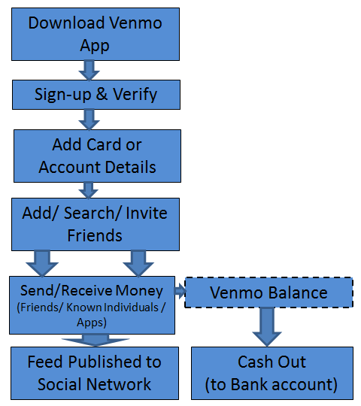

Work Cited:

"Venmo." .com. N.p., n.d. Web. 06 Nov. 2016.

Seth, Shobhit. "A Look at Venmo's Business Model and Competition." Investopedia. N.p., 2016. Web. 06 Nov. 2016.

