Audrianna Holsey
Samsung Challenges
Contemporary Business Issues
Albany State University
September 25, 2016

Samsung’s Smartphone Business Faces Challenges despite Strong Sales Growth
Samsung is well known for making some of the best smartphones and televisions on the market. According to Forbes, Samsung Electronics’ mobile phone division has proved to the bread and butter of the company over the previous few years, helping to offset the unfavorable business environment that some of its other business has been facing. Research has shown that their mobile division alone accounts for 40% of its company value with shipments increasing by about 22% year to year (Forbes, 2014.) However, regardless of their powerful output, there have been signs the mobile division could come across potential threats due to its increasing low-end and high-end competition.
High-End Competition is Intense
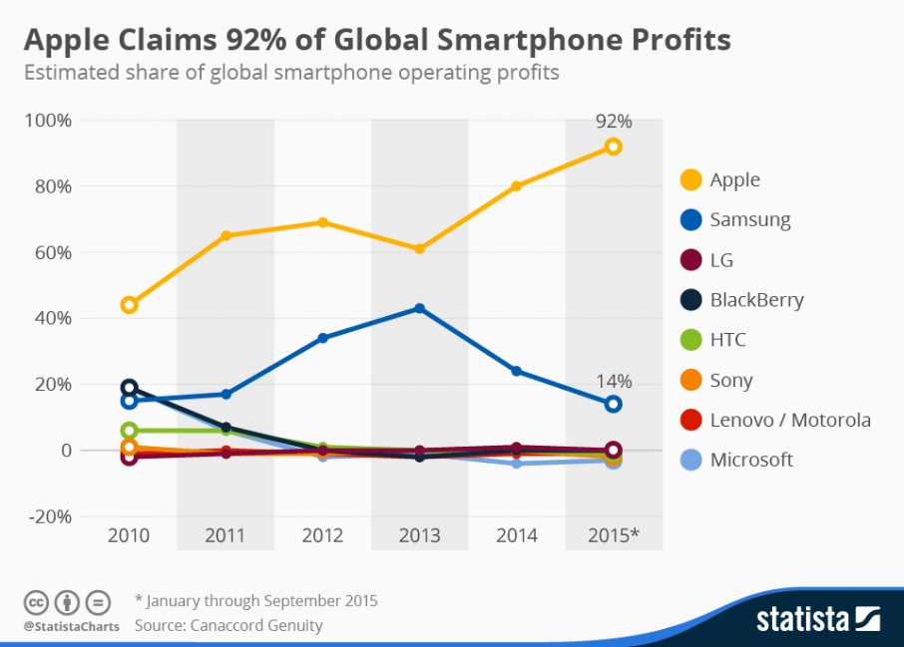
In terms of their low-end market, Samsung is slowly experiencing a decrease in demand in its mobile department. This is because Chinese and Indian manufacturers are beating out their low-end offerings which mean Samsung needs to act fast to start reevaluating its mobile strategy (Pestle Analysis, 2015.) Competing against the Chinese and Indian low-end market may not be the best business strategy as the rapidly declining profit margin may soon make this segment less desirable for Samsung. According to CNBC, Chinese and Indian vendors currently have models that are close to $100-200, and they are decent smartphones. Samsung still does not have a healthy pipeline of models between these average selling prices (CNBC, 2013.)
In addition to the challenges, Samsung faces high-end competition such as Apple as it has become the number one source for mobile devices for some markets like America. In 2014, Samsung was ordered to pay Apple millions of dollars for infringing three of patents of Apple and copying the look of the iPhone (Reuters, 2015.) This will continue to be an issue with Samsung as long as both companies continue to sell very similar products. Apple products are well known for being reliable, quality devices and the sophisticated choice overall. This is why the company’s market continues to grow, and they remain a threat to Samsung’s Electronics division. Furthermore, this makes Samsung’s choice of using Android operating systems less desirable than Apple’s iOS system. Also, because of Apple’s market for demand, the company has plans to expand their market to smart home technology, appliances, cameras, and televisions (Fortune, 2014.) This will allow them to compete directly with Samsung, which is why Samsung needs to maintain expert research abilities and design manufacturing skills. Moreover, the company may need to upgrade its smartphone design and recreate new marketing strategies to keep up with the market trends in America.
Rising Manufacturing Cost
The basic paradigm of the smartphone has mostly been set, and similar to a number of other manufacturers, Samsung has started considering the innovation phase. Samsung is placing great emphasis on product innovation as a way to stay ahead and competitive. An opportunity, as a result, arose for the company to introduce a significantly new product this month that will make a debut later this year. Gear 360 is Samsung’s first virtual reality consumer camera that can be used to view angles at a 360-degree. Their strategy intent is to allow users to an immersive experience and not share just a flat image. According to Fortune, “the new camera should open up new bundling opportunities for Samsung to offer consumers both a way to film in 360-degree video and then watch that content” (Guadiosi, 2016).
With these inventions, on the other hand, there is a significant increase in the manufacturing cost that is leaving the organization with a number of challenges. When one compares the manufacturing costs of Samsung with one of its top competitors, it can be seen that the cost of building Apple’s flagship iPhone 5S was estimated to $207, while the cost for Samsung S5 was almost $256. Same was the case with the earlier version, i.e. Galaxy S4. In the top end of the marketplace, higher costs in addition to the likelihood of lessening average selling prices would be expected to pressure the gross margins of the company going forward.
Recall of Note7
Recalling by Samsung for of 2.5 million Galaxy Note7 after a number of phones exploded and caught fire may stem from a manufacturing error, but it emphasized: “the challenges that Samsung faces in packing ever more battery power into ever thinner phones while rushing for faster release dates.” (Youkyung Lee, 2016).
This recalling of Note7 is a major challenge for Samsung as the competitor of Samsung; Apple has announced its iPhone 7. Apple can take advantage of recalling of Samsung for Note7 because, in the market, there is only Apple’s new iPhone 7. Samsung must overcome this challenge by making sure that there are no faults in the phone before launching the phone. The R&D department of Samsung is not as stronger as it could be because they have released a mobile phone with a major fault that could even become the reason of the death of the user.

References
Apple wins patent ruling against Samsung in U.S. appeals court| Reuters. (2015). Retrieved from http://www.reuters.com/article/us-apple-samsung-idUSKCN0RH23G20150917
An 'emerging' threat to Samsung, and it's not Apple. (2013). Retrieved from http://www.cnbc.com/id/100915961
Forbes Welcome. (2014). Retrieved from http://www.forbes.com/sites/greatspeculations/2014/05/29/samsungs-smartphone- business-faces-challenges-despite-strong-sales-growth/#245efca0225e
Gaudiosi, J. (2016, February 21). Samsung, LG Enter Virtual Reality Camera Fray. Fortune. Retrieved from http://fortune.com/2016/02/21/samsung-lg-virtual-reality- camera/?iid=sr-link5
Youkyung Lee, 2016. Galaxy Note 7 recall shows challenges of stronger batteries. Retrieved from http://phys.org/news/2016-09-galaxy-recall-stronger-batteries.html

